13th February 2025

Dear Parents / Carers,

Thank you for your support this half term. We have all really enjoyed our Journeys topic, especially learning about interesting explorers and seeing where Flat Stanley has been on his visits! The marble jars are filling up, so it won’t be long before our next reading treat. Please keep reading over the holiday. Thank you for engaging with the reading bingo. We have loved seeing all the reading photos!

Next half term our topic is plants and birds. We will be launching our topic with a walk around the school grounds to spot some new things growing and finding out the names of some of the plants. We will be busy planting sunflowers seeds and beans then comparing how they grow. Lots of our art will be around observational drawings and still life paintings and we are sure the children will be busy making lovely topic crafts on our make and do tables each week. We shall also be creating a little animation clip of a seed growing into a bean using the ipads. In our PE we will continue to have Miss Viles on a Thursday and be looking at target games. In PE on a Monday we will be doing dance.

If you are having a clear out of sheds and garages this half term could we ask for any donations of old seeds or plastic flowers for our role play garden centre area – many thanks. We will be planting some seeds so please can each child bring in two small and label free glass jars.

Please send a water bottle every day – the sports tops help prevent spillages in the classroom – the open top bottles have been spilling a lot. Please only send water.

We hope you have a lovely half term break.

Thank you for your continued support.

Year 1 Team

Our topic for this half term is ‘Plants and Birds. This is what we shall be covering in each subject.
Further information can be found on our school website:
www.abbeyroadprimary.co.uk/curriculum-assessment/

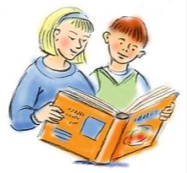  Literacy | Traditional tales and stories with a familiar setting.  The Enormous Turnip.  Christopher Nibble  WOW! Said the Owl  Owl poems
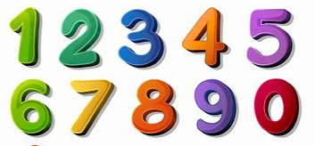  Maths | Place value within 50.  Counting in 2’s and 5’s.  Length and height.  Weight and volume.  Counting backwards in 1’s.
  Science | Plants and trees at Abbey Road.  Sorting and classifying seeds and leaves.  Different parts of a plant.  British birds.  Wangari Maathai- What did she achieve?
  Geography | Plants in the school grounds and around the world  Maps
  Art | Georgie O’Keeffe art  Plant and tree art, sketching and painting  Eliot Porter – photography in nature
  Computing | iProgram – algorithms and simple programming  E safety
  RE | Bible stories and Easter
  PSHE | Being healthy
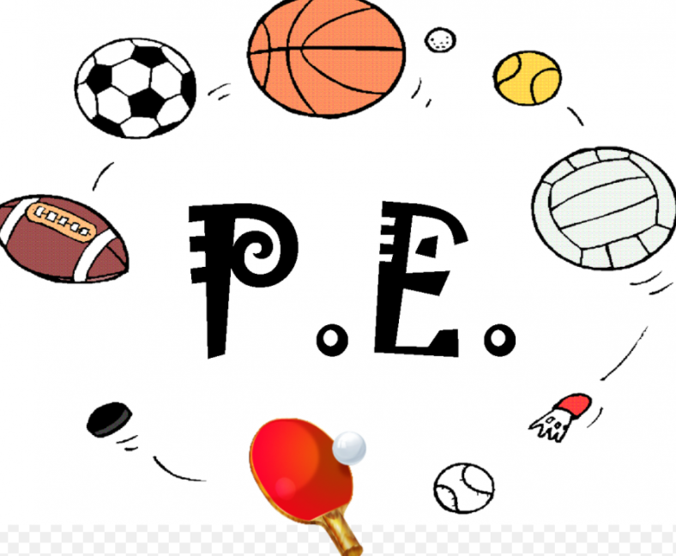  PE | Target games and dance
  Music | Recorders – school will provide these

