Dear Parents / Carers,
Thank you for your support this half term. We have all really enjoyed our Plants and Birds topic, especially learning about interesting owl facts this week!
Next term our topic is Animals. We are launching this topic with a special visit from the animals at White Post farm on Tuesday 29th April. We are excited to learn all about them and have a good hands-on experience! We have decided not to visit the farm itself as the children were getting less and less time to handle animals. We are hoping having the animals here will mean more time with them. We shall be going on a school trip later on in the Summer term to Clip n Climb as part of our ‘Healthy Sport Week’.
In science we are sorting and classifying animals and learning about sea creatures. We are learning about our five senses which we will explore fully on our fun ‘Science Day’ later on in the term.
Our art will study the work of Matisse and look at patterns in nature. We shall also be doing lots of lovely sea creature crafts. In geography we will be learning about the seas around the UK and the five oceans in the world.
PE will continue on a Monday and Thursday. Please continue to wear PE kits on those days.
Please send your child in with a named sun hat on warmer days and a water bottle every day. As the weather gets warmer the children are taking their jumpers / cardigans off to play so please can you ensure that they are named.
Just a reminder that we put photographs on our Year 1 webpage each half term for you to enjoy looking at.
Thank you for supporting your child with reading at home. We really see the progress of the children who are regularly reading. Please keep reading over the holiday. In June the Year 1 children will be doing a phonics screener. This consists of 40 words, 20 are real words and 20 are ‘alien’ words (eg broint). We are doing lots of phonics at school so please don’t worry about it. This is not a formal, stressful ‘test’ just a read with us. Here is a link to an example phonics screener, if you would like to practice over the holiday when reading with your child.
2024 phonics screening check: pupils' materials - standard
We will be sending home a paper copy of example alien words for you to read too.
We hope you have a lovely Easter break.
Many thanks for your support,
Year 1 Team

Our topic for this half term is ‘Animals’. This is what we shall be covering in each subject.
Further information can be found on our school website:
www.abbeyroadprimary.co.uk/curriculum-assessment/
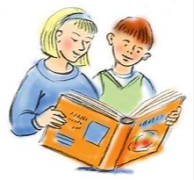  Literacy | Fantasy stories and stories with a familiar setting  Rhyming stories / rhymes  A Squash and a Squeeze  Alistair Underwater  Poetry – Commotion in the Ocean
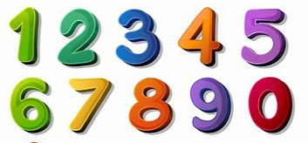  Maths | Capacity and Volume.  Multiplication/ Division:  Counting in 2’s, 5’s and10’s  Making equal groups  Doubles  Arrays  Sharing
  Science | Sorting and classifying animals including humans  Parts of the body – measuring  Our 5 senses – Science day
  Geography | The seas around the UK  The 5 oceans of the world
  Art | Collage – Matisse  Pattern in nature  3D – fish aquarium
  Computing | iProgram (2)  iPlay more
  RE | From Creation to Shabbat
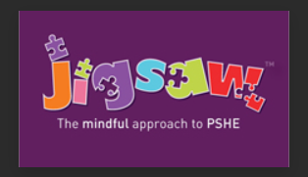  PSHE | Relationships
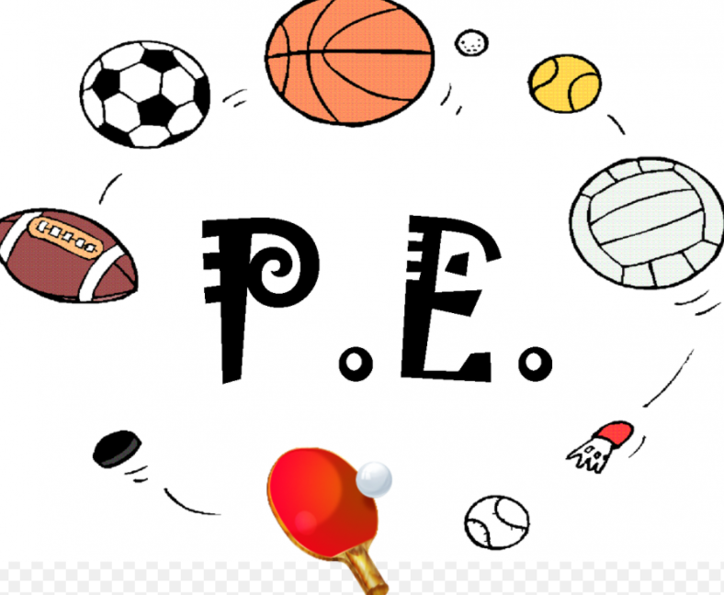  PE | Net and wall games (Monday afternoon)  Striking and fielding (Thursday morning)
  Music | Dancing and drawing to Nautilus  Cat and Mouse

