Dear Parents/Carers,
We would like to let you know about our exciting topics for this half term in Year 2!
‘How is life on a remote island home different to living in West Bridgford?’
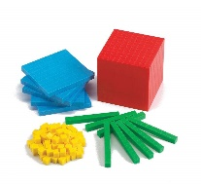  Maths | Place value – Read and write numbers to 100, place value of tens and ones, count in 2s, 5s and 10s, compare and order numbers and objects  Addition and subtraction – Addition and subtraction bonds to 20, 10 more and 10 less, skills of adding and subtracting using different manipulatives.  Telling the time- o’clock times.
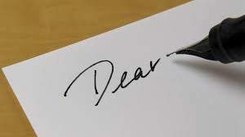  Literacy | 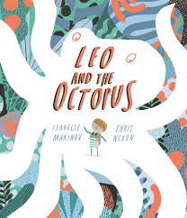  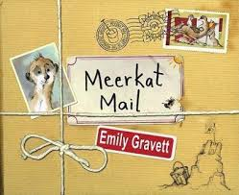  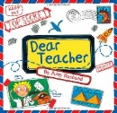  This half term we will be writing to persuade, instruct and entertain our reader. We will do this by creating a guide to take care of an octopus, a letter to persuade Mrs Toom to give us no homework and a writing a postcard from the desert. To help inspire us we will be using Leo and the octopus, Meerkat Mail and Dear Teacher.
  Geography | 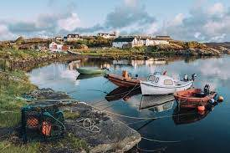  Human and physical features:  Comparing West Bridgford and Coll  Using maps and atlases to find places around the world.
  Art & DT | 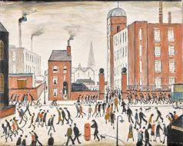  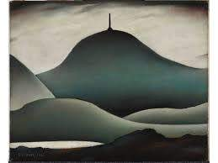  Drawing and Painting:  Landscapes and Industrial scapes, exploring the work of L.S. Lowry
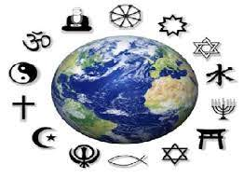  RE | Muslim Families
PE and Music  | 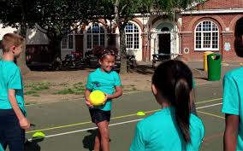  Invasion Games and Gymnastics  Tony Chestnut (Sing Up)
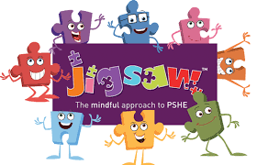  PSHE | Being Me (Jigsaw)
  ICT | i-Detail (e-safety)  i-program 1  Using the context of art and drawing, the children will be engaged in creatively developing simple animations.
  Spanish | In my Town (across the full Autumn Term)

