October 2025
Dear Parents/Carers,
We are delighted with how well your children have settled into Year 1. We hope they have had a happy first half term – and are looking forward to a well-earned two-week break! We will send home a couple of extra reading books.
Reader of the week
Thank you to our wonderful stories shared by the ‘reader of the week’. The books we have shared have been thoroughly enjoyed.
PE days
We will continue to have PE on Monday and Wednesday. Please wear PE kits to school on these days.
White t shirt or navy ‘Abbey Road’ t shirt, navy/black shorts or navy/black joggers/leggings, trainers / plimsolls, plain navy/black sweatshirt or hoodie and no earrings please.
Autumn Day
On Thursday 6 ^{th} November we will be having an ‘Autumn Day’ in Year 1. (As mentioned in previous email). We shall be doing lots of lovely Autumn craft, writing Autumn poems and learning all about Autumn. Please can the children come to school in non-uniform but wear Autumn colours – reds, oranges, browns etc. Please don’t buy anything special – just wear something that loosely fits the theme! Can we also ask for donations of conkers on the day – we would like to fill our Tuff Spot with conkers to do some sensory activities and some maths!
Topic launch
On Friday 7th November the children can bring in a toy to share and play with to start our ‘Toys’ topic. This could be a doll, a cuddly toy, car, game etc but please no electronic gadgets.

Diary Dates Year 1
The Year 1 Christmas play will be Tuesday 9th December at 2pm and Wednesday 10th December 9.30am.
On Thursday 11th December we shall be inviting Grandparents into school for 2pm to share our History learning. More information to follow nearer the time. We are looking forward to our trip on December 16th to see The Little Mermaid.
Our topic for next half term is Toys. The information below shows what we shall be covering in each subject.
Further information can be found on our school website:
www.abbeyroadprimary.co.uk/curriculum-assessment/
Wishing you a lovely half term
Year 1 Team
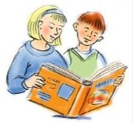  English | Robot Dog  Toy Story (short video clips)
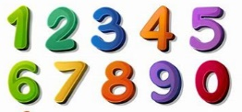  Maths | Addition and subtraction (within 10)  Geometry: Shape  Number: Place value (within 20)
  Science | How are the seasons different? What is special in Autumn?
  History | How are toys in the past different to toys today? What are the similarities and differences?  Grandparent Afternoon
  Geography | Countries around the world. Where does Santa deliver presents to?
  Art | Diwali – crafts  Autumn – collages, printing, clay hedgehogs  Murakami Japanese cartoonist – colour mixing/feelings
  Music | Sing Up! Colonel Hathi’s March  Christmas songs for our nativity play (info to be sent nearer the time)
  Computing | iModel from iCompute
  RE | Learning about celebrating Diwali and celebrating Christmas
  PSHE | Celebrating difference.
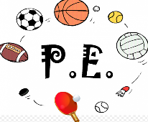  PE | Monday PE – Yoga  Wednesday PE – sending and receiving
  DT | Investigating puppets then designing and making their own felt puppets. Sewing skills.

