
Autumn Term 2

November 2025

Dear Parents/ Carers,
We hope you had a wonderful half-term break! We had a fantastic first half of the term and are excited for more learning and fun in the weeks ahead. Our next history topic will focus on inspiring women throughout history, and we can’t wait to dive into our learning.

Fruit:
A reminder fruit is provided in school for all Year 2 pupils. If you wish to provide an alternative snack, we ask that it is a healthy option.

PE days are Tuesday and Friday.:
Please ensure your child is wearing the correct PE kit: white or dark Abbey Road t-shirt, plain dark shorts or joggers, plain dark jumper, trainers. We will be outside for our lessons this half term so please wear weather appropriate clothing.
Earrings: Children must not wear earrings for PE lessons.

Cloakroom:
Please note that with the onset of colder weather, space in the cloakroom is limited so ensure all clothing items are named (including gloves). We would prefer children to bring book bags, which are stored in the classroom, as rucksacks take up a lot of room which we do not have. Many thanks for your support on this.

Our learning:
Maths | 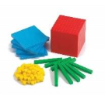  Time: O’clock and half past.  Number: Addition and subtraction.
English | This half term we will be re-writing traditional fairy tales and tales with an alternative twist. To inspire our writing we will be using these texts:  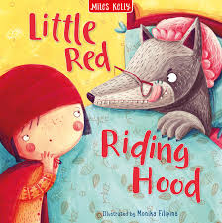  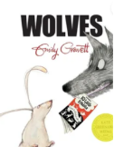  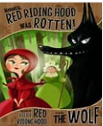  -Litte Red Riding Hood  -Red Riding Hood was Rotten  -Wolves
History | How have these wonder women changed the world?  We are looking at the lives of significant women in history, their impact on the world and the legacy they left. We will study: Florence Nightingale, Grace Darling, Rosa Parks, Emmeline Pankhurst, Ada Lovelace and Greta Thunberg.  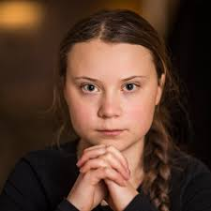  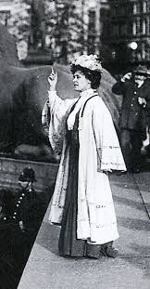  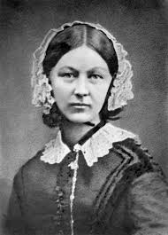  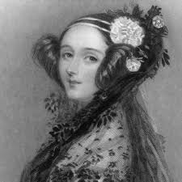  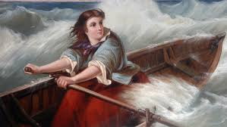  We will finish our topic with a ‘Lasting Legacy’ day in school.  
Art & DT |   Photography and Printing: Pop Art and Andy Warhol  We will be taking photographs and producing a mono-print in the style of Andy Warhol  DT: We will be creating a moving card using mechanisms of levers and sliders
RE | Celebrations: Eid and Christmas  We will be looking at similarities and differences in celebrations.
PE | Fitness and Ball skills
PSHE |   Celebrating Differences (Jigsaw)
ICT | I-Search - In this unit the children will learn how to use the internet to find out answers to questions  E-Safety  Images – taking images and altering them using filters
Spanish |   My Town

Homework: Remember little and often has a big impact on learning!
Reading | 4 times a week minimum (10 minutes a time)
Ed – Shed spelling | Within the next two weeks your child will be given an Ed-shed login that will be stuck in to the back of their reading diaries.  In class we teach the statutory year 2 spelling rules. These are then loaded on to the app for the children to practice the following week.  Please try and login at least 3 times a week.

If you have any further questions, please don’t hesitate to contact us.
The Year 2 Team (Miss Malbon, Miss Moore, Miss Shaw, Mrs A, Miss Bakewell and Mrs Mason) .

