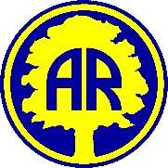
Year 2 Curriculum Coverage: Spring 1 2026
Here is some information about the topics we will be covering this half term.

Literacy  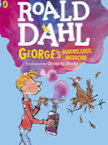 | Letters: The Day the Crayons Quit  Write letters for different purposes.  Narrative: George’s Marvellous Medicine.  Instructions:  Create a magic medicine  Make a healthy wrap
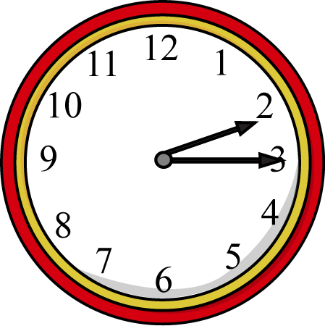  Maths | Time  - Quarter past  Addition and Subtraction  - Adding and subtracting one-digit from a two-digit number  - Adding and subtracting two-digits from a two-digit number  Shape  - Faces  - Edges  - Vertices
Science  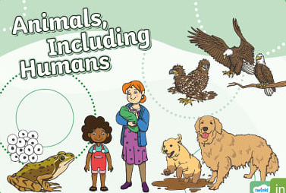 | Animals including Humans  We will find out what animals and humans need to survive.  We will describe the importance for humans of exercise and learn about different food groups and eating the right amounts of different types of food.  We will also investigate the importance of washing hands when preparing food and general hygiene.
Art  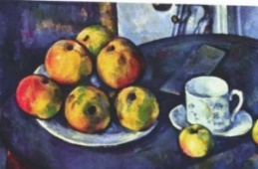 | Still life – drawing  We will be sketching still life images of fruit and vegetables.  We will focus on the work of Paul Cezanne.
DT | Food – making a healthy wrap  Design, make and evaluate a variety of food in both taste and texture to create our own healthy and tasty wrap.
Computing | iAnimate  We will use technology to create our own short animations.
RE | Jesus’ friends and followers
PSHE | The Jigsaw scheme - Dreams and Goals
PE  Tuesdays and Fridays | Fundamentals  Sending and Receiving  Please ensure your child wears a warm PE kit as we are outside.

