
Year 2 Curriculum Coverage: Spring 2 2025
Here is some information about the topics we will be covering this half term.
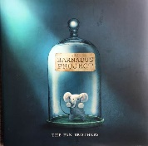  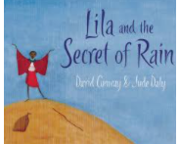  Literacy | Lilia and the Secret of the Rain  We will create some poetry based on this story, in addition to sequencing the story, learning about a variety of time adverbials, and using them to help us retell the story.  Barnabus project  We will be creating some character descriptions on the not so perfect pets.
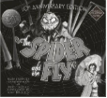  Whole Class Reading  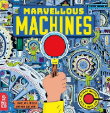  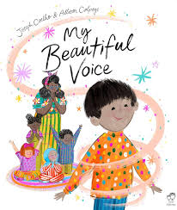 | My Beautiful Voice  Marvellous Machines  Spider and the Fly
Maths | Multiplication and division  - Grouping: using arrays  - 2, 5 and 10 times tables  - Division
Science  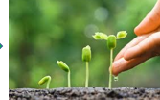 | Plants  - Observe and describe how seeds and bulbs grow into mature plants.  - Find out and describe how plants need water, light and a suitable temperature to grow and stay healthy.
Art  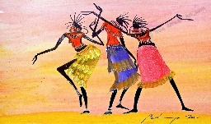 | Our artwork will be inspired by the creativity of the Maasai and Martin Bulinya. We will make our own bracelets, masks and pastel/charcoal pieces.
Geography  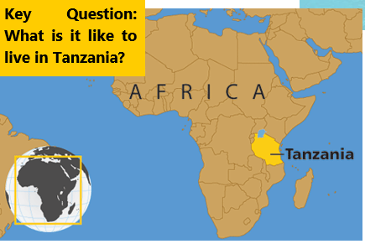 | Children will build on the map reading skills and will further develop their understanding of Human and Physical geography. Our big question this unit is ‘Would you like to live in Tanzania? Why?
Spanish | Numbers and greetings.
Computing | Children will research the remarkable advances computing and technology has made throughout time. They will present their findings and develop digital literacy skills by producing multi-media interactive eBooks.
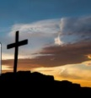  RE | The Torah  Easter
PSHE | The Jigsaw scheme- Healthy Me looking at how to keep our mind and body healthy.
PE  Tuesday and Friday | Striking and Fielding  Target Games

