Dear Parents/Carers,
We would like to let you know about our exciting topics for the Summer 1 half term in Year 2!
How do habitats help living things to survive or thrive?
Maths | Measurements: (cm, m)  Fractions: wholes, halves, quarters, thirds.  Time: Time to 5-minute intervals
Literacy | This half term we will be writing a recount of our trip, creating our own riddles and exploring effective descriptions of characters and settings. We will use the following books to inspire us:  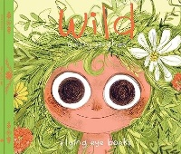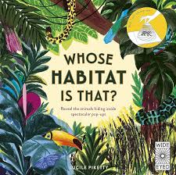
Reading | This half term we are continuing to focus on fluent reading in our sessions. We will be using the following texts:  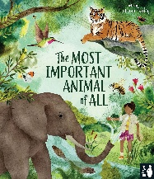  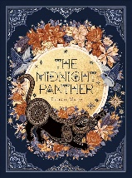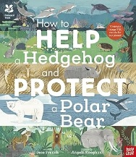
Science | How do habitats help living things to survive and thrive?​
Art & DT | Sculpture – Elizabeth Frink  Design and make a healthy wrap.
RE | Jewish Stories (David and Daniel)
PE and Music | Athletics  Net and wall games  Swing-a-long with Shostakovich  Charlie Chaplin
PSHE | 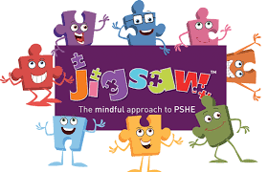  Relationships (Jigsaw)
Computing | E-Safety  i-blog
Spanish | Fruit

