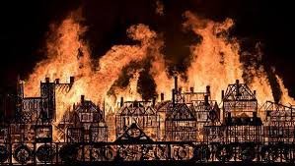
Was the Great Fire of London ‘great’?
Maths | Measurement:  - Mass, capacity and temperature  - Statistics  - Position and direction
Literacy | 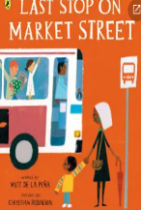  - Our writing will be inspired by the book Last Stop on Market Street. We will be writing our own narratives, with a focus on detailed character descriptions.  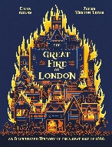  - We will also be using a non-fiction text about the Great Fire of London to write diary entries in the role of Samuel Pepys.  - Researching and creating persuasive writing to encourage tourists to visit modern-day London.
Art & DT | DT: Researching, designing and making a wheeled vehicle to carry water  Art: Painting: Colour mixing Pointillism: Georges Seurat
RE | Jewish Places of Worship: Visiting a Synagogue
PE and Music | PE: Athletics and dance  Music: Tańczymy Labada (traditional Polish singing game)
PSHE |   Changing Me (Jigsaw)
Computing | iDo Mail (iCompute)
Science | Uses of everyday materials -What are things made of and why?
History | The Great Fire of London- Was the Great Fire of London ‘great’?

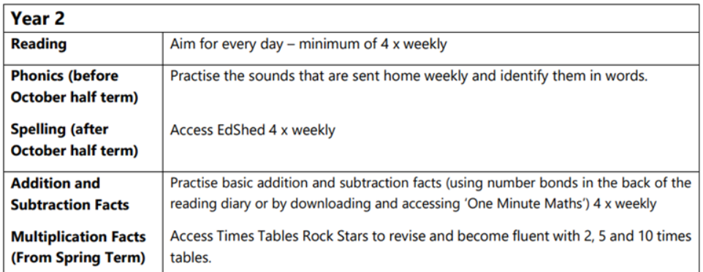
Homework expectations:

