Dear Parents/Carers ,
We would like to let you know about our topics for the Autumn Term in Year 2.

‘Where would you prefer to live?’
Maths | Place value – Read and write numbers to 100, place value of tens and ones, count in 2s, 5s and 10s, compare and order numbers and objects  Addition and subtraction – Addition and subtraction bonds to 20, 10 more and 10 less, skills of adding and subtracting using different manipulatives
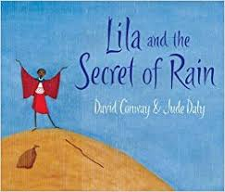  Literacy | We are looking at texts that are set in different places around the world:  Katie Morag – Isle of Struay  Lilia and the Secret of Rain - Kenya  Zahra – Film clip set in Africa  We are aiming to make a class anthology of stories.
Geography | Human and physical features:  Comparing West Bridgford and Coll  Comparing West Bridgford, different islands and Africa.  Using maps and atlases to find places around the world.
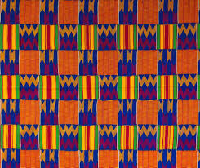  Art & DT | 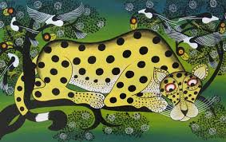  Kente cloth weaving  Painting silhouette colourwashes  Martin Bulinya- The Massi
RE | Jewish celebrations and stories
PE and Music | Invasion Games and Gymnastics  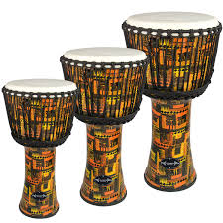  Charanga Music Programme:  Djembe drumming  Hands, heart, feet song
PSHE | 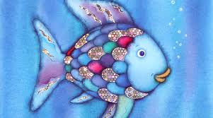  The Rainbow Fish  New Beginnings
ICT | E-Safety – Hectors World  Keeping everyone safe online
