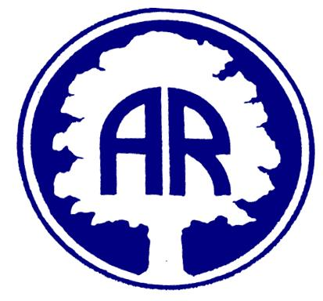
Foundation Newsletter November 2019

Dear Parents/ Carers,
Thank you for all of your support and for your delightful children who really are a credit to you all. They are all doing so well, making good progress and enjoying their learning. This half term our topic is Winter Wonderland. We will be covering the following areas…
Understanding the World
We will be learning about ice melting.
How can we melt ice and how can we stop it melting?
We will be investigating how polar bears keep warm.
We will be learning about the different animals that live in the Arctic and the Antarctic.

Literacy
We will be playing in Santa’s grotto and writing good lists and labels for presents.
We will be writing for different purposes including a letter to Father Christmas.
The children will be using their phonics to segment words and write them down.
Some children will start to write sentences.

Mathematics
We will be counting up to 100.
Recognising numerals to 10/20.
Using the language of addition to add two groups together.
We will be learning the names of 2D and 3D shapes and talking about their properties.

Creativity
We will be using different textures for collage.
We will be colour mixing, for example, adding white to blue.
We will be making different Christmas crafts.
We will be decorating a snow den.

Personal, Social, Emotional Development
We will be thinking about other people at Christmas time.
We will be thinking about bullying and how to stop it.
We will be learning about the Christmas Story.

Reading
Please ensure that your child’s reading books and diaries are in their bag every day. Your child will be heard read on different days and we cannot change their book if they do not return the one they have at home.
Please ensure that you write in their diary so we know how they are doing at home .
Please remember to look on the school website class blog to see what your children have been learning. Some of the learning taking place will be…

Dates for Your Diary
Christmas Fair Friday 6th December
After school in the school hall 3.30-5.00pm.
Nativity play Thursday 12th December 9.30am and Friday 13th December 9.30am
The Foundation children will be doing a performance altogether so you can come to either performance. More details will follow nearer the time.
Children’s Christmas Party Wednesday 18th December
Children to come dressed in party clothes.
Last Day of Term Friday 20th December children to wear Christmas jumpers
Reminders and requests
Please send your child with a bottle of water each day. Milk is provided by school, please register online.
If you have any spare tights or pants please could you send them in as we are very short of spares.
Please do not allow your child to bring toys into school, this is to avoid upset.
Thank you for your continued support.
Thank You.
Kind Regards,
Foundation Team.

