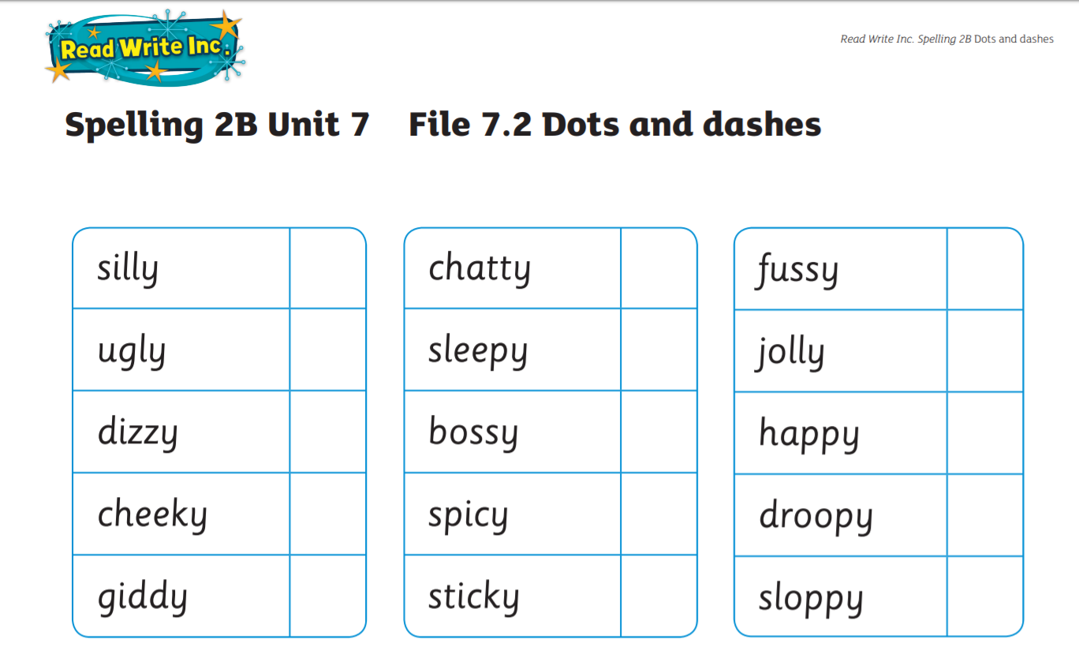
Week 2 30-3-20 Please practise this week’s spelling pattern by ‘changing the y for an i and adding ness) to make a new word. Discuss what the new words mean and try to use them in your sentences (written and oral) this week. (The fussiness of the children is difficult to cope with when I’m trying to work.)

