Grammar and Punctuation
Coordinating Conjunctions
LO: I can identify and use coordinating conjunctions.
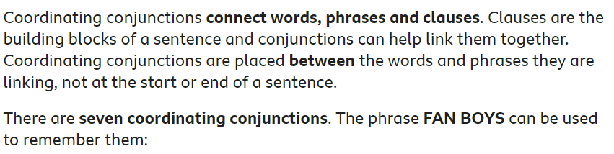
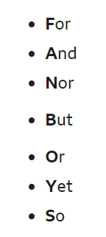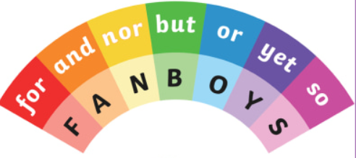
- Watch the video clip on BBC Bitesize. Here’s the link …
https://www.bbc.co.uk/bitesize/topics/zwwp8mn/articles/z9wvqhv

- Below the video clip, there is a written explanation. Read this carefully as this should be helpful.
- Now look at the sentence and highlight the coordinating conjunction.

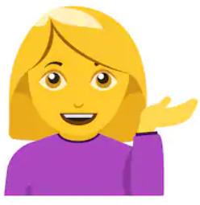
- Now look at the next page and follow the instructions.

Did you read the sentences carefully? I wasn’t expecting the robot to be doing that!

L.O. I can identify the best coordinating conjunction for the sentence.
Remember – FANBOYS:
For and nor but or yet so
Read the sentence and identify the conjunction. You can just jot down your answer on a separate piece of paper.
It was cold and icy in the morning.
I want to eat grapes or apples at lunch time.
Miss Healey wanted to play football but the field was too wet.
She went to the park so she could play on the swings. (Obviously not at the moment)
Read each sentence with the coordinating conjunction that works best. Jot down your answer.
- George wanted a new computer game ______________ his Mum said no.

- We can have apples ______ bananas at snack time.
- Mrs Mitchell likes to sing ____________ she joined a choir.
- Mrs Mitchell likes to sing ____________ she wishes she was better at it.
- Louis was feeling really hot ___________ he jumped in the swimming pool.
- Rocky refuses to eat dry cat food _________ will he touch a saucer of squid eyeball stew. (Just checking I still have your attention)
- I hate to waste a single drop of squid eyeball stew _____________it is expensive.
- Rocky frightens the poodles next door ________________ adores Labrador across the street.
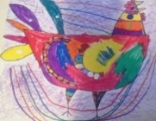
- The eyeball squid stew is so thick you can eat with a fork _____ a spoon.
Now back to your bird discovery. Write some sentences about your own bird discovery but each sentence must have a different coordinating conjunction. (Don’t just rely on ‘and’ as you already use this very well). It is a good idea to write sentences that you will be able to use in your longer piece of writing about your bird. Write 3 or more.

