Dear Year 3,
We hope that you are all well and that yourselves and your loved ones remain in good health.
In this time of unprecedented circumstances, whilst school is closed, please find attached our home learning links and tasks. These will now be sent every Friday so that you can prepare for the week ahead.
As stated in our previous letter, we are aware that learning at home will obviously look very different to a normal school day. We are not expecting children to be sat down working for the whole of school hours. Regular, short bursts of about 20 – 30 minutes at a time, with breaks and rest (down-time) is acceptable.
We have added an additional document to the end of this letter which gives a suggested timetable for those families who feel they may like to use this kind of approach but there is no pressure to do so.

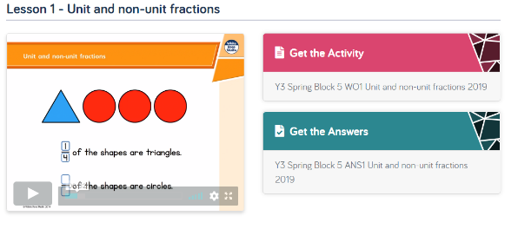
This week’s learning tasks:
- Maths - our next unit is fractions. Please follow the link to the White Rose home learning website. This week we would like you to focus on Week 1- Fractions lessons 1, 2 and 3. Watch the video and complete the activities. https://whiterosemaths.com/homelearning/year-3/

- Spelling tactic 12 – the negative prefix dis
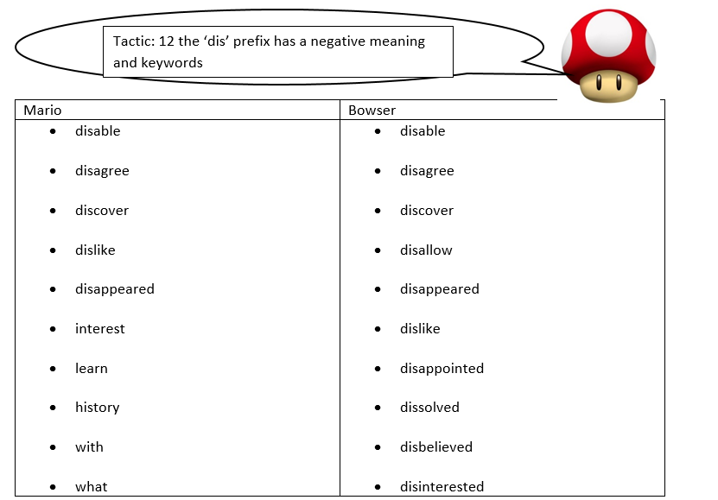
Spellzone Click to find the dis wordlist and some games to play.
Test yourself to see how many you can spell correctly. Try and use each word in a sentence.

History - Our new topic is ‘China’ in order to introduce this topic please follow the link for a history lesson all about the Shang Dynasty. Watch the video carefully and complete both the ‘move the marker’ and ‘fill in the gaps’ activities. Once these have been completed take a look at the interesting artefacts from the Shang Dynasty at the bottom of the page.
https://www.bbc.co.uk/bitesize/topics/z39j2hv/articles/z2ckrwx

P.S.H.E - In order to keep spirits high and positivity to shine through we are inviting you to take part in the ELSA support 14-day challenge. Follow the link below and choose a challenge to complete each day.
https://www.elsa-support.co.uk/coronavirus-14-day-self-isolation-activities/

Twinkl is a website we plan on using for future home learning activities so please follow this link to help you sign up for free (it is quick and painless). https://www.facebook.com/twinklresources/videos/709197152952479/?vh=e&d=n
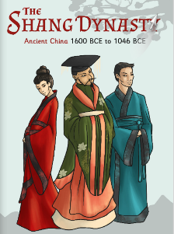
Reading comprehension - Once you have signed up for Twinkl the link below allows you to download an e-Book all about the Shang Dynasty. We will be using the E-book over the coming weeks and answering a range of comprehension questions. This week read pages 1-4 and answer the questions below.
https://www.twinkl.co.uk/resource/t2-h-4328-the-shang-dynasty-e-book
Comprehension questions:
- The Shang Dynasty was a time of rule under the Shang family in China from around:
1700 BCE to 1046 BCE
1600 BCE to 1046 BCE
2000 BCE to 3000 BCE

- What is the only evidence that the Xia could have ruled before the Shang?

- What do you think is meant by ‘A Shang’s kings’ ambition was to further and expand their rule’?

- The Shang Dynasty was part of the…
Chinese Bronze Age
Chinese Silver Age
Chinese Gold Age

- How long did the Shang maintain their place on the throne of Ancient China for?

- Why was Di Xin a poor leader?

Look out for the answers next week everyone.
Don’t forget to do your daily reading and write it in your diary. We will check in on Times Table Rock Stars next week too.
Take care, work hard and look after each other.
Miss Moore, Mrs Seagrave and Mrs Horton

