Summer Term 1
Healthy Living

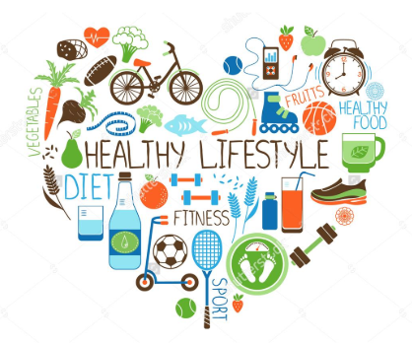

- describe the importance for humans of exercise, eating the right amounts of different types of food, and hygiene
- asking simple questions and recognising that they can be answered in different ways
- observing closely, using simple equipment
- using their observations and ideas to suggest answers to questions
- gathering and recording data to help in answering questions.
- design purposeful, functional, appealing products for themselves and other users based on design criteria
- generate, develop, model and communicate their ideas through talking, drawing, templates, mock-ups and, where appropriate, information and communication technology
- Make
- select from and use a range of tools and equipment to perform practical tasks [for example, cutting, shaping, joining and finishing]
- select from and use a wide range of materials and components, including construction materials, textiles and ingredients, according to their characteristics
- Evaluate
- explore and evaluate a range of existing products
- evaluate their ideas and products against design criteria
- use their voices expressively and creatively by singing songs and speaking chants and rhymes

