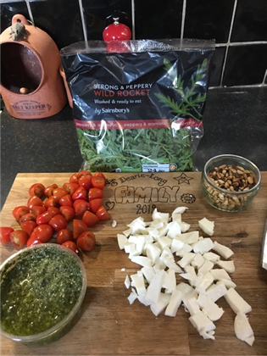
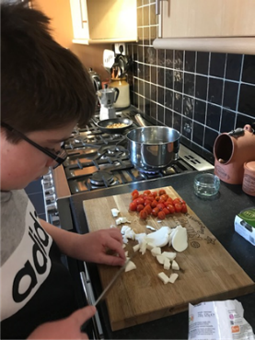
Pesto Pasta (serves 4)
Ingredients:
- 500g Penne pasta (cooked or dried)
- 75g Pesto
- 12 baby tomatoes
- 1 ball of mozzarella
- 25g Pine nuts
- Rocket, Ciabatta and butter to serve
Method:
- Pre-heat the oven to 180°C (160°C Fan).
- Cook pasta according to packet instructions.
- While the pasta is cooking, toast the pine nuts in a small saucepan.
- Put the Ciabatta in the oven and heat according to pack instructions.
- Once cooked, drain the pasta well, reserving a spoonful of the cooking water.
- Put the pasta back in the saucepan that it was cooked with, add the reserved cooking water and stir in the pesto and tomatoes.
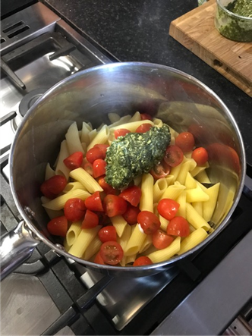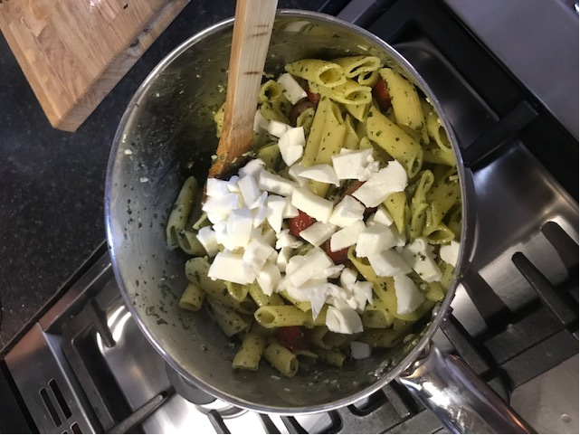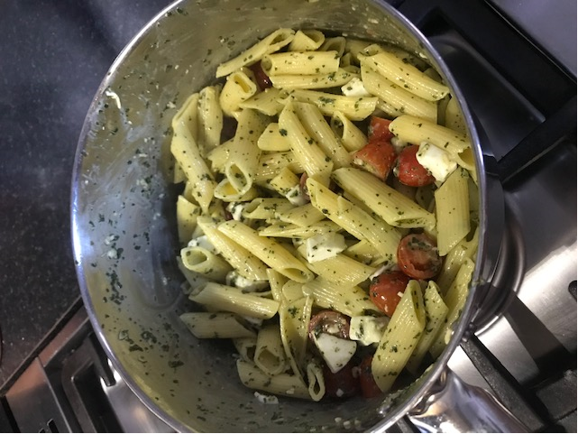
- Once well mixed, add the mozzerella and stir through until the cheese starts to melt.
- Serve the pasta into bowls. Top and pine nuts.
- Serve with Rocket and warmed Ciabatta with butter.
