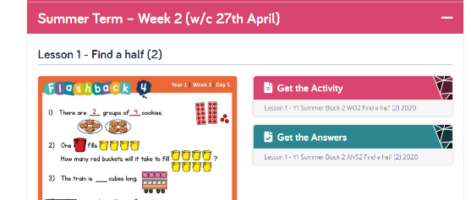
Summer: Maths Wk 2
https://whiterosemaths.com/homelearning/
Please continue following the lessons on this website: Summer Term -Week 2 (w/c27th April) Find a half and find a quarter.
This website is putting five lessons on each week, which your child should aim to do. These lessons are in line with what they would usually do at school. Every lesson comes with a short video showing you clearly and simply how to help your child to complete the activity successfully.
Please continue practising your number bonds on NumBots.
Please also continue to practise counting: forwards / backwards in ones and forwards in 2s, 5s and 10s up to 100.
Additional ongoing maths games:
- https://www.primarygames.co.uk/pg2/splat/splatsq100.html
Splat the 2s numbers on a 100 square then complete the counting in 2s number lines.
What other number patterns can you splat? Counting in 10s, counting in 5s?
- Play hit the button use the ‘doubles’ and the number bonds section:
https://www.topmarks.co.uk/maths-games/hit-the-button
- http://ictgames.com/sharkNumbers/mobile/ Place value game.
- https://www.oxfordowl.co.uk/for-home/kids-activities/fun-maths-games-and-activities/ Click on the add and take away games for 5-7 year olds.

