TOPIC ACTIVITIES SUMMER TERM WEEK 2:
- Science: Research two British birds. Divide your page into two and write the headings same / different. Write three things that are the same about your two birds and three things that are different. Remember to write in complete sentences with a full stop and capital letter. Draw your two birds too. Look carefully at the colours.
https://www.rspb.org.uk/fun-and-learning/for-kids/facts-about-nature/facts-about-birds/

- Tube farm animals:
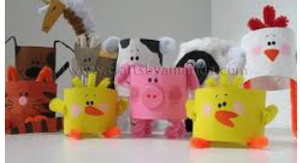

- Paper craft birds – Can you make a nest for your birds too?
https://www.youtube.com/watch?v=a80VcYzQQE4 – simple instructions.

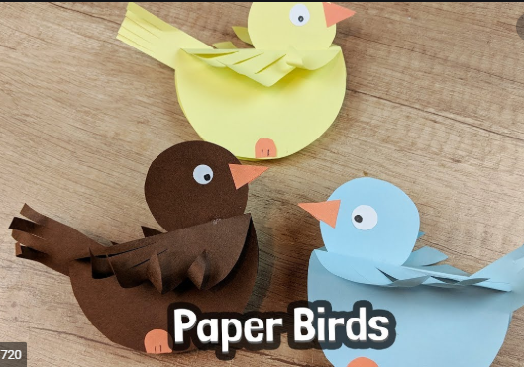

- Draw a detailed picture of a bird – Use shading with your pencil. Use the video clip below to help you.
https://www.youtube.com/watch?v=UMwx4raERDs

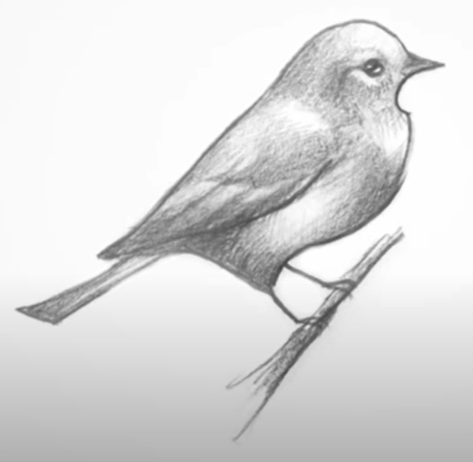
- Music – go onto out of the ark online at:

https://www.outoftheark.co.uk/ootam-at-home/?utm_source=homepage&utm_campaign=ootamathome2&utm_medium=banner

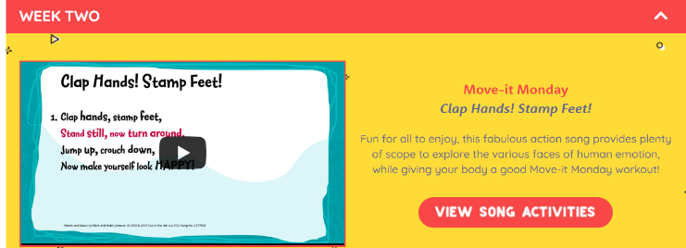
Select week 2 song 1 – Clap Hands Stamp Feet

Can you listen to the song and do some actions to go with it?
Can you clap in time to the beat?
Maybe march around the room clapping and stomping in time to the beat.

Add an accompaniment, this could be an instrument you have at home, or simply get a bowl or pan and a wooden spoon and use as a drum!

