Maths Planning
Activity One
Warm Up
Jack Hartman count to 100
https://www.youtube.com/watch?v=cVwjmC-gpBU
- Write numbers 1-20 on separate pieces of paper.
- Get your child to order the numbers from 1- 20.
- Then point to different numerals and start counting and pointing to the numerals e.g. 17 18 19 20 or
14 15 16 17 18 19 20
- Also count backwards from 20 to the number that you started at,
- Hold up random numbers from 1-20 children say the number and show with fingers and toes. For example 19 will be 10 toes and 9 fingers 17 will be 10 toes and 7 fingers.
- Play a game and get your child to turn over all of the numbers that are
more than 10
more than 15
less than 5
more than 5
between 7 and 17 etc.
Missing number sheet

Activity Two
Warm up
Doubles song
https://www.youtube.com/watch?v=8jOzhiACB68
- Get your child to show you on their fingers doubles up to 5.
Say double 1 and they show you one finger on each hand and say 2.
Keep going to double 5

If you have two dice, show your child a number on one dice and get them to show you the same number on their dice and say the sentence double 6 equals 12 etc…
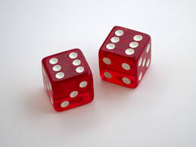

Watch the pp on twinkl Ladybird doubles to 20
https://www.twinkl.co.uk/resource/t-c-254566-ladybird-doubles-to-20-powerpoint

Then complete the sheet
Maths double ladybird sheet 1-5 by drawing the same amount of spots on the other side and adding the amount together.

Extra challenge
Doubling number sheet 5-10.
Play doubles up to 20 game on Twinkl
https://www.twinkl.co.uk/go/resource/T-GO-03-doubles-up-to-10

Activity Three
Warm Up
Halving song on bitesize

https://www.bbc.co.uk/bitesize/clips/z6bq6sg

Give children whole objects to halve.
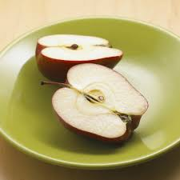
Halve an apple, cake, biscuit.
Talk about how both halves need to be equal in size.
Halving numbers.
Give children an amount of beads, sweets, raisins etc.
Use even numbers 2, 4, 6, 8, 10, 12 ,14, 16, 18 and 20
Can they remember how to share them into halve.
Share equally one for me, one for you…
Can they work out halve of all of the even numbers up to 20.

Activity Four
Warm Up
Doubles song
https://www.youtube.com/watch?v=8jOzhiACB68

Watch the power point
Teaching the Pirates to be fair power point.
Complete some of the problem solving sheets
Doubling, halving and sharing sheets included

Extra challenge
Halving and doubling activity sheet

