[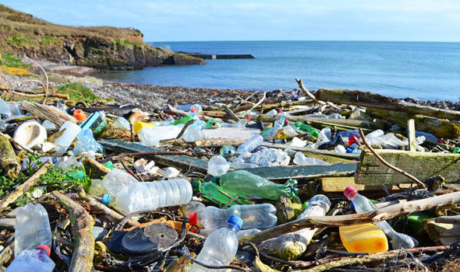](https://www.google.co.uk/url?sa=i&rct=j&q=&esrc=s&source=images&cd=&ved=2ahUKEwiYx_CEvN3bAhUGsBQKHdPfBoEQjRx6BAgBEAU&url=https://www.express.co.uk/news/uk/939782/penalties-for-litter-louts-increase-to-150-pounds-crackdown-on-litterers&psig=AOvVaw3dcAiuyAe30XVgzQVmhTlB&ust=1529420081506485)

[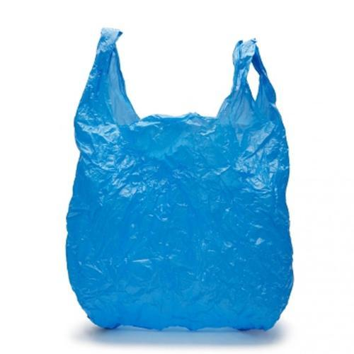](https://www.google.co.uk/url?sa=i&rct=j&q=&esrc=s&source=images&cd=&cad=rja&uact=8&ved=2ahUKEwjgk-Pevd3bAhVBlBQKHTSAAWQQjRx6BAgBEAU&url=https://www.indiamart.com/proddetail/blue-plastic-bag-15991248548.html&psig=AOvVaw2evo5QnmvAFAR3It1BHMnc&ust=1529420558757294)

[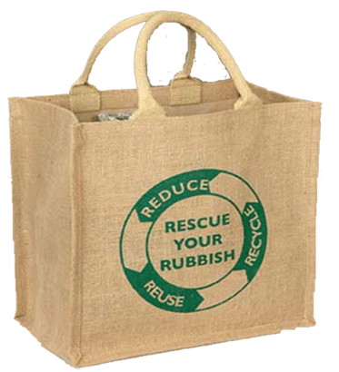](http://www.google.co.uk/url?sa=i&rct=j&q=&esrc=s&source=images&cd=&cad=rja&uact=8&ved=2ahUKEwjmtJn2vd3bAhWEcRQKHUWJD3sQjRx6BAgBEAU&url=http://www.bag-for-life.co.uk/bag-for-life/jute-bags/&psig=AOvVaw37rH6ww7liuTtizffVJ4c0&ust=1529420614343252)

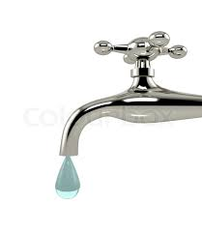

[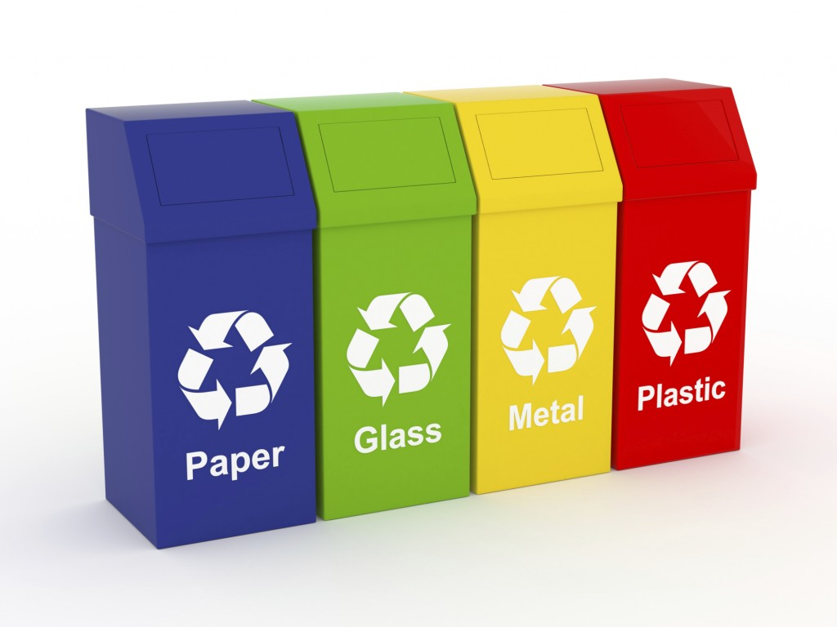](https://www.google.co.uk/url?sa=i&rct=j&q=&esrc=s&source=images&cd=&cad=rja&uact=8&ved=2ahUKEwjn4_uLvt3bAhVBPRQKHbAdCXYQjRx6BAgBEAU&url=https://www.recyclingbins.co.uk/blog/cat/news/post/how-using-recycling-bins-helps-the-environment/&psig=AOvVaw23Xo0s24xhP5aTU7qTRng2&ust=1529420654467816)

[](https://www.google.co.uk/url?sa=i&rct=j&q=&esrc=s&source=images&cd=&cad=rja&uact=8&ved=2ahUKEwjKs9Okvt3bAhUKXRQKHTHiCGIQjRx6BAgBEAU&url=https://www.indiamart.com/proddetail/colored-plastic-straw-15864191488.html&psig=AOvVaw2iJG8MSHoGqgtbfBQXspwA&ust=1529420707060225)

[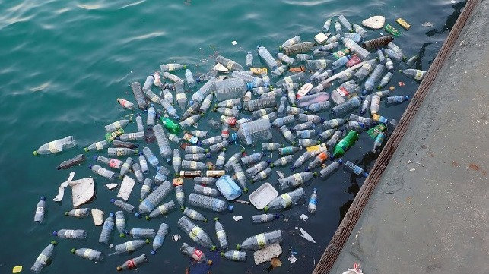](https://www.google.co.uk/url?sa=i&rct=j&q=&esrc=s&source=images&cd=&cad=rja&uact=8&ved=2ahUKEwiSnLrHvt3bAhVE7BQKHanaCscQjRx6BAgBEAU&url=https://www.maritime-executive.com/editorials/growing-concern-over-plastic-pollution-in-rivers-and-lakes&psig=AOvVaw033tC4WyAgEoRV940O0KgZ&ust=1529420780325014)