Year 1 Escape Room Challenge.

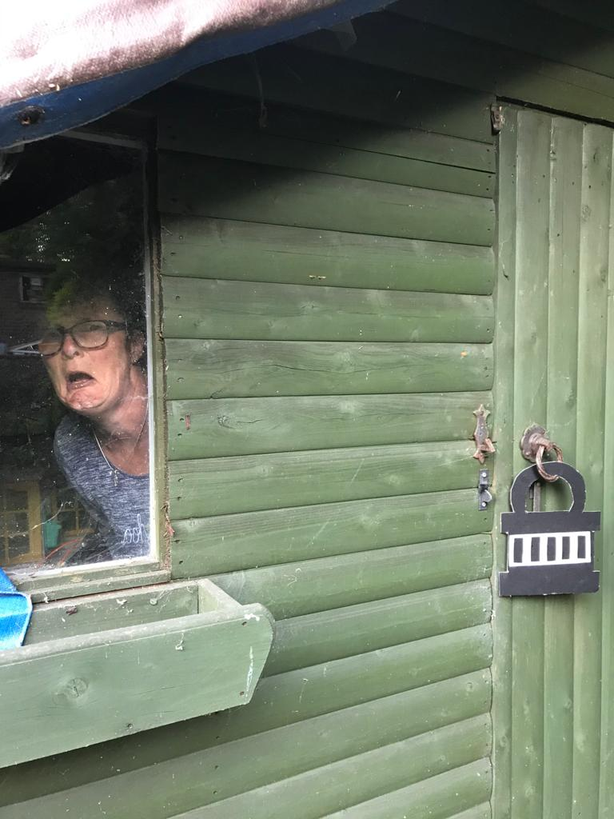
Oh no! We need to help Miss Fox!! I’m hoping you have remembered all your secret agent spy moves from gymnastics....can we all help poor Miss Fox – she is stuck in her shed......

Can you see there is a padlock on the door......The only way out is to solve a series of clues to reveal the secret code.

As you solve each page of clues, note down the answer (each page will give you one number)

Good Luck!

Code One Questions.

Find the answers to these sums.

- How many are there in 2 groups of 5?

- What number is 2 more than 18?

- What is 5 + 5 + 5 =

- What is 10 less than 40?

- What is double 6?

- How many letters are there in the number 13?

Find the answer with the highest number.

Add the two digits together and the answer is the first number for your code.

Write it down on paper (or in the first box on your padlock).

Code Two Questions.
Find the answers to these questions.
- How many sides do all these shapes have together? (you may want to write down the number for each shape then add up)

- How many sides does the next shape in this repeating pattern have?

- Which shape is on each end of a cylinder? (think can of beans) How many letters does it have?

- Which shape is the odd one out?

How many letters does it have?

- How many corners does a square have?

- How many edges does a cuboid have?(think tissue box)
Which one of your answers is an odd number?
That is the next number in your code.

Code Three Questions.
(These are related to our Science topic, if there are numbers this is your answer)
- Which part of a plant grows beneath the ground? 1. roots 2. seed
3. stem 4.flower

- Which of these things help plants to grow?
water a dark place cold
lemonade sunshine soil
How many have you ticked?

- How many of these are real flowers?
daisy oodoo dandelion
rose sunflower dipper
How many have you ticked?

- How many of these are living?
tree stone frog car
dog book flower baby
How many have you ticked?

- How many of these are vegetables?
apple potato beans orange
carrot peas banana grapes
How many have you ticked?

- Which one of these has petals?
- seed | - root
- flower | - stem

Which answer is the highest number?
This is the next number in your code.

Code Four Questions.
(These are phonics based)
- How many of these words have split digraphs? (think magic ‘e’)
him | bike | hoop | look | hope | cube
met | make | tape | her | like | hide
How many have you ticked?

- How many of these are real words?
ozk | boy | lqua | side
book | you | met | grik
How many have you ticked?

- How many letters are missing?

a b c ______________ k l m

- How many of these words rhyme with sat?
cat | splat | splash | pit
mat | fat | lot | top
How many have you ticked?

- Which word is the odd one out?
bake | cake | made | stay | lake | pale
How many letters does it have?

- How many letters are missing?
s t y z

Can you see an even number?

This is the next number for your code.

Code Five Questions.
(General knowledge questions)
- In 1HB there are 34 chairs, in 1P there are 32 chairs? What is the difference between these numbers?

- Our story for English this week is
“Commotion in the Ocean”, how many arms does an octopus have?

- How many months are there in a year?

- How many colours in the rainbow?

- How many legs does a spider have?

- How many days in a week?

Look at your answers.

Which one is the lowest number?

This is the next (& final) number in your code.
Have you done enough to escape?
Ask your parent to email the code.
If you are correct you have set Miss Fox free and can have tomorrow off school!
Check the website around tea time to see if we have managed it!!

If you are wrong, do 20 star jumps to help her escape!

