Dear children,
We hope that you are all staying well and continuing to keep smiling. We have been so impressed with all the hard work you have been doing at home. Just like you, we are also missing school, but we know that you are staying positive and trying your best at all the tasks we set you at home.
We have really enjoyed seeing lots of pictures of you all doing different activities and we hope that you are enjoying seeing these pictures of your friends as much as we are .
Next week the half-term holidays start and even though this year might not turn out as you’d planned, we want you to have fun! Make sure you plan to do something that you enjoy, whether that be a bike ride or spending some time reading your favourite book in the garden. Most importantly though, make sure you get time to relax! You’ve all been working so hard on the tasks that we have sent home, so enjoy a bit of rest and relaxation. Your happiness is what matters to us most, so find something that makes you happy and make sure you do lots of it!
We’ve included some other fun activities at the end of this letter that you that you could get involved in over the next week. Hopefully, there will be a few that you’d like to have a go at! We would love to hear how you get on.
We know that you’ve all been helpful, positive and kind to everyone in this strange time. We also know that your smiles will be making others at home smile too, so keep it up!
Take care of yourselves, keep smiling!
Miss Moore, Mrs Horton and Mrs Seagrave

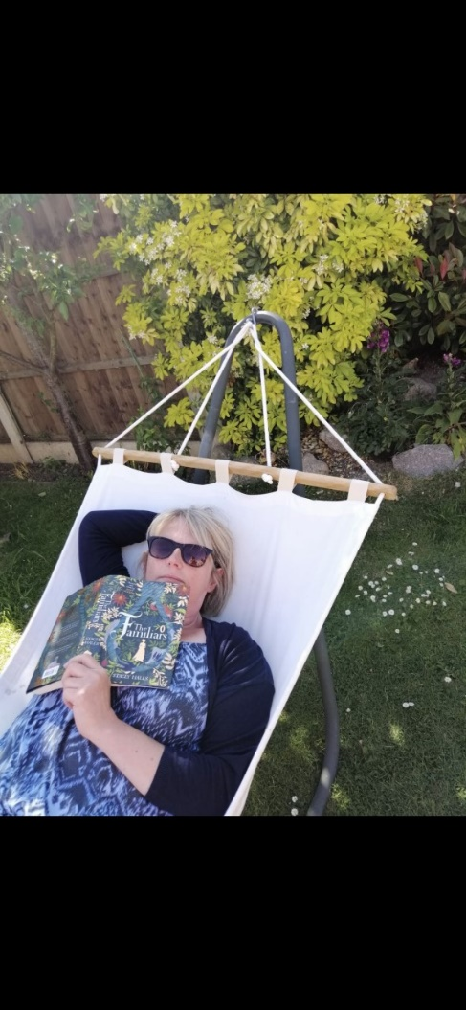
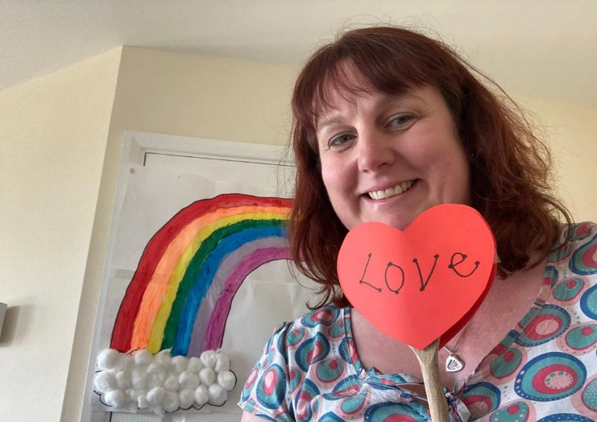
Here are some photos of what we will be getting up to over the holidays….
Become an Engineer!  Click – Challenge 1  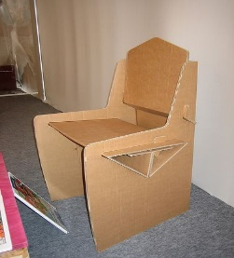  Watch the clip and challenge yourself to make a chair that you can sit on-only using cardboard, a pen, ruler and scissors!  The challenge card can be found at the bottom of the document. | Watch the clip of CBeebies presenter Ben making some delicious scones.  https://www.bbc.co.uk/cbeebies/makes/scone-bake  You can use the recipe, which can be found at the bottom of the document to try and make your own tasty scones. | Using the ‘Household Treasure Hunt’ worksheet, have a go at solving the clues and filling in as many different household items as possible.  This can be found at the bottom of the document.
Make invisible ink using lemon juice and a few drops of water. Write a message on paper by dipping a paintbrush in the lemon juice mixture and write a secret message. Place the message on a radiator, near a lightbulb or in the sun to reveal the hidden message. | Chose a friend from your class and write a letter to them. You could tell them all the exciting things you’ve been up to over half term and even include a few drawings. Once you have written your letter, you could post the letter in the letterbox or through their door if they live close by. If not, your parents could take a picture of your letter and send it to your friend’s parents for you. | Design and create your very own bowling set using empty bottles and a soft ball. You could even decorate your bowling pins.  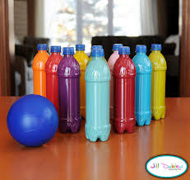
Have a video call with a relative. You could read them a story; show them a drawing you have done or tell them about what you've been doing. | Nature Scavenger Hunt!  Chose a different route for your daily walk, keep your eyes peeled and see how many different things you can find from the Nature Walk Scavenger Hunt worksheet.  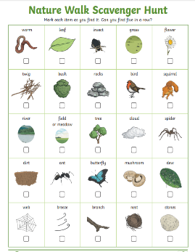  This can be found at the bottom of the document. | Get planting!  Help around the garden, you could help dig up weeds or water some of your existing plants and flowers. You could even use your time to have a go at planting something new!  