Welcome back Year 3!
We hope you had a lovely half term break and managed to find some time to relax and enjoy yourselves. I’m afraid we start with a bit of sad news. As you have probably gathered, our camping trip to Camp Redwood, scheduled for next week 8th June, will not be able to go ahead. We are all gutted and saddened by this but know that it is the right decision in the current situation. Those of you who have paid, or made instalments, will get a full refund. The office are working hard at the moment sorting out refunds for all trips within the school and will process them as soon as possible. Thanks for your understanding with this.
As you are probably aware, we may not be able to respond to your messages and emails as promptly as before due to our increasing teaching commitments within school. We will continue to set home learning and will be on hand to answer any queries – email Mrs Horton who will forward to either Miss Moore or Mrs Seagrave – just bear with us – we will reply!
This week’s learning tasks:
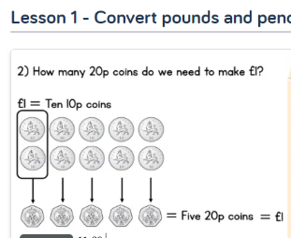
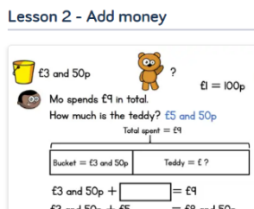
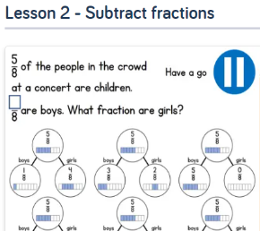
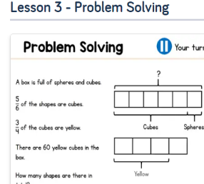
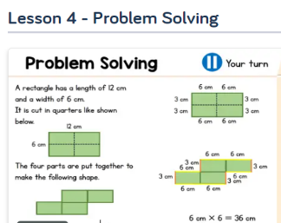
Maths:

This week we will be focusing on recapping our learning of fractions, problem solving and money. Firstly, have a look at the work you completed before the holidays and recap what you have already learned. This week, we would like you to focus on ‘Summer Term Week 2 w/c 27th April’- lesson 2, 3, and 4. Also ‘Summer Term Week 3 w/c 4th May’- lessons 1 and 2.
Please watch the video and complete the activities. If you are feeling extra confident you could have a go at the ‘Friday Maths Challenge’ found at the bottom of the page.
https://whiterosemaths.com/homelearning/year-3/

P.E:
Notts School Games Organisers are publishing weekly PE ideas which we would like all the children to have a go at. We hope you enjoyed last week’s activities and virtual competition. Follow the link to see what this week’s activity is and enjoy taking part. https://www.abbeyroadprimary.co.uk/weekly-pe-skills-physical-activity-and-competitions/

Science:
Over the next few weeks, our home learning is going to require you to become scientists. This week our topic is magnets. For this week learning activities, you will need a magnet this could be a fridge magnet or a magnet from a mobile phone case. If you don’t have access to one, please let us know and we will endeavour to deliver some to your house. If you do require us to do this, please e-mail Mrs Seagrave by Tuesday 2nd June. joanne.seagrave@abbeyroad.notts.sch.uk

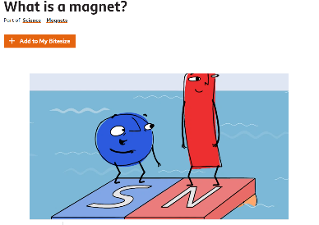
To introduce our topic please watch the ‘What is a magnet?’ clip which can be found on the link below.

https://www.bbc.co.uk/bitesize/topics/zyttyrd/articles/zpvcrdm
After you have watched the clip, scroll down and have a go at completing both the quiz and the choose the magnet that will attract north game.
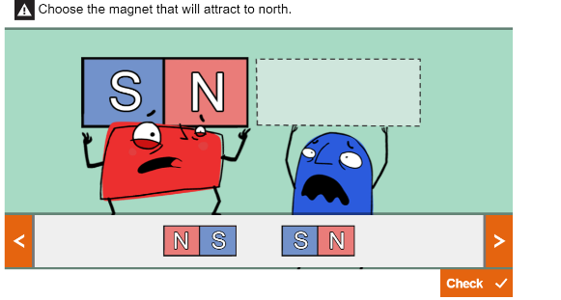
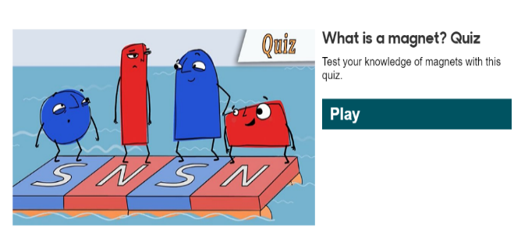

Magnet hunt:
Magnets have many different uses and can be found all around – often in places, you don’t realise. Have a hunt around your home and look for magnets (plus any that might be hidden!) and make a list – as you do think what the magnets are used for. For example, a travel game – the magnets hold the pieces on the board. Fridge door – the magnet keeps the door sealed shut.

Use your magnets to complete the following experiments:
Use the worksheet found at the bottom of the document. Before each experiment predict what the result might be. After you have completed the experiment, record your findings. You can either use the worksheet provided or make your own.
Experiment 1:
How many paperclips can your magnet hold? Did you predict correctly?

Experiment 2:
Test out 3 magnets from your house – you could use 3 different fridge magnets – predict which will be the strongest. See which magnet holds the largest amount of paper to the fridge by gradually adding one piece of paper at a time. Did you predict correctly?

Identifying forces:
As you have learnt whilst watching the videos, when two magnets are close, they create pushing or pulling forces on one another.
Please read through the ‘Identifying Forces’ PowerPoint. This can be found on the AR website on the year 3 page. Once you have read through the PowerPoint please have a go at completing both worksheets. These can both be found at the bottom of the document.

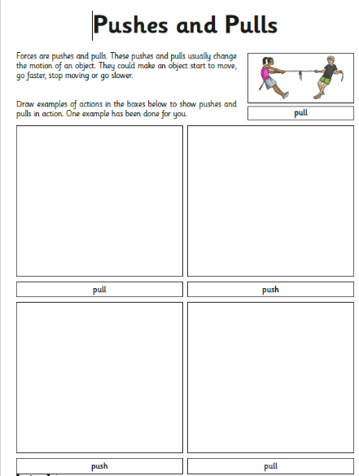
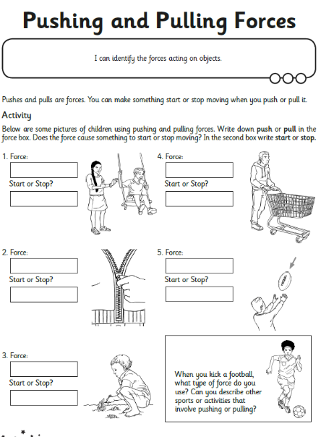

DT:
This week our DT task is also all about magnets. We would like you to try and create your very own magnet maze.
You will need a magnet, an empty water bottle, a magnetic item and a marker pen.
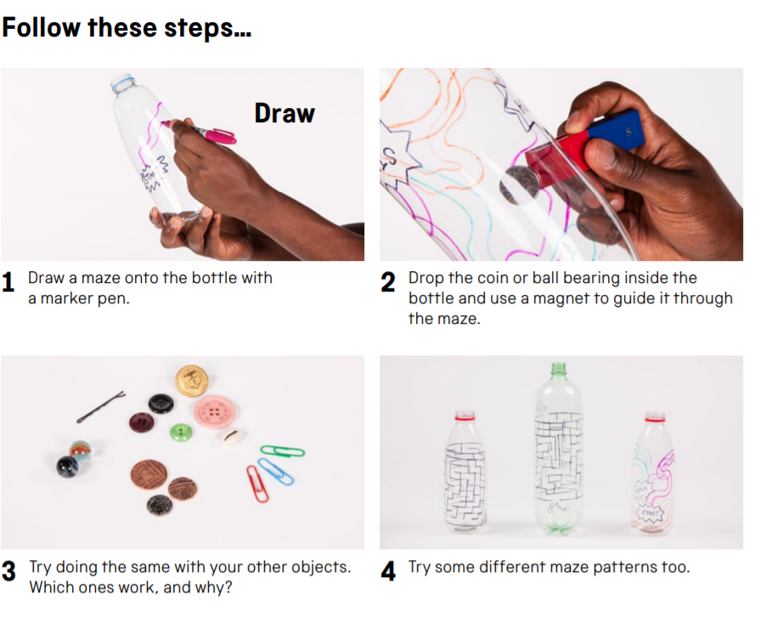
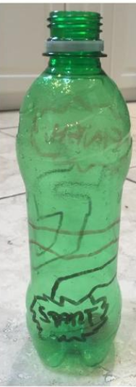

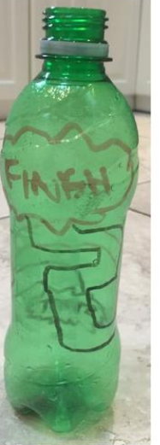

Spelling:
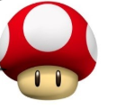
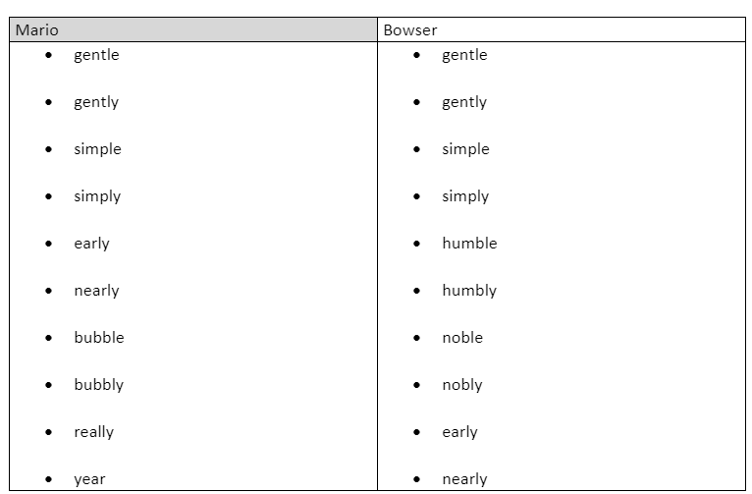
Tactic 17- If it ends in ‘le’ change to ‘ly’ and keywords.

Click - Spellzone- to find the wordlist and some games to play. Test yourself to see how many you can spell correctly. Try and use each word in a sentence.

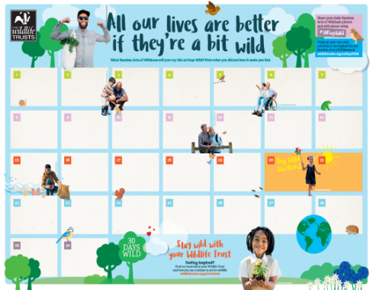
Forest School:
We are all desperately missing our Forest School sessions. With this in mind, we would like to encourage the children to take part in the #30 days wild event organised by the Wildlife Trusts. The aim is to get children (and adults) into nature more often and appreciate the natural world. I know many of you have been engaging in these types of activities during lockdown – but a way to mark these would be lovely. On the website, we have included some ideas and inspiration for the activities as well as the calendar for you to print out and fill in. Aim to do something ‘wild’ every day in June.
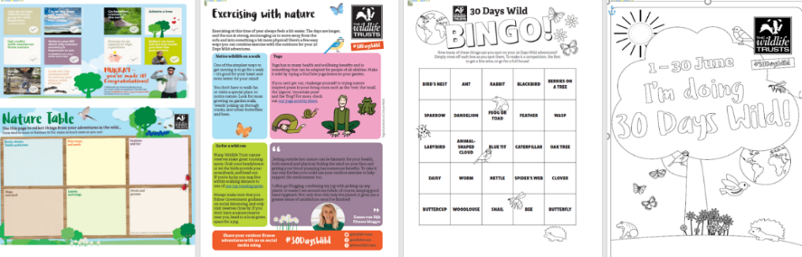

Reading comprehension:

Week 5 comprehension question answers:
- Aside from her many job roles, why else was Lady Fu Hao regarded as being so important?
Her husband was the Shang King, Wu Ding. She also performed sacred ceremonies, which was very unusual for a woman.

- The picture shows a square bronze vessel called a ‘ding’, that was found in Lady Fu Hao’s tomb. What do you think it might have been used for at the time of the Shang Dynasty?
A Ding is a prehistoric and ancient Chinese cauldron, standing upon legs with a lid and two facing handles. They were used for cooking, storage, and ritual offerings to the gods or ancestors.

- Tick all the correct answers:
‘The Shang’s worked with many materials to produce works of art. These included…’
Clay, jade, bone and bronze.

- The people of the Shang Dynasty were most renowned for their ‘intricate’ artwork. What do you think is meant by the word ‘intricate’?

Intricate means very complicated or detailed. An example of intricate is a puzzle with 1000 pieces.

6. Why is the Shang Dynasty known as ‘China’s Bronze Age’?
The Shang Dynasty is known as China’s Bronze Age. The reason for this is the sheer skill they showed in making beautiful bronze art.

7. What does an ‘alloy of metals’ mean?
Bronze is an alloy of metals, meaning it is made up of different metals; copper, tin and lead.

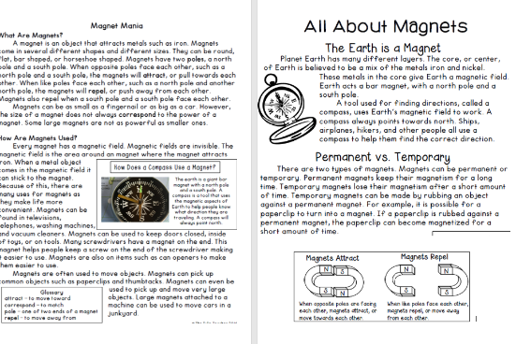
Week 6 comprehension questions
This week we would like you to read the non-fiction text all about magnets. You can also access the text on the Year 3 page along with this week’s home learning letter, click on the document ‘Magnets Reading Comprehension’.
Once you have read the extracts answer the comprehension questions below.

Please read ‘Magnet Mania’.
- What is a magnet?

- Tick the correct answer:
Magnets have two poles, these are called…

North pole

West pole

East pole

South pole

- ‘When the same poles face each other, such as a north pole and another north pole they will repel’. What does the word repel mean?

- ‘The bigger the magnet the more powerful it is’.
Is this statement True or False? How do you know?

- List at least three places you might find magnets in your home.

- Which direction will a compass always point?

Please now read ‘All about Magnets’.

- ‘The Earth is a Magnet’- carefully read the information under this heading.
In two sentences summaries what you have found out.

- What is a ‘temporary magnet’?

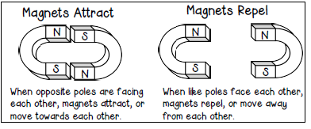
- Use the box below to draw your own diagram of two magnets attracting. Remember to label the poles.

- Use the box below to draw your own diagram of two magnets repelling. Remember to label the poles.

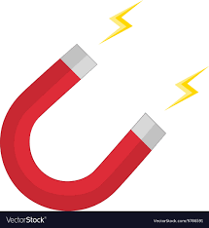
Magnet Experiments

Experiment 1:
How many paperclips can your magnet hold? Did you predict correctly?
Prediction
I predict that

I think this because

Results
After you have completed your experiments, we would like you to record your findings.
Please write in full sentences and try to include as much detail as possible.

What did you do?

What did you notice?

What were your results?

Experiment 2:
Test out 3 magnets from your house – you could use 3 different fridge magnets – predict which will be the strongest. See which magnet holds the largest amount of paper to the fridge by gradually adding one piece of paper at a time. Did you predict correctly?
Prediction
I predict that

I think this because

Results
After you have completed your experiments, we would like you to record your findings.
Please write in full sentences and try to include as much detail as possible.

What did you do?

What did you notice?

What were your results?

