Dear Parents/ Carers,
We hope that you have managed to enjoy the bank holiday weekend and spend some time outside in the lovely sunshine!
A huge thank you to all of those who have sent us such lovely pictures to share on our ‘stay connected’ page. We hope that your children have enjoyed seeing photos of their friends. We will be continuing to update these so please keep sending them in, they do bring a smile to our faces.
We hope you enjoy seeing some familiar faces in our home learning tasks this week. Miss Moore has also recorded the next two chapters of ‘The Boy Who Grew Dragons’. https://youtu.be/VOLqQTWr0LY
Below are this week learning tasks, please do let us know if you require any extra support or guidance with the tasks, we are all more than happy to help.
This week’s learning tasks:
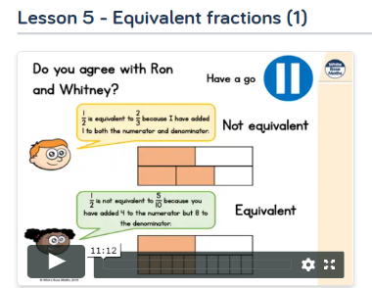
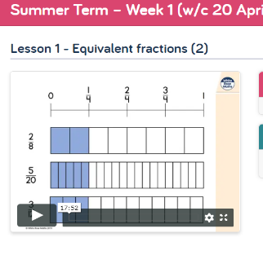
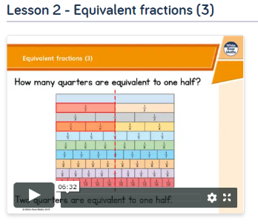
Maths:

This week we will be following on from last week’s lessons and focusing on equivalent fractions. Firstly, have a look at the work you completed last week and recap what you have already learned. This week, we would like you to focus on Week 2 lesson 5 and ‘Summer Term- week’ lessons 1 and 2. Please watch the video and complete the activities. https://whiterosemaths.com/homelearning/year-3/
ICT:
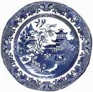
This week Mrs Horton has received a very exciting delivery. Watch the video below to find out your challenge for the week.
https://www.youtube.com/watch?v=2xDU_sWcZ7c&feature=youtu.be
Mrs Horton has challenged you to research the story of the Ancient Chinese myth the Willow Pattern. If you require some guidance, we have uploaded some information all about the Willow Pattern in this week's Home Learning section on the AR website.
English:
Mrs Seagrave has recorded a video reading the story of the Willow Pattern. Please watch before you complete this week’s task.
https://www.youtube.com/watch?v=KKUaAxfHAvI&feature=youtu.be

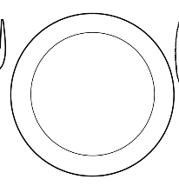
Once you have researched the myth and listened to Mrs Seagraves recording, we would like you to use your new knowledge to retell the story of the Willow Pattern.
This can be done by drawing on the plate template which can be found at the bottom of this document or if you have a spare paper plate.
Think carefully about the key events of the story and then carefully draw them onto the plate. Label each of the parts of your story with a number to show the order of which the events happened. Once you have done this write some key sentences to describe what is happening at each stage in the story. When you have completed your task, have a go at retelling the myth to a family member using your decorated plate and sentences.

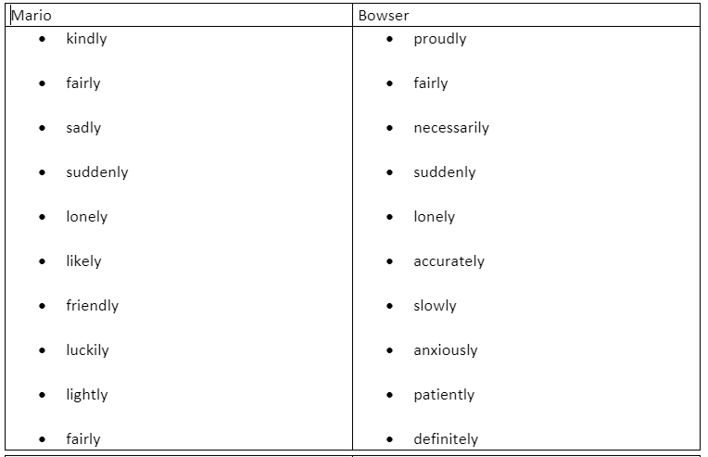
Spelling: Tactic 15- the suffix ‘ly’

Click - Spellzone- to find the ‘ly’ wordlist and some games to play. Test yourself to see how many you can spell correctly. Try and use each word in a sentence.
Spanish:
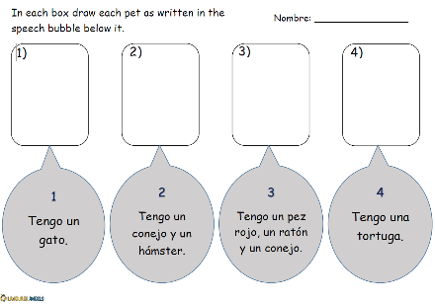
In our Spanish lessons, we had begun learning all about pets. This week we would like you to remind yourselves of the names for the different pets by watching the clip. Whilst you listen to the clip have a go at speaking the Spanish names out loud. https://www.youtube.com/watch?v=jdBIIV3RhDM
After you have watched the video have a go at completing the worksheet which can be found at the bottom of the document.
P.E:
Notts School Games Organisers are publishing weekly PE ideas which we would like all the children to have a go at. We hope you enjoyed last week’s football activities and virtual competition. Follow the link to see what this weeks activity is and enjoy taking part. https://www.abbeyroadprimary.co.uk/weekly-pe-skills-physical-activity-and-competitions/

Art & DT:
At the time of the Shang Dynasty people relied heavily on fortune-telling to help them make decisions about their lives. This week we would like you to have a go at creating your very own Ancient Chinese fortune teller.
First, use the instructions found at the bottom of the document or watch the video below to help you fold your fortune teller correctly. https://www.youtube.com/watch?v=BxyXk1sr2io
Next, think carefully about the type of questions people at that time might have asked and what answers they may have been given.
An example question could be:
Will we receive enough rainfall this month to nourish our crops?
Possible answers could be:
1. Yes, it will rain for many days, all your crops will be nourished and grow well.
2. No, the sun will continue shining and your crops will die.
3. The sun will shine for 20 more days then rain will fall just in time.
4. The answer is unknown.
Once you have thought carefully about your questions and answers write them into the correct sections of your fortune teller.
Finally, add some colour and decorations to your fortune-tellers.
We hope you enjoy making your very own fortune-teller. We would love to share some of your marvellous creations with your friends, so please remember to e-mail them to Mrs Horton and we will upload them to the AR website.
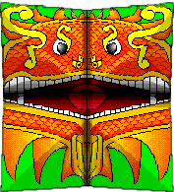
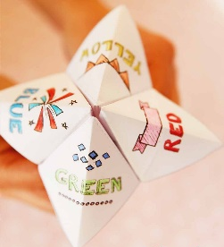
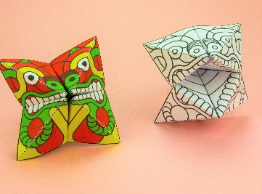

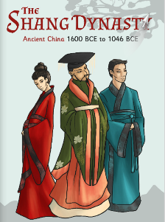
Reading comprehension-
https://www.twinkl.co.uk/resource/t2-h-4328-the-shang-dynasty-e-book
This week we will be continuing with the E-book ‘The Shang Dynasty’. You can also access these pages on the Year 3 page if you can’t access them online.
Week 3 comprehension question answers:
Recap what you have read so far by marking your answers from last week.
1. Who was thought to have built the city of Shang?
The first Shang king, Tang.
2. What was believed to be the main difference between the buildings from the Han Dynasty and the Shang Dynasty?
Unlike the buildings from the Han Dynasty, the Shang buildings had thatched roofs, rather than tiled.
3. Instead of being surrounded by a huge wall like the other Shang capitals, how were the central palaces and shrines in Yin protected?
By small buildings built around them.
4. Give a reason that might explain why remains from the Shang buildings are hard to find:
Shang buildings were made mainly of wood and clay, instead of stone so would have been easier to knock down, be affected by weathering or have crumbled over time.
5. What do we believe the people in Ancient China used ‘dragon bones’ for?
Their medicinal properties and they were sold by chemists.
6. ‘Many of the ‘dragon bones’ found had strange, special marks scratched onto them’. What do you think these marks might be?
Information and messages were written by the people from the Shang Dynasty.
7. In Chinese folklore and myths, dragons symbolise….
Power, luck and wisdom.
8. What did historians uncover from the bone fragments?
The fragments of bone were like a jigsaw that historians managed to piece together and help explain the history of the Shang Dynasty. They learnt about the ancient royal rituals and ceremonies of the Shang. The bone fragments also revealed the hopes and concerns of a Shang king.
9. The bones are now known as… Oracle bones.
Week 4 comprehension questions:
Please read pages 14-18 and answer the questions below.
- Why was finding the Ancient Shang bones really exciting for historians?

- Tick the correct answer:
Chinese sentences are read…
from the bottom to the top
upside down
left to right

- In the box below have a go at writing ‘sun’ in ancient Shang characters:

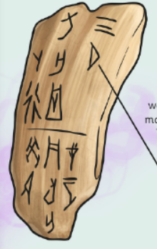

- The ‘D’ shape means ‘moon’ and the 3 strokes above it mean the number 3. Can you guess what the two together could mean?

- ‘The Shang were worshipers of their ancestors and other gods’. What does the word ancestor mean?

- Why did the diviners and oracle bones play a huge part in Shang history?

- Tick all the correct answers:
What were the ceremonies believed to bring?

children

sunshine

luck

rainfall
chocolate
On page 18 read the first section ‘Lady Fu Hao’.
- List the roles that Lady Fu Hao had:

- ‘Fu Hao also performed sacred ceremonies, which was very rare for a woman, since it was such an important part of life back then.’ Why do you think it was rare for a woman to perform sacred ceremonies?

- Why do you think Fu Hao was described as ‘extraordinary’?

Look out for the answers next week! Please remember to do your daily reading and record it in your diary and continue practising your speedy number recall on Times Tables Rockstars.
Take care, work hard and look after each other.
Miss Moore, Mrs Seagrave and Mrs Horton.

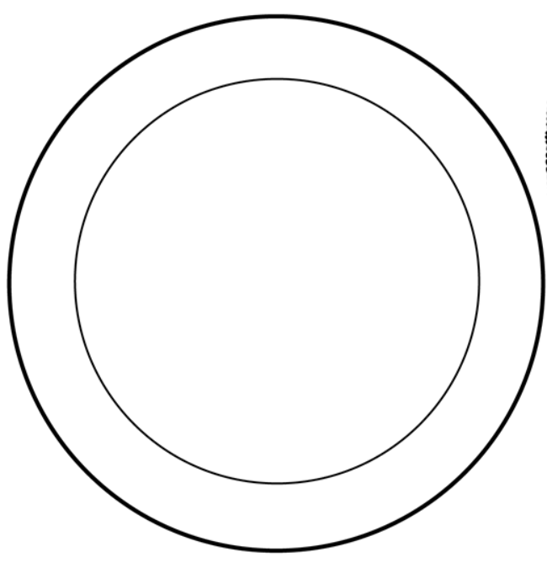
Instructions to make a fortune-teller

Step 1: Start with a square sheet of paper. You may need to cut your paper into a square if it is a regular rectangle piece.

Step 2: Fold the paper in half by folding the bottom left corner to the upper right corner, then unfold.

Step 3: Fold the paper in half again by folding the bottom right corner to the top left corner, then unfold again.
Step 4: Fold the paper in half by folding the bottom edge
to the top edge, then unfold.
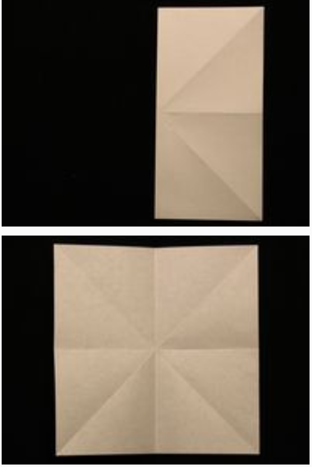

Step 5: Fold the paper in half again by folding the left edge to
the right edge and then unfold again.

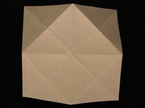
Step 6: Fold all four corners to the centre.

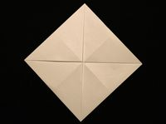

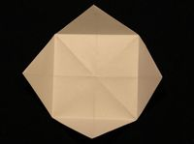
Step 8: Once again, fold all four corners to the centre.

Step 7: Turn the paper over.

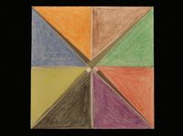

Step 9: Colour or label all the triangles with different colours.

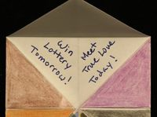
Step 10: Write a fortune underneath each colour and close the flaps again. Remember to think carefully about the type of questions people in the Shang Dynasty might ask.

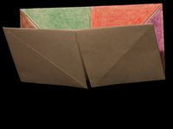
Step 11: Fold the bottom half to the top.

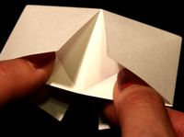
Step 12: Tuck your thumbs and forefingers in the four openings below. Now you're ready to play with the paper fortune teller.
