Dear Parents/ Carers,
We hope that you and your families are all managing to stay safe and healthy.
As the week commencing Monday 25th May is half term we won’t be setting any structured Home Learning tasks. Instead Friday 22nd May we will be uploading a letter for the children from the year 3 teachers wishing them a happy half term. The letter also contains some fun activities which we thought they might enjoy over the week. There is no pressure or obligation to complete any of these activities, we just thought it might give you some different ideas. Please keep us updated and send in pictures if you do decide to take part in the activities as we will create a ‘Half Term Fun’ album the following week which we will post on the website to stay connected.
We hope your children are enjoying seeing some familiar faces in the home learning tasks. Miss Moore has also recorded the next two chapters of ‘The Boy Who Grew Dragons’. https://studio.youtube.com/video/uQCDSv_3uNc/edit
Below are this week learning tasks, please do let us know if you require any extra support or guidance with the tasks, we are all more than happy to help.
This week’s learning tasks:
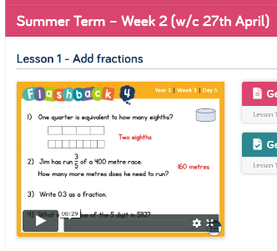
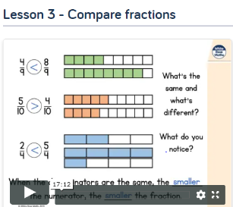
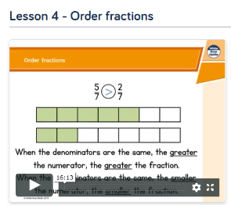
Maths:

This week we will be following on from last week’s lessons and focusing on comparing, ordering and adding fractions. Firstly, have a look at the work you completed last week and recap what you have already learned. This week, we would like you to focus on ‘Summer Term- week 1 w/c 20th April.’ lessons 3 and 4. Also ‘Summer Term Week 2 w/c 27th April’- lesson 1. Please watch the video and complete the activities. If you are feeling extra confident you could have a go at the ‘Friday Maths Challenge’ found at the bottom of the page.
https://whiterosemaths.com/homelearning/year-3/

P.E:
Notts School Games Organisers are publishing weekly PE ideas which we would like all the children to have a go at. We hope you enjoyed last week’s Netball activities and virtual competition. Follow the link to see what this week’s activity is and enjoy taking part. https://www.abbeyroadprimary.co.uk/weekly-pe-skills-physical-activity-and-competitions/
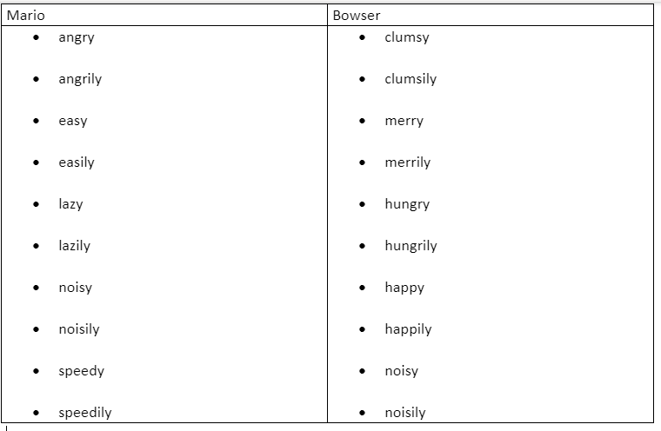
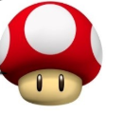
Spelling: Tactic 16- the suffix ly- if it ends in a ‘y’ with a consonant before it the ‘y’ changes to an ‘i’.

Click - Spellzone - to find the wordlist and some games to play. Test yourself to see how many you can spell correctly. Try and use each word in a sentence.
History:
This week we will be looking at what it would have been like to live at the time of the Shang Dynasty. Life in the Shang Dynasty was very different depending on whether you were rich or poor.
First, watch the BBC bitesize clip ‘What was it like to live in the Shang Dynasty?’. Then use the knowledge you have learnt from the video to complete the activity.
https://www.bbc.co.uk/bitesize/topics/z39j2hv/articles/zqtn6yc
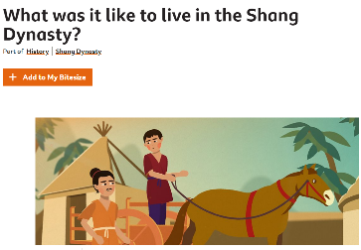
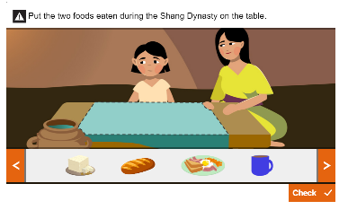

Next, watch the ‘What jobs did the Shang people do?’ clip carefully and complete the ‘Work out which job the person does’ activity below the video.
https://www.bbc.co.uk/bitesize/topics/z39j2hv/articles/zx8dcj6
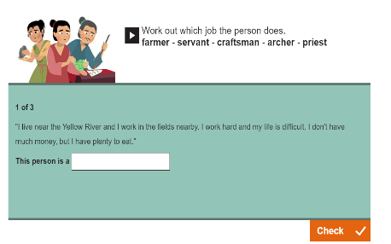
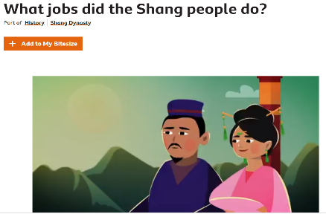

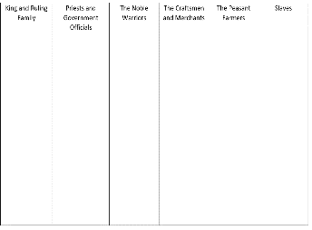
Once you have watched these two clips, read through the PowerPoint which will be e-mailed from school, to find out about this week’s task. To help you complete this week’s task we advise the children record notes when reading the information from the slides. This can either be done by writing each of the headings on your own paper or printing out the template found at the bottom of the document.

Art & DT:
Mrs Seagrave has recorded a message telling you all about this week’s creative challenge. https://youtu.be/BVAfqbJuoPw
Can you create a dragon puppet? There are some ideas below – use one of these or create your own! See if you can use items from your recycling bin. Once you have made it see if you can create a puppet show to explain to your family what you have learnt about China. You could even send a recording to Mrs Horton for us to watch!
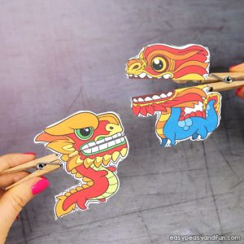
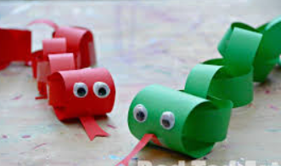
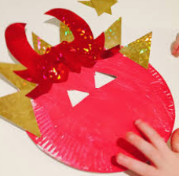
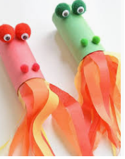
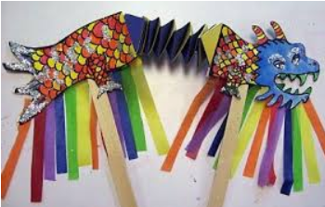
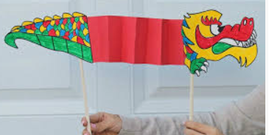
Spanish:
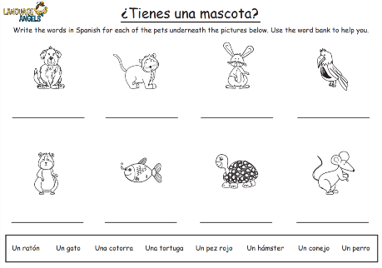
Last week we asked you to recap your learning all about pets. This week we would like you to continue this and use your Spanish knowledge to identify and write the correct names of the different animals in Spanish. If you would like to recap the names of the pets first, please watch the clip again.
Whilst you listen to the clip have a go at speaking the Spanish names out loud. https://www.youtube.com/watch?v=jdBIIV3RhDM
After you have watched the video complete the worksheet which can be found at the bottom of the document.
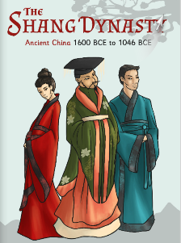
Reading comprehension-
https://www.twinkl.co.uk/resource/t2-h-4328-the-shang-dynasty-e-book
This week we will be continuing with the E-book ‘The Shang Dynasty’. You can also access these pages on the Year 3 page if you can’t access them online.
Week 4 comprehension question answers:
- Why was finding the Ancient Shang bones really exciting for historians?
As paper had not been invited at the time of the Shang Dynasty so it was very hard to find any historical records from this time.

- Tick the correct answer:
Chinese sentences are read…
from the bottom to the top.

- In the box below have a go at writing ‘sun’ in ancient Shang characters:
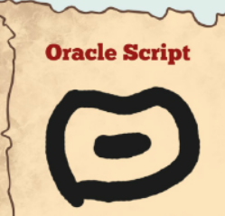

- The ‘D’ shape means ‘moon’ and the 3 strokes above it mean the number 3. Can you guess what the two together could mean?
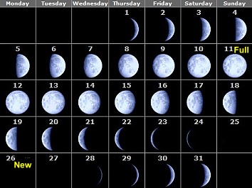
In cultures across the world, the moon is often used to symbolise a month. This is because the moon's cycle (new, first quarter, full, last quarter) takes approximately 29-31 days…the same as a month.
The D is meant to look like a moon and the three strikes symbolise 3. So, this is meant to be the third moon OR the third month.
- ‘The Shang were worshipers of their ancestors and other gods’. What does the word ancestor mean?

An ancestor is a relation who lived several generations ago.
You could think of it like your grandma’s, grandma’s, grandma…

- Why did the diviners and oracle bones play a huge part in Shang history?

As the kings decided what to do from what the diviners predicted for the future.

- Tick all the correct answers:
What were the ceremonies believed to bring?
Children, luck and rainfall.
On page 18 read the first section ‘Lady Fu Hao’.
- List the roles that Lady Fu Hao had:
Warrior, high priestess and politician.

- ‘Fu Hao also performed sacred ceremonies, which was very rare for a woman, since it was such an important part of life back then.’ Why do you think it was rare for a woman to perform sacred ceremonies?
At the time of the Shang women's roles were very different from what they are today. Women primarily took on kinship roles: daughter, sister, wife, daughter-in-law, mother, and mother-in-law.
- Why do you think Fu Hao was described as ‘extraordinary’?
The word ‘extraordinary’ means very unusual or remarkable. Fu Hao was both of these things. Unusual as it was rare for a woman at the time of the Shang to be so powerful or important. Remarkable because she was extremely intelligent and hardworking.
Week 5 comprehension questions:
Please read pages 18-22 and answer the questions below.

- Aside from her many job roles, why else was Lady Fu Hao regarded as being so important?

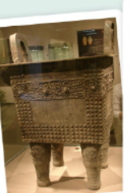
- The picture shows a square bronze vessel called a ‘ding’, that was found in Lady Fu Hao’s tomb. What do you think it might have been used for at the time of the Shang Dynasty?

- Tick all the correct answers:
‘The Shang’s worked with many materials to produce works of art. These included…’
Clay
Bricks
Metal
Bone
Bronze
Plastic
Jade
- The people of the Shang Dynasty were most renowned for their ‘intricate’ artwork. What do you think is meant by the word ‘intricate’?

- Imagine you are a Shang artisan (a worker in a skilled trade, especially one that involves making things by hand). Use the box below to sketch a design for your next jade carving. Remember to pay close attention to detail.

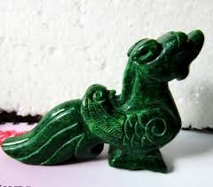
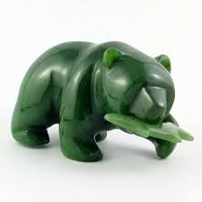
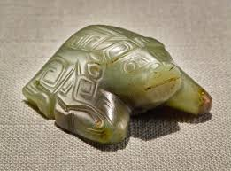

- Why is the Shang Dynasty known as ‘China’s Bronze Age’?

- What does an ‘alloy of metals’ mean?

Final task-
We hope that you have enjoyed this Shang Dynasty E-book as much as we did. The book contains so many interesting and exciting facts. For your final task, we would like you to review the book.
First recap what you have learnt by looking back through the pages. Whilst you are reading think carefully about what you think is the most interesting or important information in the book.
Please answer in full sentences.
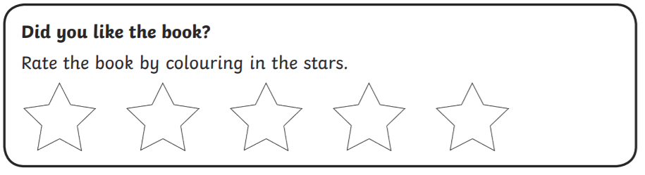

Why did you give the book this rating?

Summary- what was this book about?

List the two most exciting or interesting facts you have learnt from this book:

Look out for the answers next week! Please remember to do your daily reading and record it in your diary and continue practising your speedy number recall on Times Tables Rockstars.
Take care, work hard and look after each other.
Miss Moore, Mrs Seagrave and Mrs Horton.

