Literacy
Activity 1 – Watch the clip and answer/talk about the questions
Watch the video clip Bubbles - https://www.literacyshed.com/bubbles.html

Talk to your grown up about the film – these questions might help. You may need to pause the film or watch it a couple of times -

How do you think the little girl is feeling at the start of the film?
How does she feel when she picks up the bubbles?
What colours does she see when she sets off on the bubble? How does she feel now?
What does she see from her bubble under water?
What can she see in space?
How does she feel when she sees the girl on the beach?
How do you think the girl feels?
Why does she put the bubbles on the floor?
Where do you think the little girl goes on her adventure?

Draw a story map of the Bubble story. It might start a bit like this …
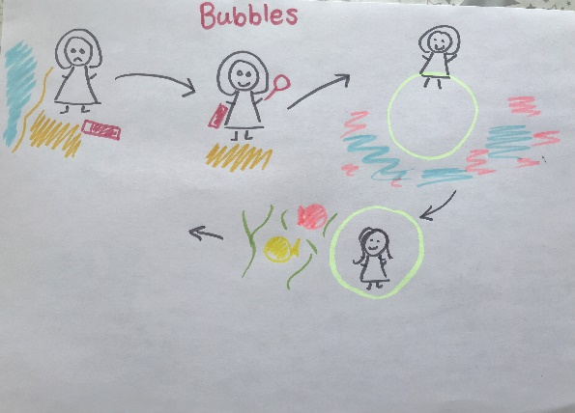

.

Activity 2 – Reading comprehension – Write the answers in your book.
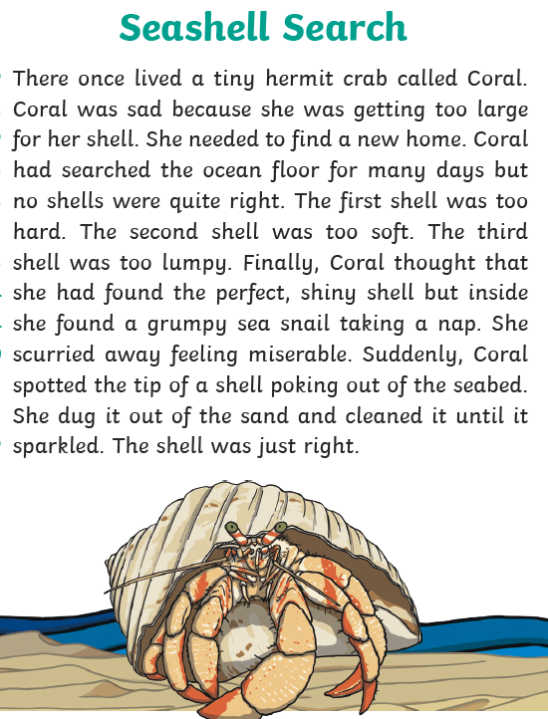

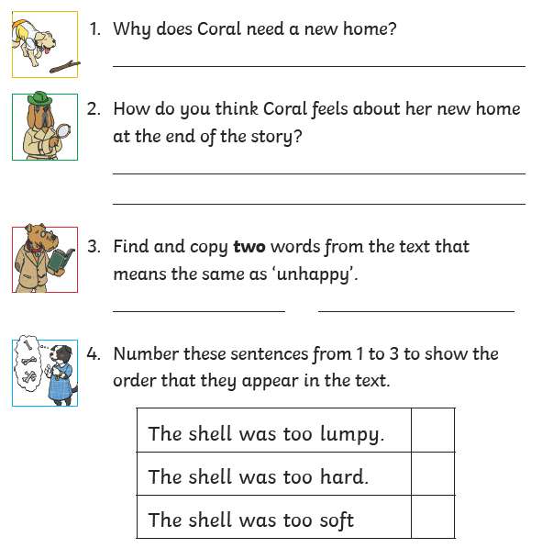

Activity 3 –Watch the Bubble film again and write what the little girl can see and hear from her bubble while she is under the sea. You can use this picture to help too. Remember to use some lovely adjectives.
Eg The round, yellow fish is swimming quickly through the seaweed.

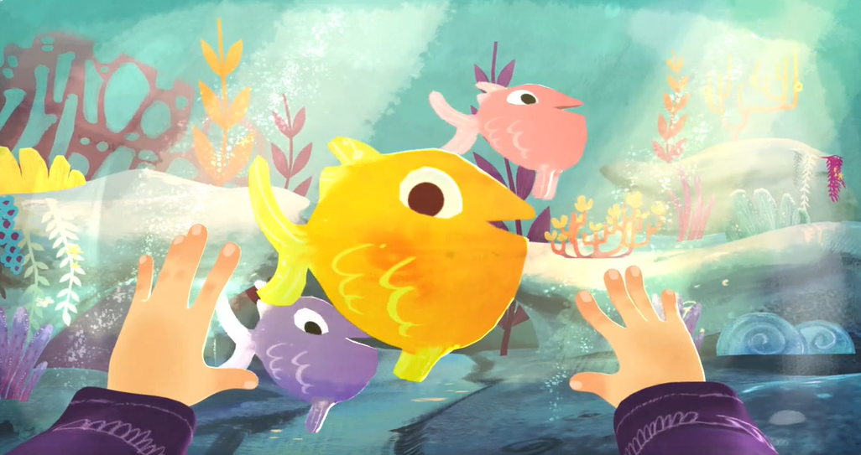

Write your sentences in your book and then you can draw a lovely picture of what the little girl can see.

Activity 4 – Spellings
Circles: loud out shout
Triangles: ground proud about count house round

Activity 4 – ou pairs game. Cut up some pieces of paper and write each word twice or print out the words below, cut them out, turn them face over and take turns to find a matching pair. Make sure you read out the word carefully each time you turn a word over.
count | count | cloud | cloud
about | about | round | round
shout | shout | loud | loud
house | house | out | out
proud | proud | counting | counting
sound | sound | ground | ground

Activity 5 – Write your own bubble adventure. You can visit two different places in your bubble but one has to be under the sea. Then choose another place for your bubble to take you. Where will you go? A jungle, a desert or to the park – its up to you? Try to describe what you can see, hear and how you are feeling. Make sure you use lots of the lovely language you have been using over the last two weeks. Did the author of Commotion in the Ocean use any words you’d like to use in your story? Remember capital letters and full stops!
You can write your adventure in your book or on the bubble if you’d prefer.
