Physical Development week 4

- Just dance – learn how to recycle by doing the Daisy Dance.
Click on the link below,
https://www.youtube.com/watch?v=Ggvzm0jOp4A

- Try a fun yoga story with Cracker the dragon
https://www.youtube.com/watch?v=7NWzS2xziI4

- If the weather is fine, you could make your own obstacle course in your garden.
- Use whatever you have…
- a rope to balance along
- lay out some stones to walk in and out of while balancing a book on your head
- If you have a hula hoop you could crawl through it
- A spoon and stone to do an egg and spoon race
- Hop along some zigzag lines you could draw on your path with chalk.

You could chalk out numbers to play hopscotch
Below is a link explaining the rules
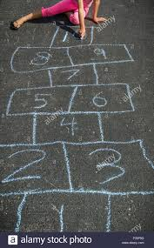
https://www.youtube.com/watch?v=fZzswQaICfM

