TOPIC ACTIVITIES WEEK 4:
- Science – Look at the Fish power point. Try and learn the names of the different parts of a fish and their purpose. Draw a large detailed fish with a pencil (You don’t need to colour it in) and label the parts.

- Geography – Learn the names of the world’s five oceans. Can you look on a globe or a map and name them?
These video links tell the children about the five oceans. There are a lot of facts and there is a lot of information, that many children will enjoy finding out about. However, please don’t worry if they can’t retain this. The children are just trying to learn and remember the names of the oceans.
https://www.bbc.co.uk/bitesize/topics/z849q6f/articles/zmqwscw
https://www.youtube.com/watch?v=XUAGVToKgLo

You might like to listen to these songs too:
https://www.youtube.com/watch?v=X6BE4VcYngQ
https://www.youtube.com/watch?v=vfv7TF9RHbY

- Make an aquarium or under the sea scene out of a cereal box/egg box/shoe box or any box from your recycling.
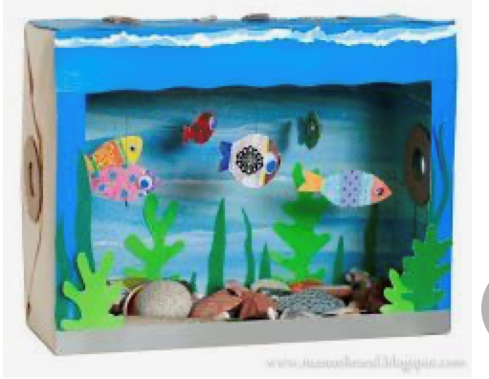

- Spanish:
https://www.youtube.com/watch?v=8rd516_QxiU
https://www.youtube.com/watch?v=VNqIwnrP8Co
Watch these clips. Can you learn the names of 5 sea creatures in Spanish. You could draw them and label them in Spanish too.

