Abbey Road Primary School
Tewkesbury Close
West Bridgford
Nottingham
NG2 5ND
Tel: (0115) 9748055
Head Teacher: Mrs. Ly Toom Email: office@abbeyroad.notts.sch.uk
Dear Parents/Carers,
We are missing you all so much and hope you are all safe and well. Thank you to the families who have sent in a photo showing something their child is proud of – this could be a piece of art, a story, a photo of bike riding – anything! Keep them coming! Please send them by Monday 11th May, thank you, and let us know if you do not want the photo sharing on the website.
Please email the photo to the office email:
office@abbeyroad.notts.sch.uk
Put either 1P or 1HB in the subject so the office can forward to the right teacher.
We can’t believe it’s already week 4 of Summer term – at least the weather is being kind to us!
Hope you all enjoy VE day on Friday – and have picnics in your garden or put up some colourful bunting.
The activities
- Physical activity : Joe Wicks, Cosmic Yoga, walk, bike/scooter ride, in the garden etc, plus there’s some fun new PE planning (see home page on Abbey Road website) Oti from Strictly has some good half hour dance workshops on YouTube too.
- Phonics – Daily lesson - Read write Inc is the phonics scheme we use in Year 1. Every day they are live streaming a phonics lesson on this website : https://www.youtube.com/channel/UCo7fbLgY2oA_cFCIg9GdxtQ
Set 2 10am Set 3 10.30. They can be accessed later on in the day too.
Look at set 2 / set 3
- Maths – Daily lesson – we are now going back to White Rose as it seems much better (see maths info sheet)
- Literacy – Daily activity (5 are planned for the week, including spelling practice)
- Topic activity – At least two during the week, including the science activity.
- Reading – Sharing a book, using the viper questions to further learning. - https://www.oxfordowl.co.uk/for-home/ This website has free ebooks for your child to read. They are colour banded just like school.
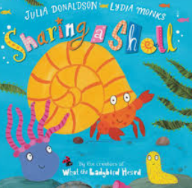
- This week Mrs Hicking will be reading the children a story
Many thanks
The Tear 1 Team
SUMMER TERM WEEK 4

