Week 4 Personal, social and emotional

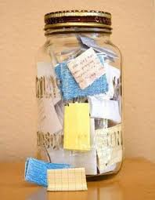
- Whenever anyone in your family has done something that has gone well or made you happy, adult to write it on a small piece of paper and place in a jar. This could be anything from baking yummy biscuits or a delicious dinner, to watching a funny T.V programme together or enjoying a walk or story together. At the end of the week gather together and read out all of the things that have gone well. This is good for the mental wellbeing of the whole family.

- This lovely idea came from Jessica in Sunshine’s and thought it was so lovely that you all might like to do it. Get your child to lie down on a big piece of paper with their arms out to the side. Draw around them and then let them decorate themselves and draw on their face. On the back write “sending you a big hug until I can see you again.” Fold up and send to Grandparents or other people who you are missing seeing during lock down.
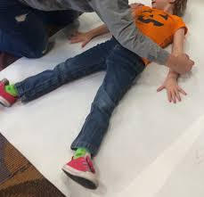

- Self- help skills to practise …

Get your child to practice the skills on the sheet.

