Week Four Foundation Planning One world
Creative Planning
- Listen to this song and join in
https://www.bbc.co.uk/cbeebies/watch/cbeebies-recycle-song

- Here are some ideas to inspire you to create your own clothes using the rubbish in your blue bin. I can’t wait to see your outfits.
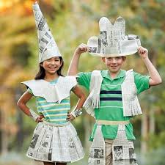
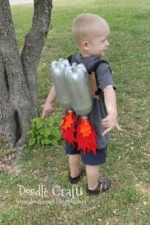

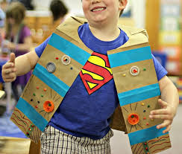

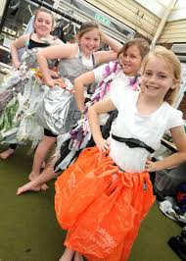

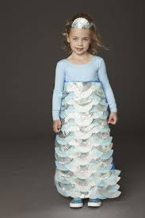

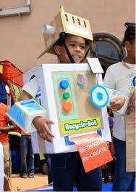

- Lots of you enjoyed making your natural pictures outside. You could have a go at using leaves to make some people. Look at the pictures for inspiration.
