Creative Caterpillars
Activity One
Watch the clip and draw a caterpillar and lettuce leaf
https://www.bbc.co.uk/cbeebies/watch/get-squiggling-caterpillar

Activity Two
Cut out an outline of a butterfly.
Paint one side and then fold it over.
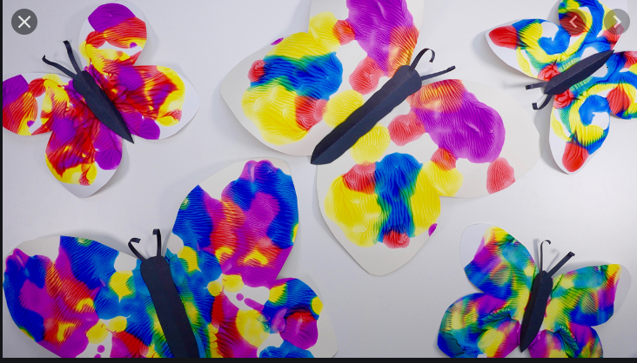
Talk about symmetry, how both sides are symmetrical (the same).
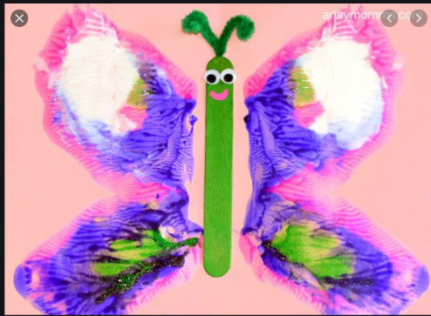

Activity Three
Use your finger dapped in paint to paint a repeating pattern caterpillar.
See Mrs Simister on YouTube demonstrating.

https://youtu.be/dZMtdnDPCqc

Activity Four
Use the print out butterfly outline or draw your own.
Use some cotton buds dapped into different coloured paints to create a beautiful butterfly.
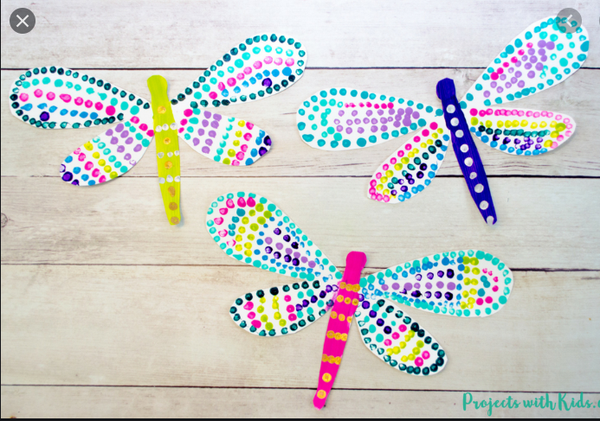

Activity Five
Cosmic Yoga
The Very Hungry Caterpillar
https://www.youtube.com/watch?v=xhWDiQRrC1Y
Activity Six
Dance Butterfly wings
https://www.youtube.com/watch?v=Lkza_tRlNRE
Electronic song Minions
https://www.youtube.com/watch?v=FP0wgVhUC9w
Get ready to wriggle dance
https://www.youtube.com/watch?v=Qm1Tiw4Y0Es

Activity Seven
Sing the songs
Hungry Caterpillar song
https://www.youtube.com/watch?v=_tUBBh4QzTU
Rhyme Cecil is a caterpillar Cecil is my friend
https://www.youtube.com/watch?v=ANO37eCV5C4
There’s a tiny caterpillar on a leaf
https://www.youtube.com/watch?v=LI2Wo2rRWqM
Caterpillar crawled
https://www.youtube.com/watch?v=1MxjGNA1igE

Activity Eight
Colouring sheets to practise fine motor skills, you can cut out the pictures to practise cutting skills.
Activity Nine
Colour and cut mini beast masks and make up your own story and act it out.

