Creative Development Bees Week 5
Activity One
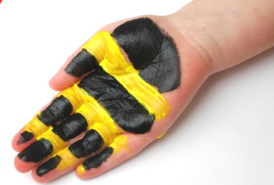
Paint your hand with yellow and black stripes.
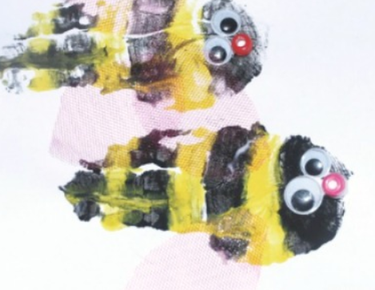
Print on to paper and decorate eyes and nose with paint or googly eyes. You could draw on wings, legs and antennae.

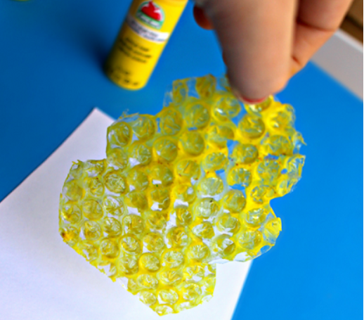
Activity Two
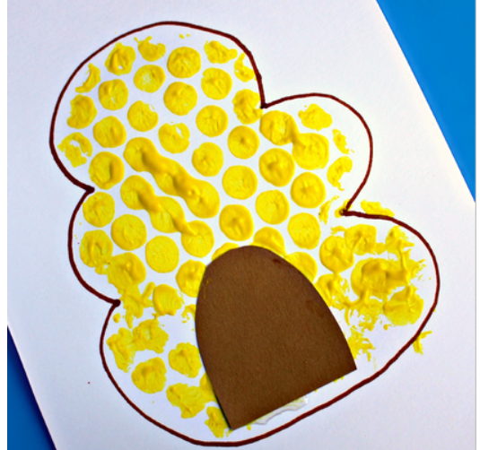
Cut out a piece of bubble wrap that will fit onto A4 paper. Cover it in yellow paint.

Press it onto the paper to make a hive. When it’s dry draw around it in black pen and cut out and stick on a brown door.

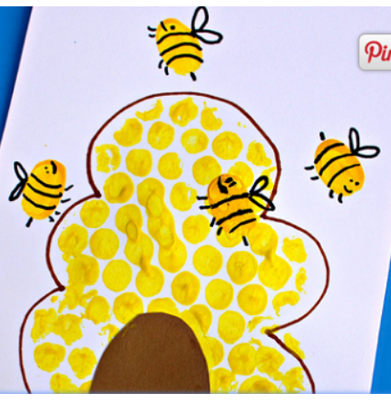
Use your thumb to finger paint the bees around the hive.
When the paint is dry draw on the black stripes, face and wings with a black felt tip.

Activity Three
Step by step drawing of a bee See separate sheet.
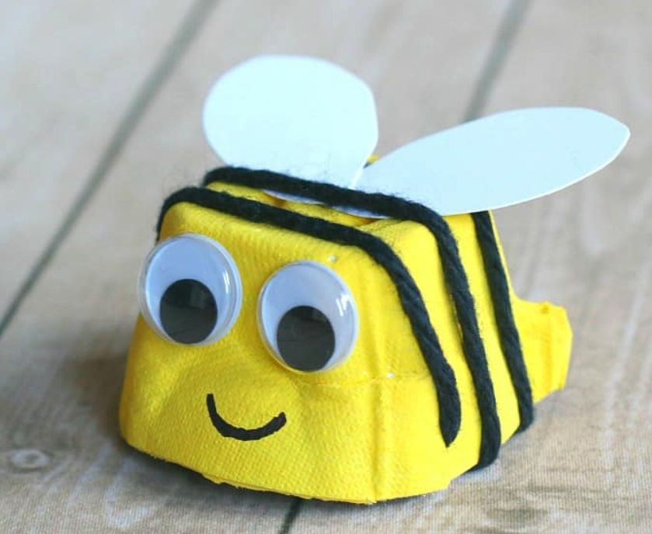
Activity Four
1. Paint one section of an egg box with yellow paint.
2. Make a small snip in the bottom, front edge of your painted egg carton. Slip one end of a piece of black wool into the slit.
3. Wrap the black wool around your yellow bee body. Make another small slit on the opposite, back end of your bee body. Slip the end of your wool into the slit to hold it in place. Cut off any extra wool.
4. Draw on a face or stick on googly eyes.
5. Cut out and stick on some wings from cardboard.

Activity Five
Making honey… use yellow coloured soap flakes or shaving foam to pretend to be honey, add spoons and plastic jars, funnels to be the honey station.
Have fun filling up some jars.
Activity Six
Use string dipped in yellow and black paint,
wriggle and squiggle it across some paper to make patterns.
Activity Seven
Play the flight of the bumble bee.

Flight of the Bumblebee - Rimsky-Korsakov

https://www.youtube.com/watch?v=aYAJopwEYv8
Then roll out big rolls of paper and give pencils and other writing tools such as chalk for the children to free draw to the music.
Can extend to painting to music as well.
Activity Eight
Yoga Enzo the bee
https://www.youtube.com/watch?v=uyj5LooYWyg
Activity Nine
Just dance it’s all about the bass
https://www.youtube.com/watch?v=OE65JfLWTbo
Just Dance what did the fox say?
https://www.youtube.com/watch?v=drWHI-l_Gew
Activity Ten
Make honey biscuits see separate recipe.

Activity Eleven
Make a jam or honey sandwich and use the sheet to order how to do it.
Extra maths challenge
Make the sandwich into 2 rectangles, then 4 squares, then 8 triangles.

Songs to sing
The Bee
https://www.youtube.com/watch?v=A2skW43HNpE
The Bees go buzzing
https://www.youtube.com/watch?v=bWUgZm_AE64
Our Bee Song
https://www.youtube.com/watch?v=oST_t2XaBaY
Bee Song
https://www.youtube.com/watch?v=HwnoLGkmglE
Five Little Bees
https://www.youtube.com/watch?v=CZP_rr1FhoQ

