Week 2 Mini Beasts
Understanding the World
Activity 1
Watch the power point about snails and slugs
https://www.twinkl.co.uk/resource/t-t-27019-all-about-slugs-and-snails-eyfs-information-powerpoint
Model writing some facts.
A snail has a shell.
A snail has eyes on sticks.
A snail leaves slime behind.
Children to write some facts about snails on any paper or on the snail sheet provided.

Activity 2
Go outside at night time or early morning and try and catch a snail.
Either keep it in a box with holes in the lid and some of the leaves that you found the snail on or make a snailery. See link to instructions.
https://www.twinkl.co.uk/resource/roi-sc-49-making-a-snailery-instructions-activity
Fill out the booklet about snails provided or draw a picture and write about your snail.
Activity 3
Go on a mini beast hunt use the tick sheet by following the link below or take some photos of as many mini beasts that you can find.

https://www.twinkl.co.uk/resource/T-T-019-Minibeast-hunt-sheet

Activity 4
Watch the power point about snails
https://www.twinkl.co.uk/resource/t-sc-270-snails-powerpoint
There are some photos and fact cards to print off if you desire.
https://www.twinkl.co.uk/resource/t-t-27016-slugs-and-snails-photo-pack
Activity 5
There is a cebeebies programme about snails to watch
Cebeebies snail programme
https://www.youtube.com/watch?v=a0Q-zFLAvPE

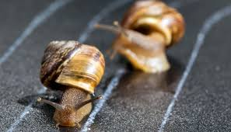
Activity 6
If you find a few snails you could draw a track with chalk outside and have a snail race. Watch how they slither along and leave the slime.

Activity 7
Once you have learnt about snails from the powerpoints.
Have a go at labelling the snail picture provided.
Label the mouth, foot, eyes, tentacles, shell

