Hello Year 3,
Over the past few weeks, you have all done a brilliant job at becoming curious scientists. We have been so impressed with the investigations and experiments you have created ensuring you have created a fair test, predicting what might happen and evaluating the result.
This week we are moving onto our new topic ‘extreme weather’. This topic requires you to become analytical geographers which means you will be identifying patterns and trends. To introduce our new topic please have a look through the extreme weather PowerPoint which can be found on the year 3 page. After you have done this, please choose the activities you wish to complete from the extreme weather choices grid. The grid has a points system which you might recognise these from past homework tasks. This week we ask that you chose any number of tasks that equate to 100 points. We would love to see and hear how you get on so please continue to send pictures and updates.

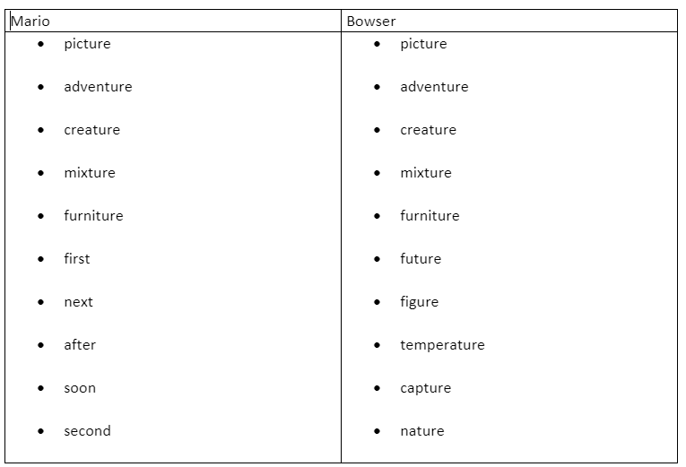
Spelling: Tactic 21- words ending in ‘ture’ and keywords.

Click-Spellzone- to find the wordlist and some games to play. Test yourself to see how many you can spell correctly. Try and use each word in a sentence.
At the bottom of the document we have also included some spelling worksheets. These will help you practice some Year 3 common exception words.

P.E:
We hope that last week you managed to get involved with some of the activities for National School Sport Week. This week we would like you to have a go at one of the Notts School Games Organisers weekly PE ideas and activities. Follow the link to see what this week’s activity is and enjoy taking part. https://www.abbeyroadprimary.co.uk/weekly-pe-skills-physical-activity-and-competitions/

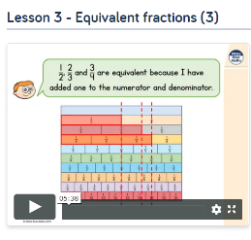
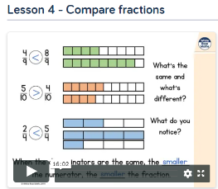
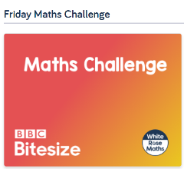
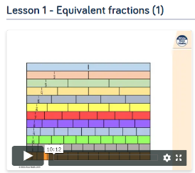
Maths:
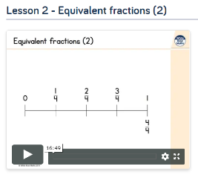
This week we will be focusing on equivalent fractions and comparing fractions. First, have a look at the work you completed last week and recap what you have already learned. This week, we would like you to focus on ‘Summer Term Week 7 w/c 8th June’- lessons 1, 2, 3, 4. Please watch the video and complete the activities. If you are feeling extra confident you could have a go at the ‘Friday Maths Challenge’.
https://whiterosemaths.com/homelearning/year-3/
We have uploaded the worksheets separately and can be found on the Year 3 page along with the learning letter.
White Rose Maths have started repeating some blocks for the children who may have missed them during home learning. If you have already completed this and you feel your child does not need to recap fractions there is an alternative plan focusing on recapping length. It is your choice which week 7 learning your child does, whichever you feel would benefit them the most. Below is the link to the alternative videos and the worksheets/answers have been uploaded to our page on the website.https://wrm-13b48.kxcdn.com/wp-content/uploads/2020/06/Y3-Week-7-Alternative-Plan.pdf

Extreme Weather Choosing Grid
Please choose activities to make up to 100 points.
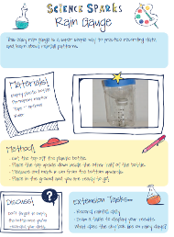  A rain gauge is an instrument used by meteorologists and hydrologists to measure precipitation (e.g. rain, snow, hail or sleet) in a certain amount of time. It usually measures in millimetres. Using the instructions that can be found at the bottom of the document, have a go at making your own rain gauge. Place your creation in a suitable place and record the amount of rain in the bottle/jar each day and empty out the rain each time. Once you have completed your experiment create a table to record your results.  (35 points) | 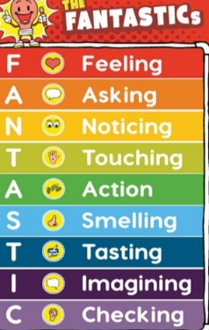  Chose an extreme weather event it could be a flood, hurricane, blizzard or hailstorm. Research what it might be like to experience your chosen weather event. Then imagine you have woken up one day and lived through it yourself. Write a diary extract of your experiences. Remember to use your FANTASTICS to describe what you might see, hear, feel and smell.  (40 points)
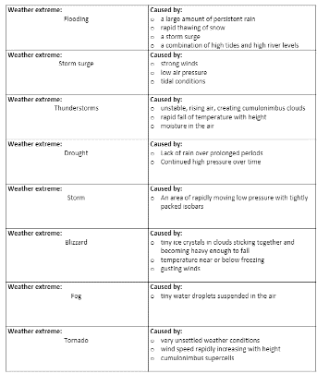  Match the extreme weather event to the correct definition. Complete the ‘Extreme Weather Definitions’ worksheet This can be found at the bottom of the document.  (20 points) | Research and create a glossary for the following words:  Extreme weather event, Tsunami, blizzard, flood, snowstorm, climate change, weather pattern, drought, tornado.  (20 points)
Create a detailed and accurate drawing/ painting of an extreme weather event. Think carefully about the types of things that might occur in this event.  (30 points) | Make a Tornado in a jar. Follow the instructions at the bottom of the document and create your very own tornado. Observe what happens carefully and discuss with a friend or family member what you have noticed.  (25 points)
In the PowerPoint, we introduced the Tempest Database. This database allows us to look back at past extreme weather events. Visit the database by following this link-  https://www.nottingham.ac.uk/geography/extreme-weather/search/  Have a go at searching and exploring the different extreme weather events and the impacts they had. You could do this by typing in a year, type of weather event or a place you wish to find out about.  (25 points) | Write and then decorate an Extreme Weather poem. At the bottom of the document, we have included some examples. Think carefully about the vocabulary you use and the layout of your poem.  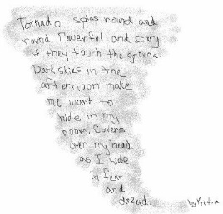  (40 points)
Become a reporter and write your own newspaper article reporting an extreme weather event. Watch the clip to help you think about how to write in the style of a newspaper article.  https://www.bbc.co.uk/bitesize/topics/zkgcwmn/articles/zbsbwty  Think carefully about using formal language and technical vocabulary just like a real newspaper article. You can create your own layout or use the template we have provided.  You could write about the extreme rain we had in February this year which lead to flooding in Nottingham.  In your article you must include; The date, location, the name of the type of weather event, A description of what happened and of some of the impacts.  (40 points) | 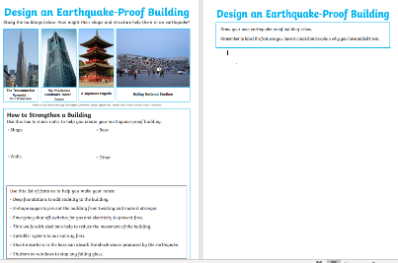  Design an earthquake-proof building. Using the worksheets provided, think carefully about the shape and structure you would want your building to have.  (35 points)

Reading Comprehension-
Over the past few weeks, you have all done a brilliant job at becoming scientists. You have discovered lots about how plants grown and created/participated in some very inventive experiments. We have now finished our plants topic, but we thought it would be nice to end it with a newspaper article all about scientists creating ‘glowing plants’.
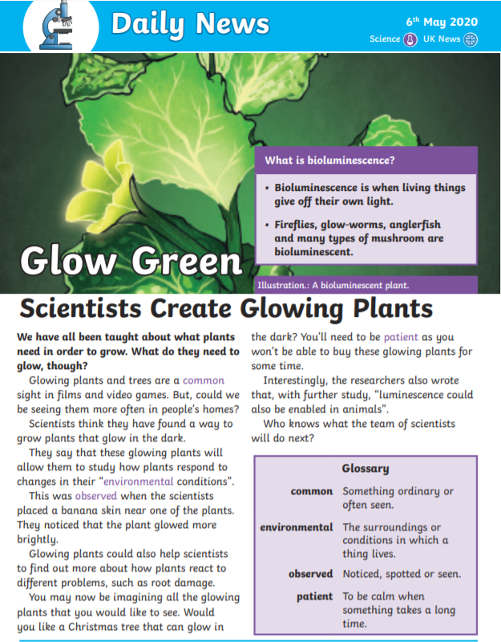
Scientist Create Glowing Plants- Questions

1. What does bioluminescence mean?
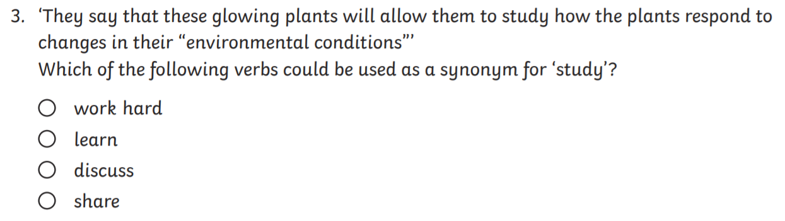
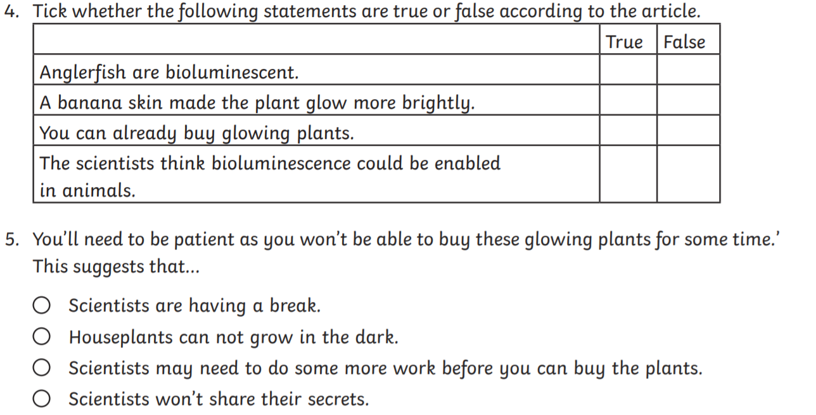
6. What might the scientists do next?

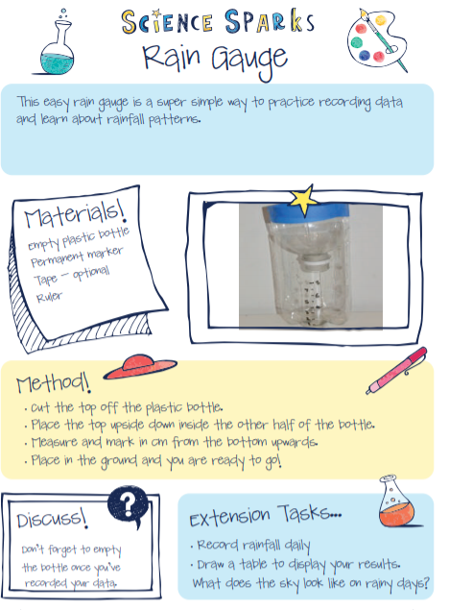

Make a tornado in a jar

Make your own tornado in a jar.

What you will need:
- A clear jam jar or similar see-through container with a screw-on lid
- Washing-up liquid or liquid soap
- Food colouring

What to do:
Fill up the container with water then add a few drops of the washing-up liquid and a few drops of the food colouring. Tightly screw on the lid.
Swirl the container around in a circle lots of times and then stop. Inside you should see what looks like a tornado. It will slowly disappear as it reaches the top of the container.
Tornadoes in the real world are made in a similar way, when cold and warm air combine and spin.

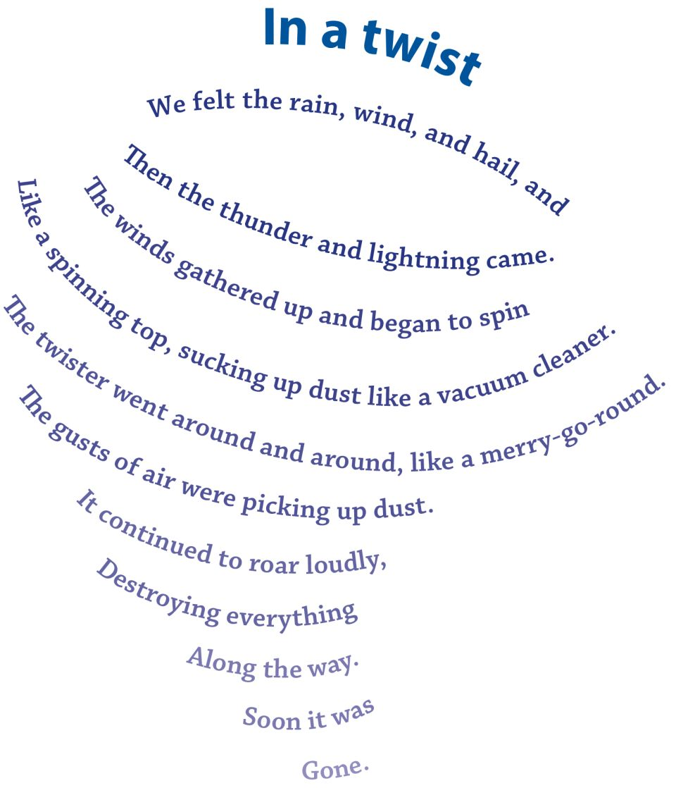
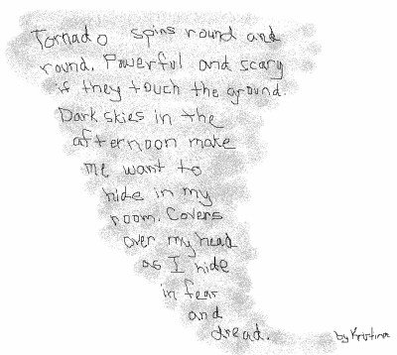
Examples of extreme weather poems

“The Storm” by Jaymie Gerard
Before the storm
The sky turns gray
The clouds roll in
The sun tucks away

During the storm
The strong wind blows
The sky is wild
The rainwater flows

After the storm
The clouds say “adieu”
The sun peeks back out
The sky turns to blue

Newspaper template-
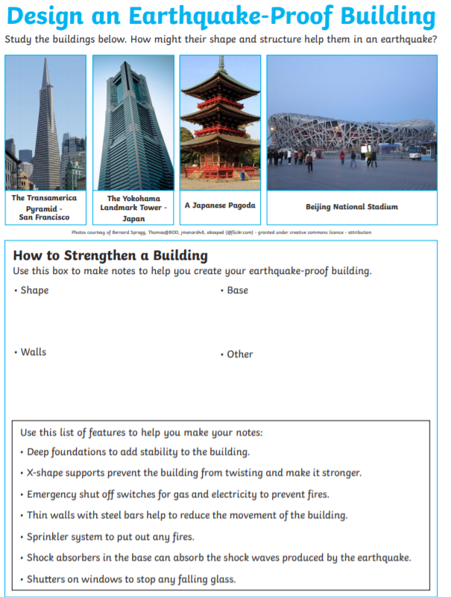

Match Extreme Weather Definitions
Weather extreme:  Flooding | Caused by:  - a large amount of persistent rain  - rapid thawing of snow  - a storm surge  - a combination of high tides and high river levels
Weather extreme:  Storm surge | Caused by:  - strong winds  - low air pressure  - tidal conditions
Weather extreme:  Thunderstorms | Caused by:  - unstable, rising air, creating cumulonimbus clouds  - rapid fall of temperature with height  - moisture in the air
Weather extreme:  Drought | Caused by:  - Lack of rain over prolonged periods  - Continued high pressure over time
Weather extreme:  Storm | Caused by:  - An area of rapidly moving low pressure with tightly packed isobars
Weather extreme:  Blizzard | Caused by:  - tiny ice crystals in clouds sticking together and becoming heavy enough to fall  - temperature near or below freezing  - gusting winds
Weather extreme:  Fog | Caused by:  - tiny water droplets suspended in the air
Weather extreme:  Tornado | Caused by:  - very unsettled weather conditions  - wind speed rapidly increasing with height  - cumulonimbus supercells
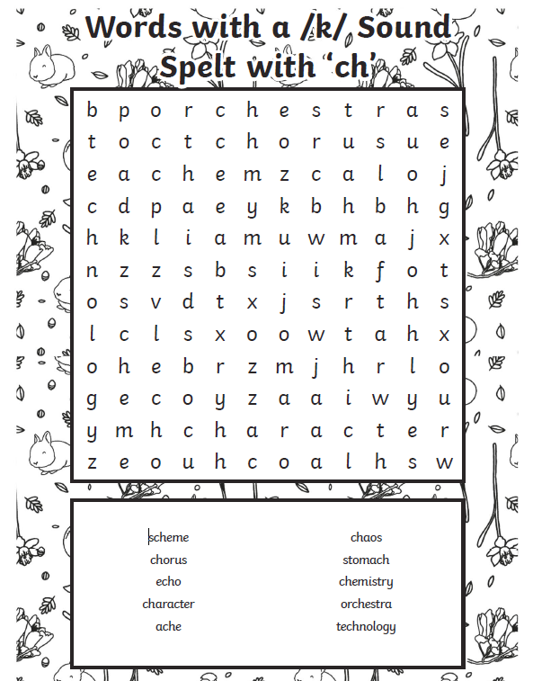
Common exception spellings worksheets-
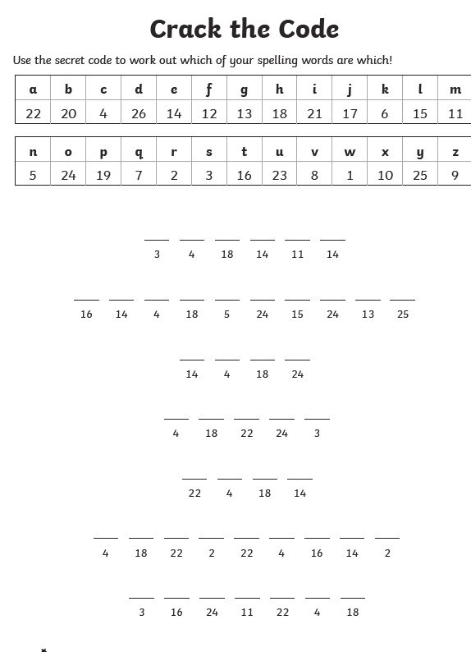
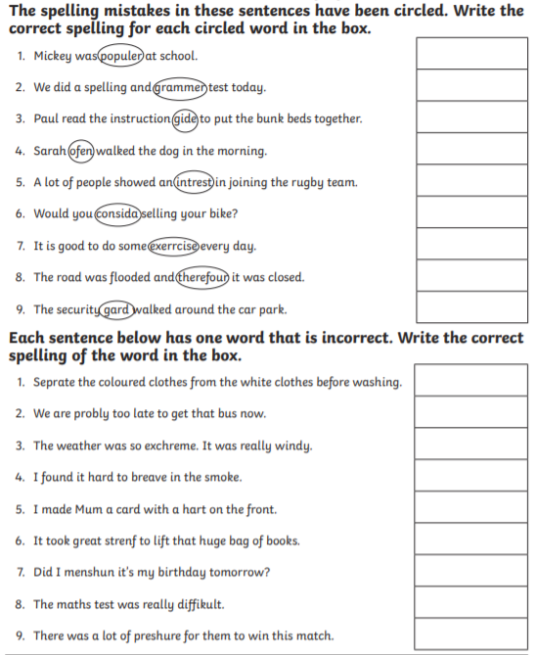
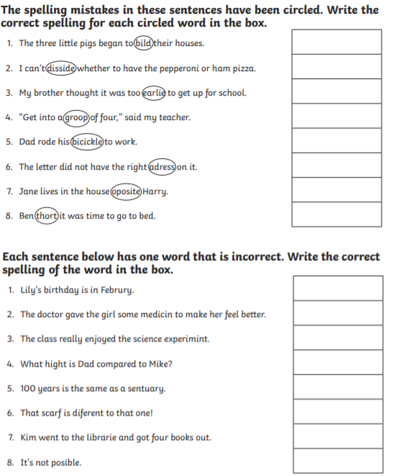

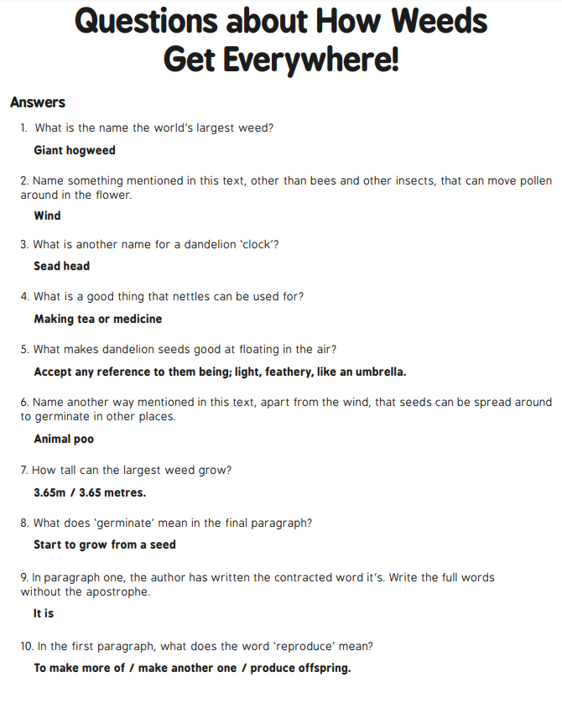
Last week’s answers:

Pollination answers
The flower ___petal’s________ bright colours and fragrant scents attract the insect.
The insect arrives on the flower to collect ____nectar_____________. This is a sweet liquid which makes perfect insect food.
As the insect is gathering the nectar it rubs against the ____stamen_____________ which rub pollen onto the insect.
When the insect gets hungry again, it gets attracted to another flower’s bright colours and fragrant scent.
As the insect feeds on the nectar in this new flower, the ___pollen___________ stuck to the insect from the first flower rubs off onto the female parts of the second flower (the __stigma________________).
Part of this pollen travels down the style and then into the ___ovary____________.
The tiny piece of pollen joins onto an ______egg_____________ in the ovary. The plant has now been fertilised.
The ovary of the flower turns into ____seeds_________________ which will then be __dispersed__
so that new plants will be able to grow somewhere else.

We do hope you enjoy these activities. Try setting yourself the target of finishing a maths and at least one another activity each day. If you have any questions or photos, please do send them to us!
Work hard, play hard and most of all stay happy and safe!
Mrs Seagrave, Mrs Horton and Miss Moore

