Hello Year 3,
We hope you are all ok. Thank you for all of your emails and pictures. It is lovely to see what you have been getting up to and also helps us feel more connected to you too.
This week, we are continuing our science theme and are beginning to look at plants and flowers for the rest of the term. If you have any questions or queries, please do not hesitate to contact us via e-mail. We will get back to you as soon as we can.
We hope your children are enjoying seeing some familiar faces in the home learning tasks. Miss Moore has also recorded the next two chapters of ‘The Boy Who Grew Dragons’. https://youtu.be/1EmnuxPrl2Y
Thank you to those of you who joined in with our ‘Pass It On Challenge’ it really was brilliant to see so many smiling faces. We hope you enjoy watching it as much as we have. If you haven’t already seen the video you can click this link to watch- https://youtu.be/FtopvzGc0VU
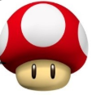
This week’s learning tasks:
Spelling:
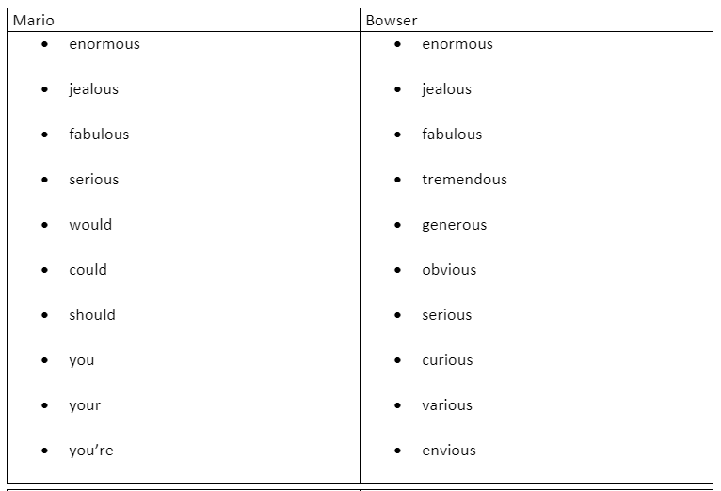
Tactic: 19 The suffix ‘ous’- and keywords
Click - Spellzone- to find the wordlist and some games to play. Test yourself to see how many you can spell correctly. Try and use each word in a sentence

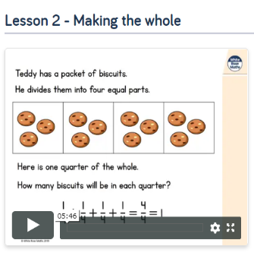
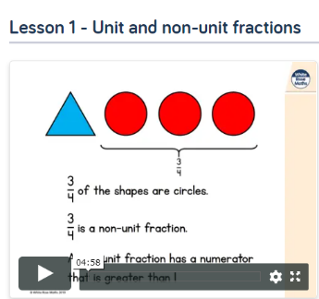
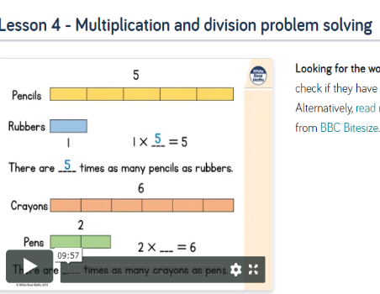
Maths:

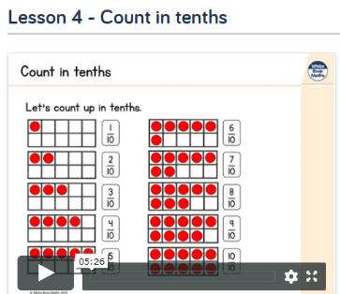
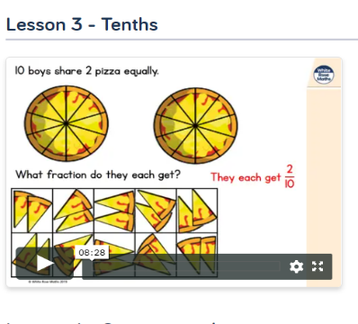

This week we will be focusing on recapping our learning of multiplying and dividing. We will then be moving on to unit and non- unit fractions. First, have a look at the work you completed last week and recap what you have already learned. This week, we would like you to focus on ‘ ‘Summer Term Week 4 w/c 11th May’- lessons 4. Also ‘Summer Term Week 5 w/c 18th May’ lesson 1,2,3 and 4. Please watch the video and complete the activities. If you are feeling extra confident you could have a go at the ‘Friday Maths Challenge’ found at the bottom of the page.
As mentioned last week the website has stopped posting the worksheets for you to access on their website. We will upload the worksheets separately and can be found on the Year 3 page along with the learning letter.
https://whiterosemaths.com/homelearning/year-3/
This week the White Rose website is having a recap week and have set the same videos and tasks from the first week of our maths home learning. If you feel your child does not need to recap fractions there is an alternative plan focusing on recapping addition and subtraction. It is your choice which week 5 learning your child does, whichever you feel would benefit them the most. Below is the link to the alternative videos and the worksheets/answers have been uploaded to our page on the website.
https://wrm-13b48.kxcdn.com/wp-content/uploads/2020/05/Y3-Week-5-Alternative-Plan.pdf

P.E:
Notts School Games Organisers are publishing weekly PE ideas which we would like all the children to have a go at. We hope you enjoyed last week’s activities and virtual competition. Follow the link to see what this week’s activity is and enjoy taking part. https://www.abbeyroadprimary.co.uk/weekly-pe-skills-physical-activity-and-competitions/

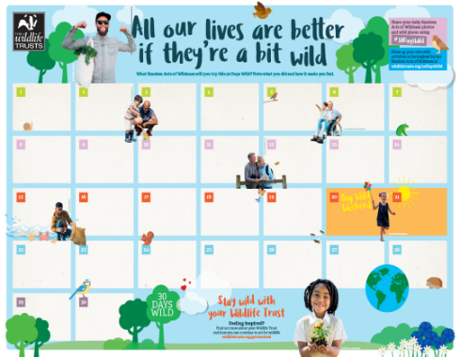
Forest School:
We hope you are enjoying taking part in the 30 days wild event. We would love to know how you are getting on and if you have had any different or exciting ideas. Please don’t forget to fill in your wild activities on your calendar and send pictures to Mrs Horton. Remember on the website, we have included some ideas and inspiration for the activities as well as the calendar for you to print out and fill in. Aim to do something ‘wild’ every day in June.

Art:
We have been so impressed with the flower drawings that lots of you have sent to us. As you seemed to enjoy this task, we are setting you another drawing task. We would like you to recap last weeks learning about the different parts of a plant by producing a folding surprise plant drawing. Watch the clip and carefully follow the steps. We would love to see your results!
https://www.youtube.com/watch?v=_J_9aZ75vM8 –
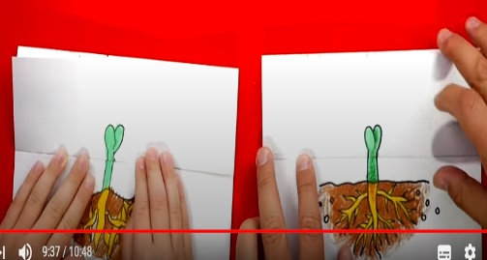
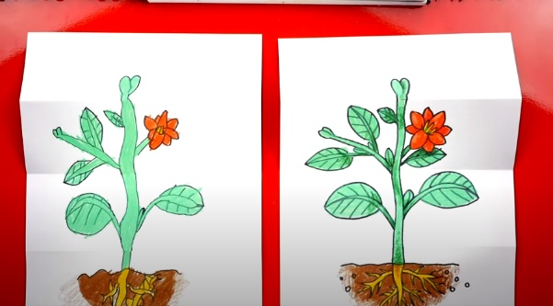

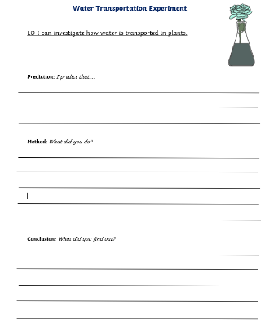
Science:
Water Transportation: This week we are learning that the stem transports water and minerals from the roots to the other parts of the plant. We are aiming to teach this by doing an experiment. For this you will need food colouring, 3 of the same plant/flower and a jar. You will also need the ‘Water Transportation Experiment’ worksheet that can be found at the bottom of the document and access to the PowerPoint ‘Water Transportation’ which can be found on the website. We would love to see photos of your experiments and your results to let us know how you got on!
Pollination:
Using the PowerPoint which can be found on the Year 3 page on the website we are learning to understand the importance of insects in pollination and that pollen is produced by flowers and is the key to pollination. Please read the slides and have a go at completing the ‘Pollination Process’ worksheet which can be found at the bottom of the document.
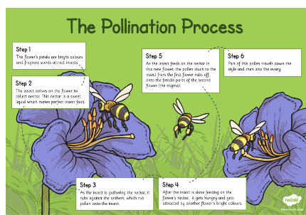
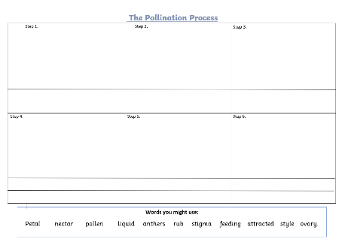

ICT:
It is estimated that a third of all the food we eat each day comes as a result of pollination from bees and other insects. Pollination is when pollen from flowering plants is taken to other plants so that seeds (and therefore new plants) can grow. For many different reasons, around one in ten of Europe’s native bee population is in danger of extinction.
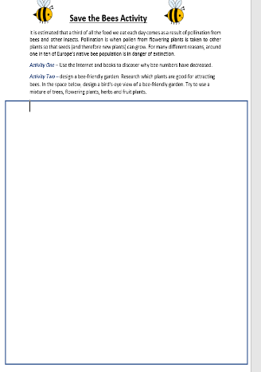
Activity One – Use the Internet and books to discover why bee numbers have decreased.
Activity Two – Using the worksheet which can be found at the bottom of the document design and label bee-friendly garden. Research which plants are good for attracting bees. In the space below, design a bird’s-eye view of a bee-friendly garden. Try to use a mixture of trees, flowering plants, herbs and fruit plants

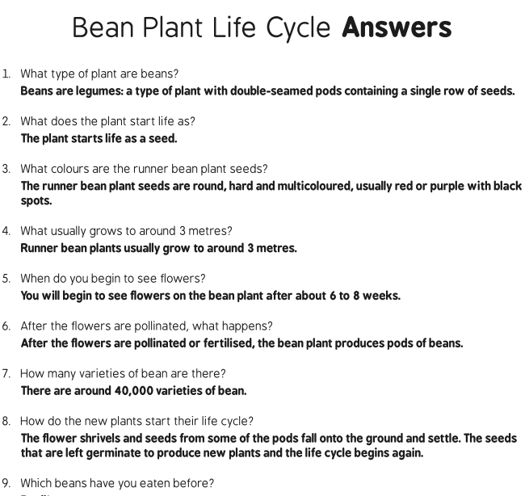
Reading comprehension:

Examples could be runner beans, baked beans, black beans, green beans, French beans, coffee beans, cocoa beans, haricot beans, soy beans, kidney beans, flageolet beans, cannellini beans, mung beans, black eyed beans.

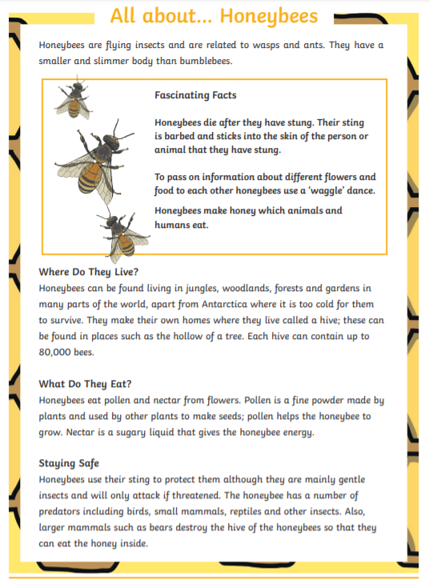
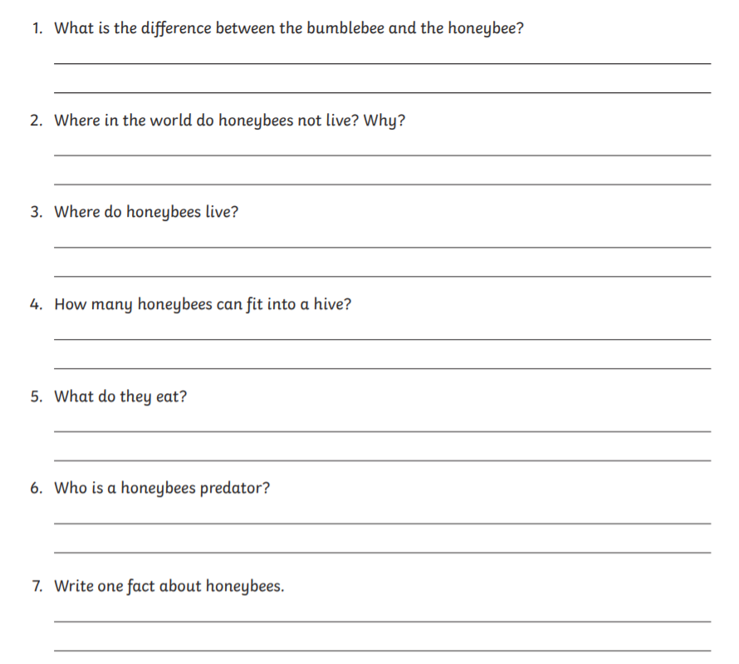
We really do hope you enjoy these activities. Try setting yourself the target of finishing a maths and at least one another activity each day. If you have any questions or photos, please do send them to us!
Work hard, play hard and most of all stay happy and safe!
Love Mrs Seagrave, Mrs Horton and Miss Moore.
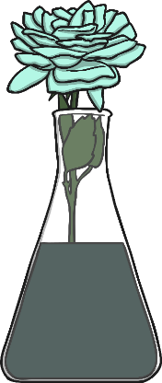
Water Transportation Experiment
LO I can investigate how water is transported in plants.

Prediction: I predict that….

Method: What did you do?

Conclusion: What did you find out?

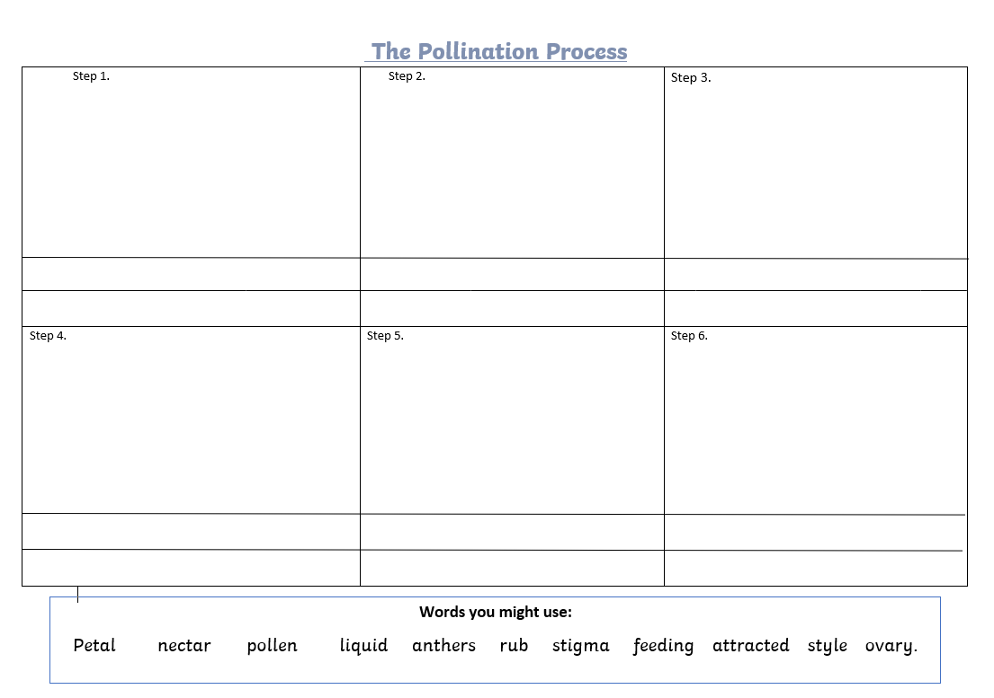
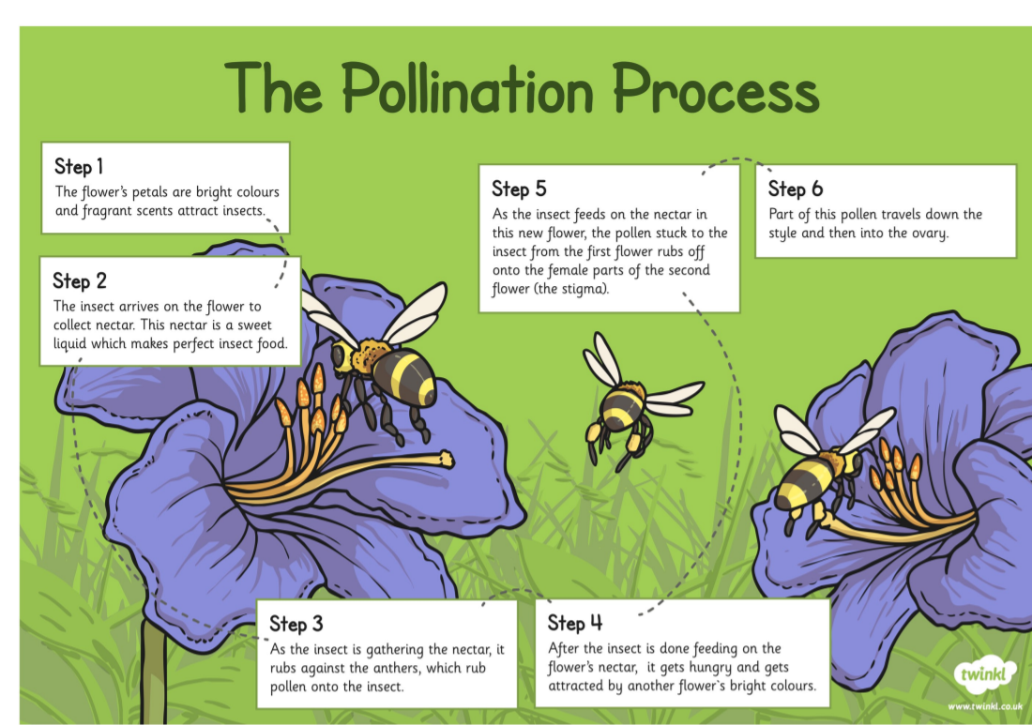

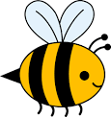
Save the Bees Activity
It is estimated that a third of all the food we eat each day comes as a result of pollination from bees and other insects. Pollination is when pollen from flowering plants is taken to other plants so that seeds (and therefore new plants) can grow. For many different reasons, around one in ten of Europe’s native bee population is in danger of extinction.
Activity One – Use the Internet and books to discover why bee numbers have decreased.
Activity Two – design a bee-friendly garden. Research which plants are good for attracting bees. In the space below, design a bird’s-eye view of a bee-friendly garden. Try to use a mixture of trees, flowering plants, herbs and fruit plants.

