Literacy Week 3 Lego History
Activity 1
Rather than a reading comprehension we are going to do a comprehension linked to a really interesting mini film about how Lego began – it’s a super cool film so you might want to sit down as a family to watch it! (Mrs Boughton made all her family watch it!)
https://www.literacyshed.com/legostory.html
Once you have finished it, try to answer these questions. You can write your answers in your book.
- What material did Ole initially use to make toys?
- What happened to his first factory?
- Why did Ole get cross with his son Godfred about varnishing ducks?
- How did Godfred manage to make the bricks stronger?
- What transport gave Godfred the idea of building a Legoland?
After this activity I imagine you will all want to play with your lego – see if you can build something really amazing! You could also think of some interesting and appropriate adjectives to go with your Lego model.
Activity 2
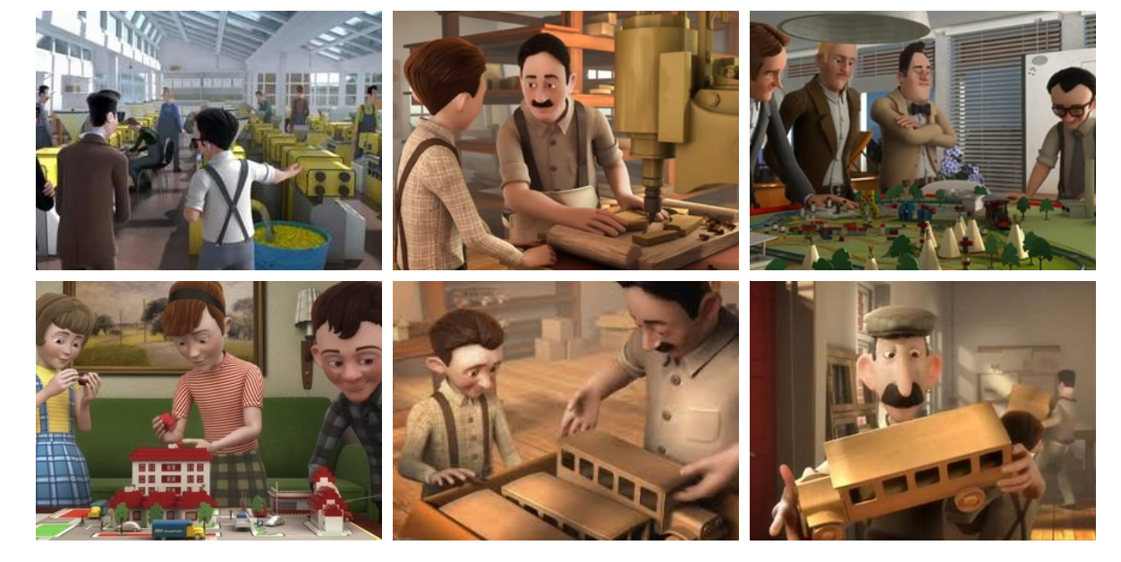
Look at these pictures from the video story. Can you cut them out and stick them in your book in the order they happened? Try to write a sentence to go with each picture, remember to start with a capital and finish with a full stop.
Activity 3
Can you design an advert for a toy you own?
This could be Lego, or it could be an LOL doll, a Spiderman toy, a My Little Pony, a train set.... anything you choose. You will need to draw a good picture of it and write some sentences about how great it is. Try to persuade the reader that this toy is really brilliant. You could also make up a price for it – is it going to be expensive? Where can you buy it from? Does it come in any different colours?
You could look online (with a grown up) at some adverts for other toys to give you ideas.

Activity 4
Spellings ‘oa’ sound
Circles : boat soap road coat Triangles: toast float coast groaned coach throat
Firstly do some practice with look, say, cover, write, check.
Can you remember in Phonics the ‘oa’ sound – Goat in a boat!
Circles can you write the correct word under each picture?
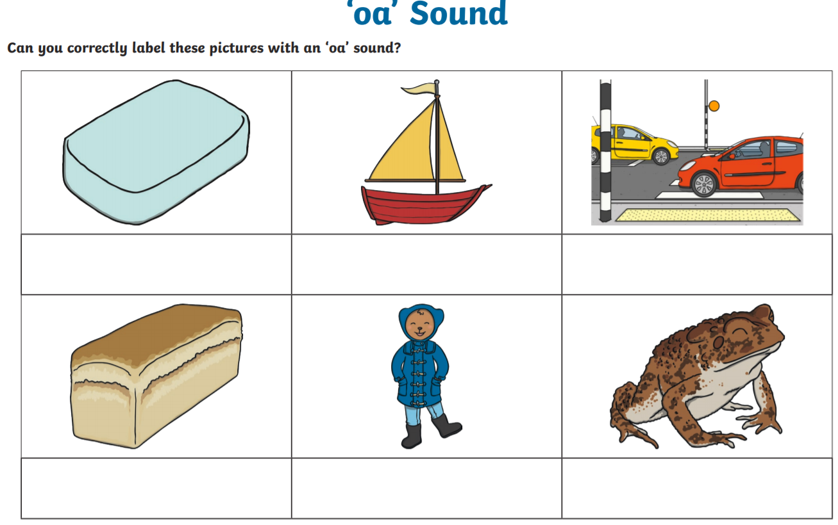
Triangles
Write your spellings on a piece of paper or card – you could write them in bright colours! Then ask a grown up or sibling to help you. They have to hide the words in your garden or bedroom, then play a game where you try to find them. The hider can say hot / cold when you are near them. Once you find the word you have to read it and write it in the air with your finger – then you get to win the word! Repeat the game a couple of times – can you win all the words?

Activity 5
Reading comprehension. Read the Information about Big Ben then try to answer these questions in your book.
Remember to write in a full sentence with a capital to start!
Then you can do a super drawing of Big Ben.

- What actually is Big Ben?

- What happened to the old Big Ben?
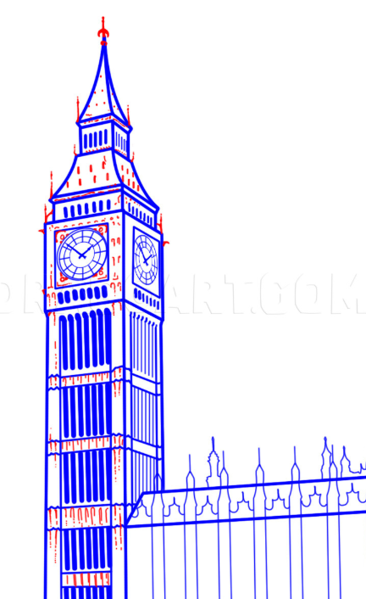
- What happened to the hands of Big Ben in 1962?

- Why do the cleaners of the clock have to wear harnesses?

- Have you ever been to see Big Ben? If so,what was it like? If not, would you like to? Can you write three adjectives to describe Big Ben.

