Learning Challenge Topic Work w/c/ 8.6.20

Activity 1

We are starting to look at buildings in Nottingham. Can you think of some buildings in Nottingham? Tell your grown up what you know already. There are some famous (well known) buildings in Nottingham, do you recognise them? Have you visited any of them?

*Which do you think is the oldest building? Most recent building? Give reasons why.*

*Discuss key features / similarities and differences : size , pillars ,building materials, shapes of windows*

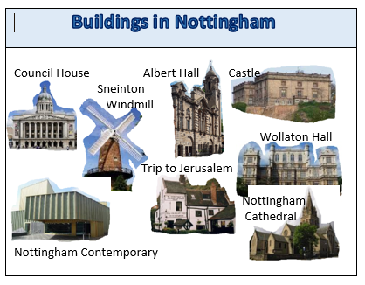

Have a look at the information below and see if you can put the buildings in order starting with the oldest.

Ask a grown up to draw a long line in your book so you can either draw the buildings on the timeline or print them and cut them out.

Albert Hall 1908

Council House 1929

Nottingham Castle 1878

Sneinton windmill 1807

Trip to Jerusalem 1189

Theatre Royal 1865

Wollaton Hall 1588

Nottingham Contemporary 2009

You could look online with a grown up at images of the building that you like the best / least!

**Activity 2**

PSHE – over the last few months you have all been super brave at putting on a smile (we have seen lovely photos!) and making the most of what you have. So we would say you have shown ‘courage’. Thinking about courage, what would you say has given you courage? If you had to be brave again – what helps you? Have a chat and a think about courage and bravery. When have you seen someone have courage in a story? What helped them? Try and make a courage recipe in this jar...

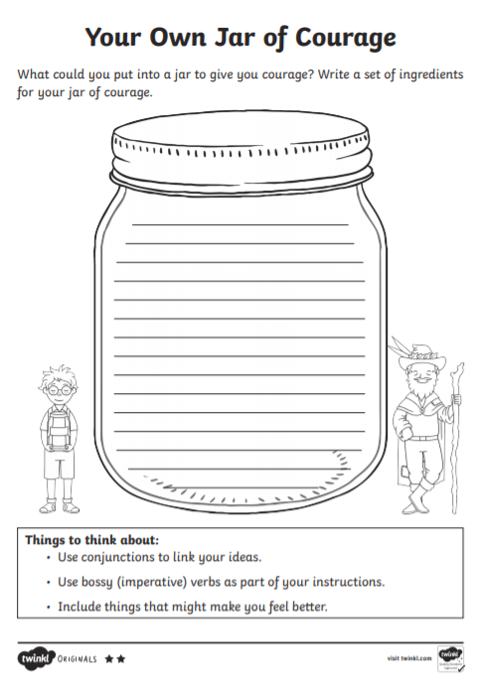

**Activity 3**

In Nottingham we are very lucky to have two well-known theatres – have you visited the Theatre Royal? We visited the other one – the Playhouse, just before Christmas – when we saw Pinocchio – can you remember?

Look at these two buildings:

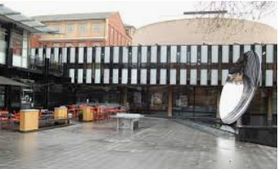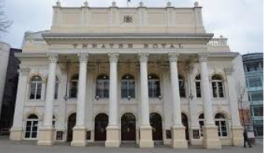

The Theatre Royal Nottingham Playhouse

Which do you like best? Why? Try to read this information about the theatres (ask a grown up to read it with you)

The Theatre Royal was built in 1865. It is a grand white building with six tall towers at the front. The front looks symmetrical (see if you can tell your grown up what this means) and it has doorways with arches. Inside 1186 people can sit to watch a show!

Nottingham Playhouse was built in 1963. It has a big round circular structure coming out of its flat roof. It has big glass windows and rectangular panel walls. There is a large round mirror outside. It can sit 770 people to watch a show.

In your book try and draw a picture of the Theatre Royal and write 3 facts underneath, then draw Nottingham Playhouse and write 3 facts underneath. You can take your facts from the text above or find your own online with help from a grown up.

**Activity 4 (see pdf emotion sentence starters)**

Cut up the emotion sentence starters – or write them on post it notes. Sit down with your family. Take if in turns to turn over a sentence starter. Read it out and complete the sentence.

After all the sentences have been used pick 2 to write and draw in your book, you could choose ones you have said or someone else in your family.

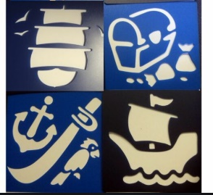**Activity 5**

**Art – making a stencil**

Stencils are great to use as you can use a

Stencil lots of times and it will make the

Same shape. These pirate stencils work by colouring or drawing the gap inside.

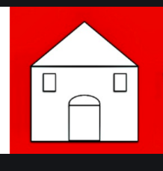We are going to have a go at making a stencil of a building. You will need a piece of card – not too think – maybe the side of a cereal box. Draw on it a simple shape, you might want to do some basic shapes to practise – like a square or a heart. Then put a blob of blue tack underneath and press through with a pencil to make a hole. You can now cut out your shape. Then using chalk, felt tips or paint you can make a repeating pattern of your shape. You might like to try a simple house shape:

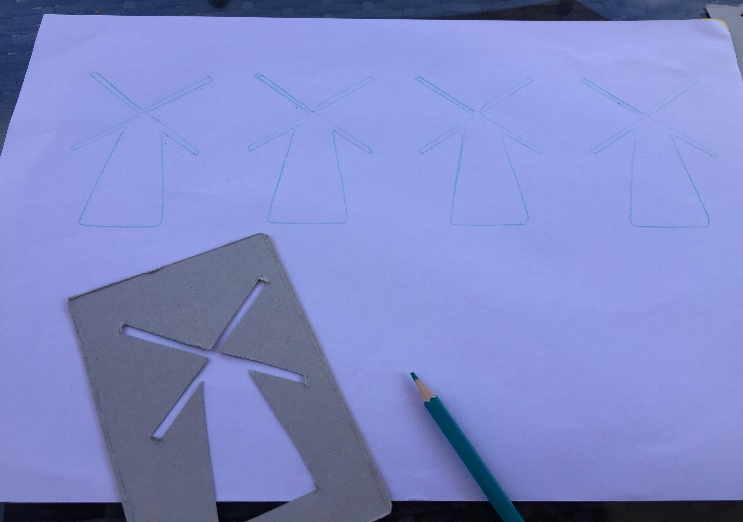Or challenge yourself to make a shape representing one of the buildings we have looked at – one of the theatres, Albert Hall, Nottingham castle, Sneinton Windmill etc.

Mrs B had a go...can you guess what building her stencil is supposed to be?