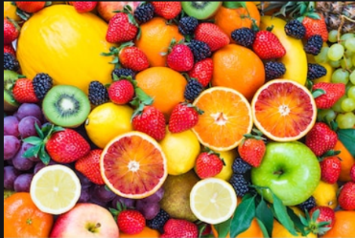
Dear Parents/ Carers
I hope you all enjoyed learning about bees last week, it has been lovely to finally be back in school and see the children enjoying their learning so much.
I have really missed them all, and it has been amazing to see how well they have adapted to the new routines. They were able to show me what to do and not do!
This week we are having a Healthy Week, basing our learning around the book Oliver’s Fruit.
The White Rose Math’s activities have some lovely learning based around the same book.

Please make sure you keep doing Rosie’s Phonics each day, that way you will not miss any sounds. We are also doing Rosie at school to keep the continuity.
Watch phonics with Rosie and practise writing the sound and words.
9.30 Phonics Set 1 - this is good for revision of individual letter sounds learnt.
10.00 Phonics Set 2 - this is for the special friends phonemes.
10.30 Phonics Set 3 - split digraphs and alternative ways to write sounds.
https://www.youtube.com/channel/UCo7fbLgY2oA_cFCIg9GdxtQ

I was really impressed with the children’s phonic knowledge and I think they were pleased not to have Rosie for a change!

Dot and Dan have got masks on this week as they wait at the bus stop. I think the locals think that I am crazy!

https://youtu.be/D9P13ZkHswg

We are trying to do some exercise challenges every day at school, see if you can do the same at home.
Have fun getting fit and healthy.
Kind regards,
Mrs Simister

Week 6 Summer Term

