List of music for kitchen

Disco

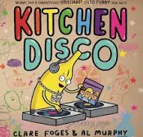

1st_________________2nd_________________3rd_________________4th_________________5th________________________________________________________________________________________________________________________

List of music for kitchen

Disco



1st_________________2nd_________________3rd_________________4th_________________5th_______________________________________________________________________________________________________________________________________________________