Creative week 6 and 7
The Gruffalo

Activity One
Follow the video to draw a step by step drawing of a Gruffalo
https://www.youtube.com/watch?v=5HmWS5PEHJM

Activity Two
Use some old kitchen and toilet roll tubes to get creative and make the characters from the story. Colour a paint a background on the back of a cardboard box and retell the story or make up your own version.
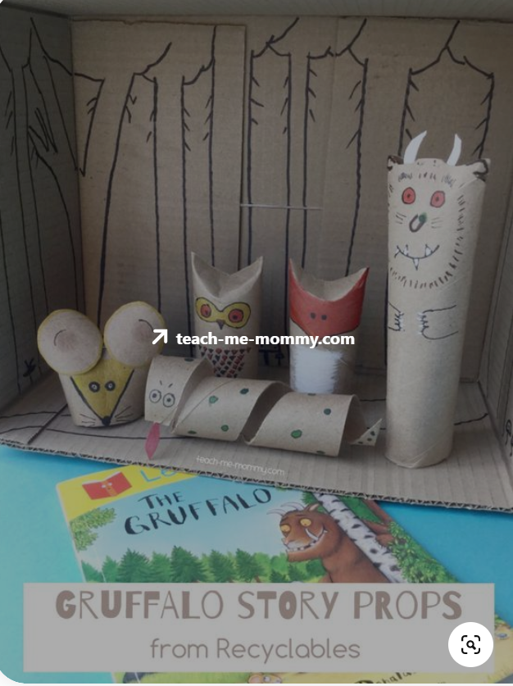

Activity Three
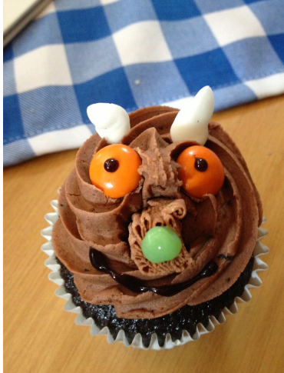
Make some cupcakes and decorate them like The Gruffalo. Pipe on some chocolate icing and use smarties and a black icing pen to make his face. Yummy!

Activity Four
Use the sheet provided or a piece of paper to draw your own creature.
Think about his size, his colour, how does he feel? How can you make him look scary? What expression will he have on his face?
Activity Five
Use the masks or head bands provide or make your own masks and retell the story of The Gruffalo.
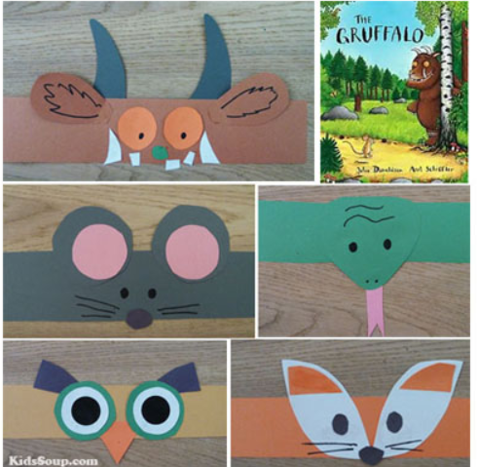

Activity Six
Print out the Story Telling Wheel and move it around to tell the story.

Activity Seven
Use two paper plates and some brown paint.
Paint the plates first and let them dry, then fold one in half for the body.
Use the second plate to make the triangle face and ears, rectangle legs and bushy tail.
If you have googly eyes and a pompom for the nose and eyes that’s great, otherwise use felt tip pens to decorate.
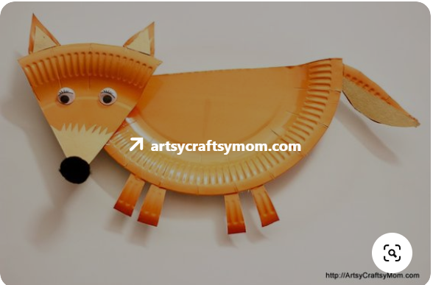

Activity Eight
Yoga The Gruffalo
https://www.youtube.com/watch?v=MtwPjwtZUZo

Cosmic yoga sadly only have The Gruffalo if you have the app
Here is a pre view
https://www.youtube.com/watch?v=EOHZgKgjhhY
There is a good dinosaur one though
Cosmic Yoga – Tiny T-Rex
https://www.youtube.com/watch?v=rnlDBKD2S78

Activity Nine
Use the recipe provided to make a Gruffalo crumble.
Write down how you made it using any paper or the writing frame provided.

Songs to sing this week
The Gruffalo song
https://www.youtube.com/watch?v=5ZfEIX2lhlI

The song Book of The Gruffalo
https://www.youtube.com/watch?v=cYbU7mnWoAg

10 Little Dinosaurs
https://www.youtube.com/watch?v=TjmGTbNLj6Q

The Dinosaur Song
https://www.youtube.com/watch?v=W0FOZ0-VpcU
The Monster Stomp
https://www.youtube.com/watch?v=_tuKpJy9484

