Paper Fans
What you will need:
- 2 sheets of A4 paper cut in half LENGTH WAYS (if you want to make the melons, you will need 1 green sheet and one white sheet too)
- Glue stick
- Craft sticks or lolly sticks
- A little tape
- Pens (optional)
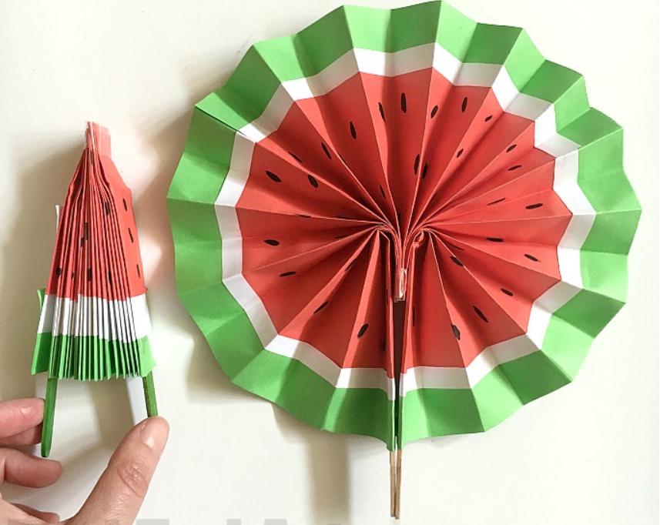
Watch: https://youtu.be/2z0AO6ozRYM?list=PL2vt_TPKQbZr9Uqd-aZbc1xEZVIKK-0A7
Instructions:
- Cut your A4 sheets of paper in half LENGTH WISE. You will only need 3 of these strips. But by all means experiment and use all four. For the MELON we cut 2 sheets of A4 of red paper. Then some strips in green (approx 2cm wide) and white (approx 1cm) and then using the glue stick we stuck them all together to create the melon piece colour order. We then added black seeds with a pen.
- Concertina fold each strip approx 1cm wide.
- Stick your three pieces together with a glue stick. Make sure they are stuck together firmly.
- Now bunch them all together to make them as flat as possible. And secure the BOTTOM of your paper with some sellotape.
- Glue a craft stick on either end.
- Carefully open up – and DONE! Gorgeous

