Hello Year 3,

We hope you have enjoyed getting into our topic of 'extreme weather'. This last week, we seem to have had some extremes of weather here! There are now only 3 weeks left of the school year. In the last two weeks, we will be seeing some of you in school again - which we are really looking forward to! We also hope you have enjoyed taking part in Wild June. There is an activity below to celebrate your '30 Days Wild'.

For the next 3 weeks, we have decided to give you a bit of choice over your learning. We still expect you to complete the daily maths, the quick reading tasks and spelling activities, but have a bit more freedom with the topic work. We would like you to continue to make sure you total at least 100 points per week. If you want to choose and study extra you are obviously more than welcome!

The topic grid that we shared last week about 'extreme weather' is included here again, so that you can continue to work on this topic. There are also a few extra activities that have been added to this!

If you have any queries, please do not hesitate to get in touch - we are all more than happy to help. We also love seeing your emails, pictures and general updates!

**Spelling**

|  |  |
| --- | --- |
| Mario | Bowser |
| * division * confusion * decision * extension | * division * confusion * decision * extension * explosion * occasion * television * invasion * conclusion * persuasion |

**Tactic: 22 words ending in ‘sion’ and keywords**

Watch the video on BBC bitesize and then have a go at the wordsearch!

<https://www.bbc.co.uk/bitesize/topics/zt62mnb/articles/zyv4qhv>

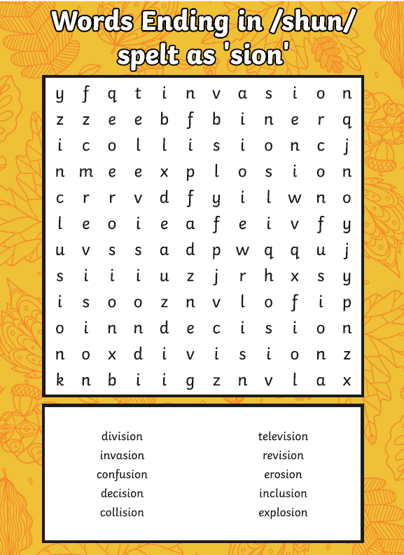

**P.E:**

Alongside the Notts PE sports ideas on the school website, we thought, as we are unable to have a sports day this year, it would be good for you to design and have a go at your own sports day at home. You could design races in your garden / local park for your family to take part in. You could have running, jumping, throwing races or even have a go at the traditional egg and spoon and three legged races. Try creating your own obstacle race and time members of your family to see who is the quickest to complete it! Please send us pictures!

**Maths:**

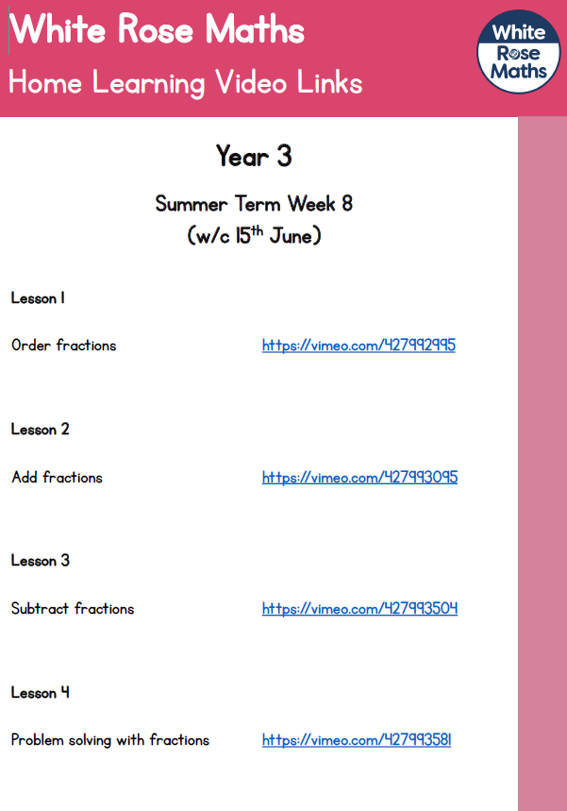

This week we will be continuing to look at fractions. First, have a look at the work you completed last week and recap what you have already learned. This week, we would like you to focus on ‘Summer Term Week 8 w/c 15th June’- lessons 1, 2, 3, 4. Please watch the video and complete the activities. If you are feeling extra confident you could have a go at the ‘Friday Maths Challenge’.

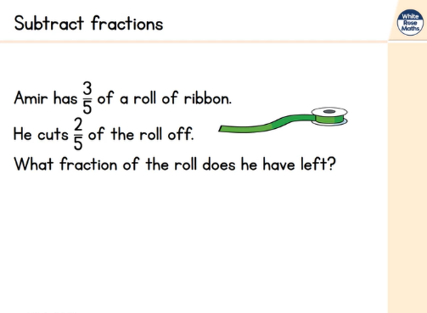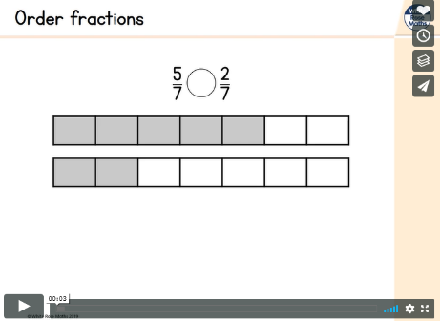<https://whiterosemaths.com/homelearning/year-3/>

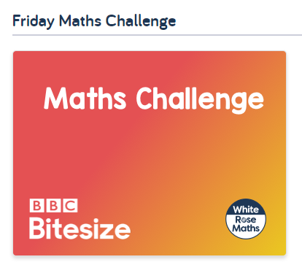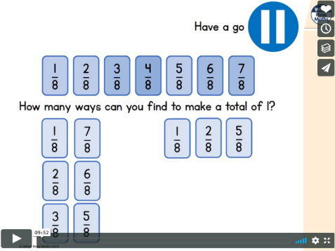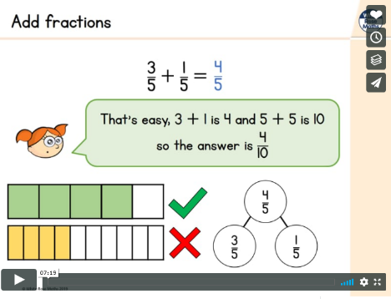

We have uploaded the worksheets separately and these can be found on the Year 3 page along with the learning letter.

White Rose Maths have started repeating some blocks for the children who may have missed them during home learning.  If you have already completed this and you feel your child does not need to recap fractions there is an alternative plan focusing on recapping length. It is your choice which week 7 learning your child does, whichever you feel would benefit them the most. Below is the link to the alternative videos and the worksheets/answers have been uploaded to our page on the website.

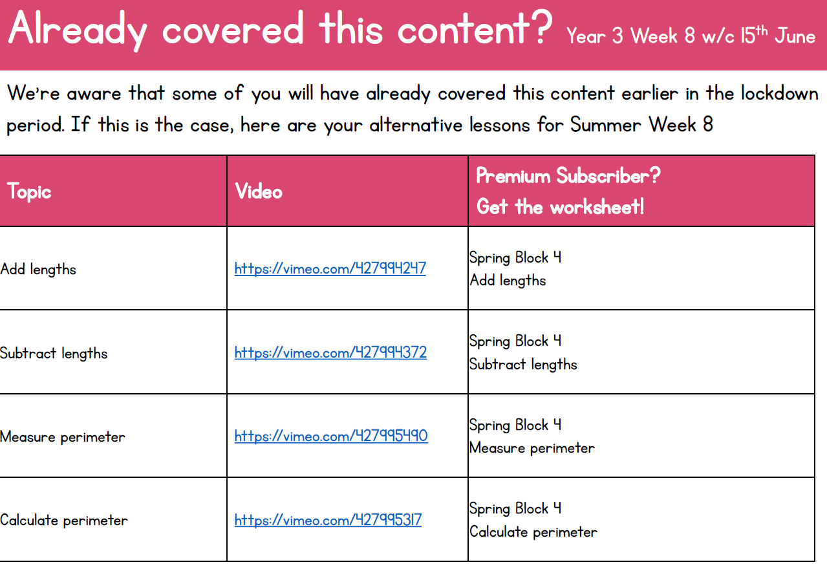

**A copy of the Extreme Weather Choosing Grid from last week**

Feel free to continue choosing activities from this grid - resources are available on the school website under home learning 29/6/2020, or you can extend your learning and choose from the additional grid afterwards.

Aim for 100 points this week by choosing from the 2 grids.

|  |  |
| --- | --- |
| A **rain gauge** is an instrument used by meteorologists and hydrologists to measure precipitation (e.g. **rain**, snow, hail or sleet) in a certain amount of time. It usually measures in millimetres. Using the instructions that can be found at the bottom of the document, have a go at making your own rain gauge. Place your creation in a suitable place and record the amount of rain in the bottle/jar each day and empty out the rain each time. Once you have completed your experiment create a table to record your results.  (35 points) | Chose an extreme weather event it could be a flood, hurricane, blizzard or hailstorm. Research what it might be like to experience your chosen weather event. Then imagine you have woken up one day and lived through it yourself. Write a diary extract of your experiences. Remember to use your FANTASTICS to describe what you might see, hear, feel and smell.  (40 points) |
| Match the extreme weather event to the correct definition. Complete the ‘Extreme Weather Definitions’ worksheet This can be found at the bottom of the document. (20 points) | Research and create a glossary for the following words:  Extreme weather event, Tsunami, blizzard, flood, snowstorm, climate change, weather pattern, drought, tornado. (20 points) |
| See the source imageCreate a detailed and accurate drawing/ painting of an extreme weather event. Think carefully about the types of things that might occur in this event.  (30 points) | Image result for tornado in a jarMake a Tornado in a jar. Follow the instructions at the bottom of the document and create your very own tornado. Observe what happens carefully and discuss with a friend or family member what you have noticed.  (25 points) |
| In the PowerPoint, we introduced the Tempest Database. This database allows us to look back at past extreme weather events. Visit the database by following this link-  <https://www.nottingham.ac.uk/geography/extreme-weather/search/>  Have a go at searching and exploring the different extreme weather events and the impacts they had. You could do this by typing in a year, type of weather event or a place you wish to find out about. (25 points) | See the source imageWrite and then decorate an Extreme Weather poem. At the bottom of the document, we have included some examples. Think carefully about the vocabulary you use and the layout of your poem.  (40 points) |
| Become a reporter and write your own newspaper article reporting an extreme weather event. Watch the clip to help you think about how to write in the style of a newspaper article.  <https://www.bbc.co.uk/bitesize/topics/zkgcwmn/articles/zbsbwty>  Think carefully about using formal language and technical vocabulary just like a real newspaper article. You can create your own layout or use the template we have provided.  You could write about the extreme rain we had in February this year which lead to flooding in Nottingham.  In your article you must include; The date, location, the name of the type of weather event, A description of what happened and of some of the impacts.  (40 points) | Design an earthquake-proof building. Using the worksheets provided, think carefully about the shape and structure you would want your building to have.  (35 points) |

**Extreme Weather additional activity choices**

|  |  |
| --- | --- |
| C:\Users\joanne.seagrave\AppData\Local\Microsoft\Windows\INetCache\Content.MSO\5E6B8D47.tmpFind out about Mount Tambora and how the eruption in 1816 affected the weather in may places around the world. Imagine a year without a summer?  Make a list of all the ways in which the Sun is important to our everyday lives.  (15 points) | Recently, with all the hot weather we have been having quite a few thunderstorms. Read the powerpoint about thunderstorms - see link on school website.  Create a factfile about thunderstorms answering these questions:  Why do we get thunderstorms?  Why are they called electric storms?  Why does the thunder come after the lightning?  What is the safest / worst place to be in a thunderstorm? (25 points) |
| What are the causes of all this extreme weather?  Read the global warming powerpoint - link on school website.  **Either**  Make a poster to help others to make a change and become greener. (15 points) | **Or**  **Write a letter to a world leader encouraging them to help stop global warming.**  There is a template attached at the bottom of this letter.  (20 points) |
| Write about the most exciting things / favourite you did during wild June. Did you make a den? Did you splash in muddy puddles? Did you find a new woodland walk? Did you learn anything new about the natural world around you? (15 points) | |

**Reading Comprehension**

On the next page are a series of short texts with quick questions about extreme weather. Please choose at least 2 to complete this week.

**Answers from last week**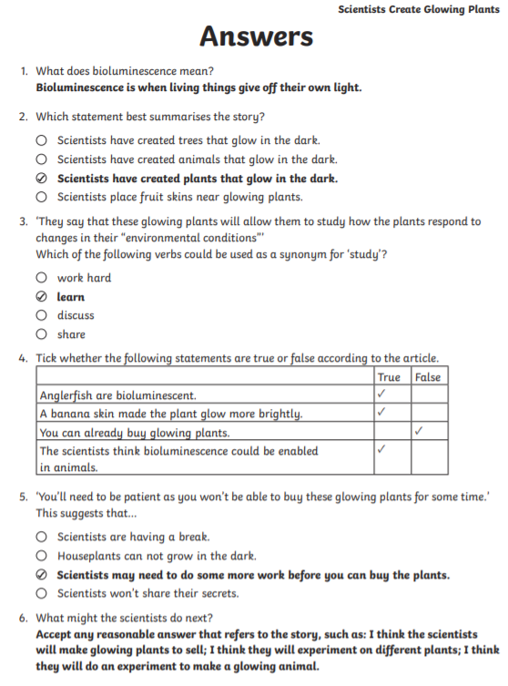

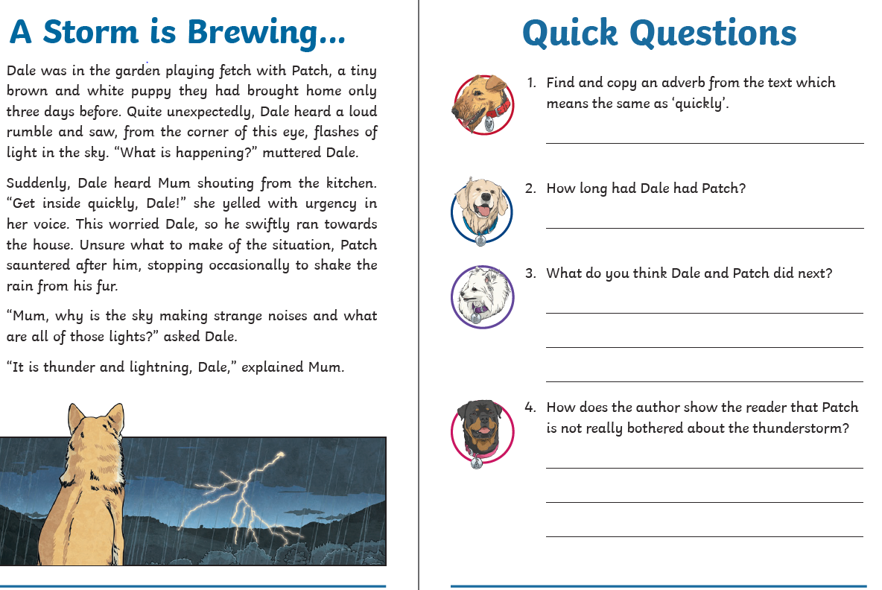

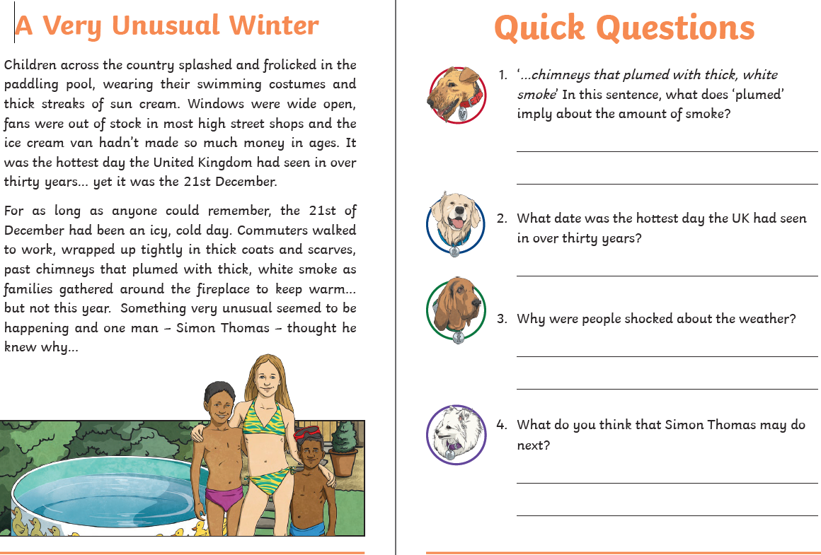

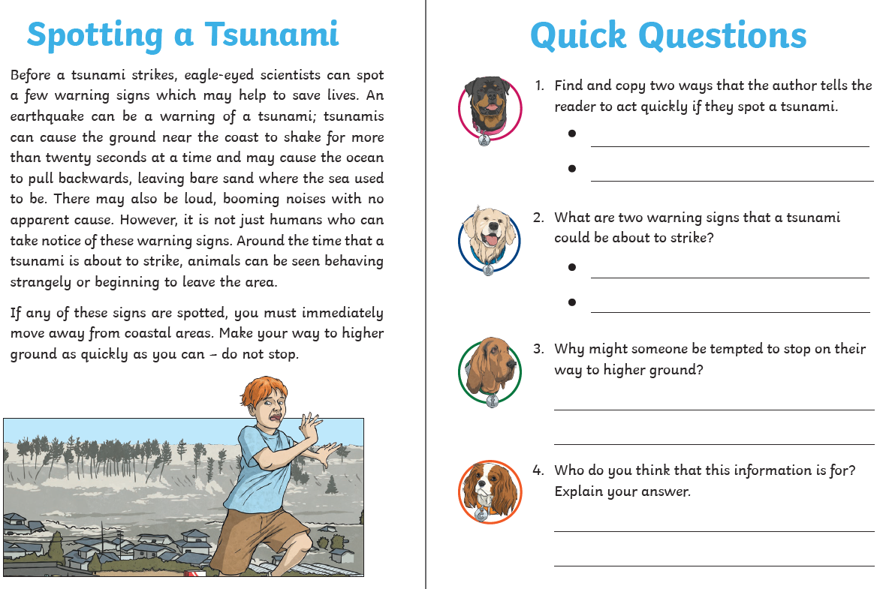 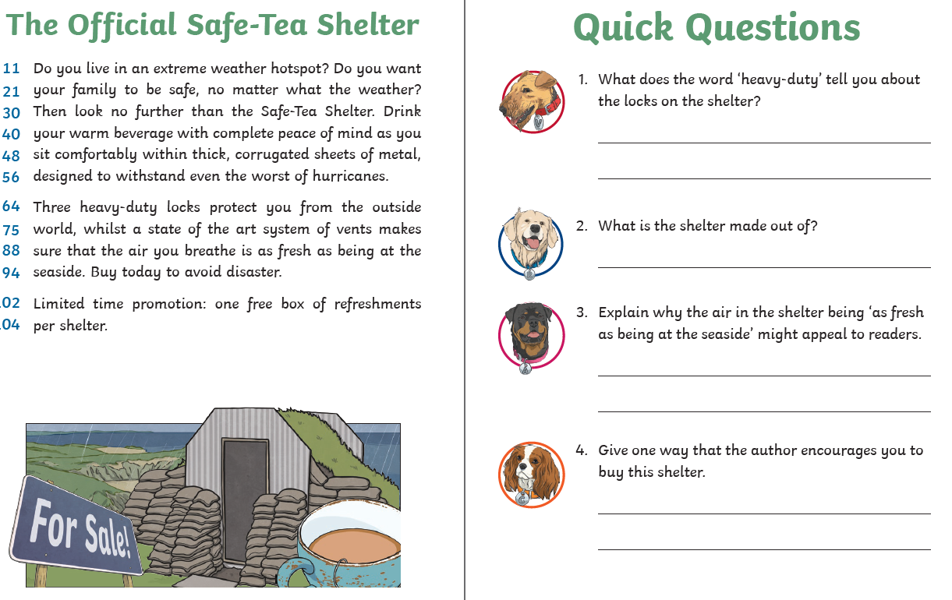



We do hope you enjoy these activities and look forward to receiving email pictures / photographs and updates.

Work hard, play hard and most of all stay happy and safe and we look forward to seeing some of you again very soon!

Mrs Seagrave, Mrs Horton and Miss Moore 😊