Literacy activities week beginning 6.7.20
Activity 1
Listen to the story Meerkat Mail by Emily Gravett
https://www.youtube.com/watch?v=DcwuTRQ16MU
Did you enjoy the story? Have a chat with a grown up or brother or sister about what you thought of the story. Did you like the pictures? What was your favourite part?
Can you remember the order Sunny visited different places?
In your book sequence the story by writing –
On Monday Sunny went to/visited/arrived at ….
On Tuesday Sunny …. etc
Remember to spell the days of the week correctly and start each one with a capital letter. Don’t forget capital letters for the names of Sunny’s family too. Finish each sentence with a full stop (Remember just a dot on the line!).
When you’ve finished you can choose your favourite place and draw a careful picture.

Activity 2
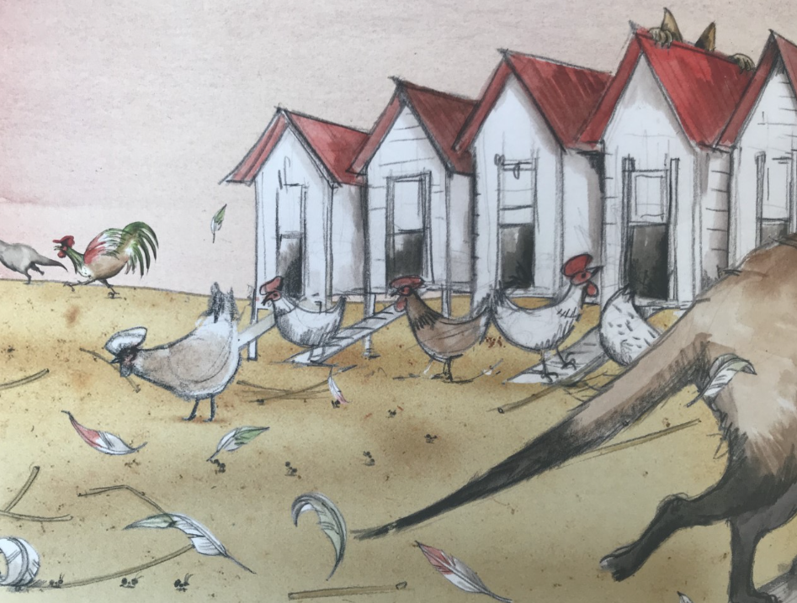
On Wednesday Sunny visits his cousin Edward who lives on a farm.

Look at the picture, taken from the book and write down what Sunny would have seen, heard and maybe even smelt on his visit. Remember to use adjectives to give descriptions eg fluffy white chickens pecking the sandy ground.
Activity 3
Use the words and phrases you wrote yesterday to write a postcard from Sunny to his family telling them about his trip to the farm. You will need to pretend you are Sunny and write ‘I am … ‘ You can print out the template below or make your own with paper or card. Remember to draw a picture of the farm on the other side.
This is the front and back of the postcard Sunny wrote in the book.
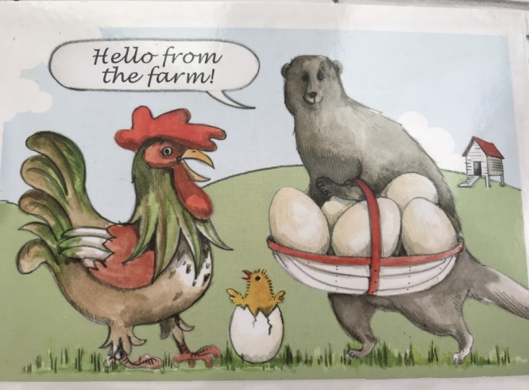
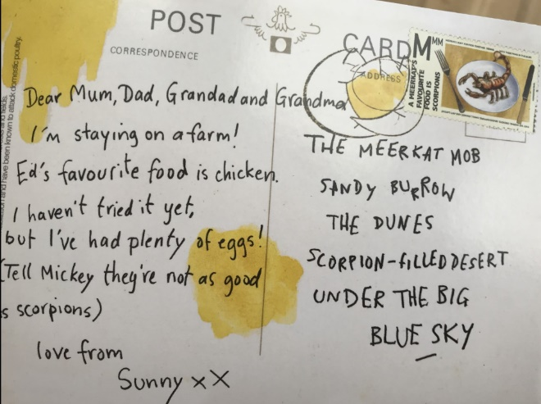

Activity 4
Meerkat reading comprehension
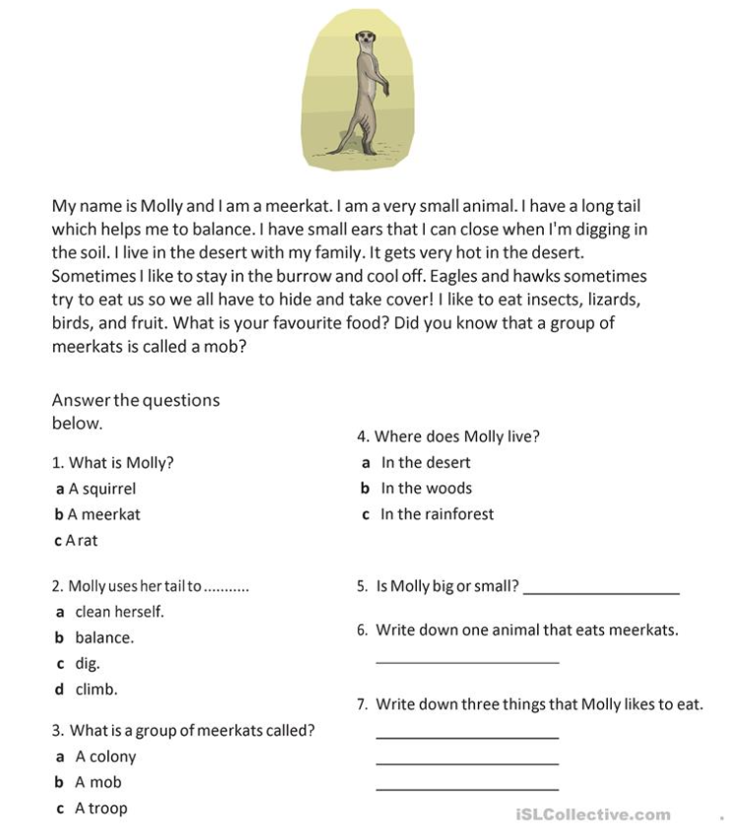

Activity 5 Spellings
Next week we will be writing a letter from Sunny and you might write ‘nice time’ which has the split i-e in it, so we are going to focus on split i-e words:
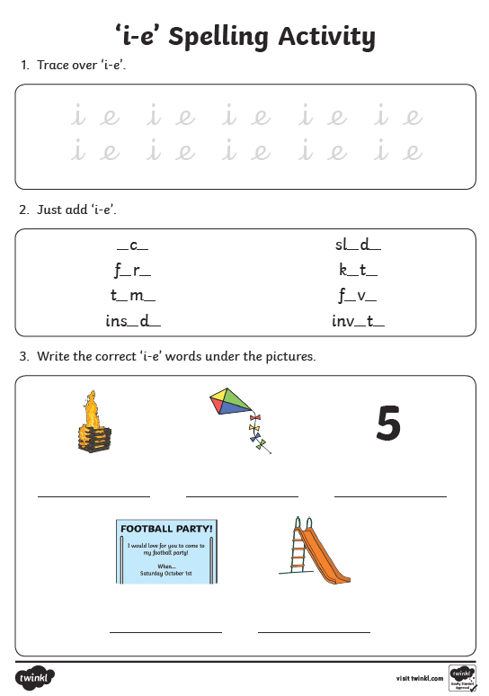
Now try and write a sentence for each of the words you wrote next to the pictures (invite, slide, fire, kite, five)
Remember to start with a capital and end with a full stop. Make your tall letters lovely and tall too!

