Mandalas
Mandalas have been used for meditation in Eastern Cultures for centuries. Circular in shape and usually containing geometric patterns, they are ritualistic symbols of the universe in both Hinduism and Buddhism.
Their often complex and intricate patterns also make them a great mindfulness tool. You can of course, create mandalas with just about anything, but we chose to use items from nature for ours. The natural elements made it a peaceful, grounding experience.
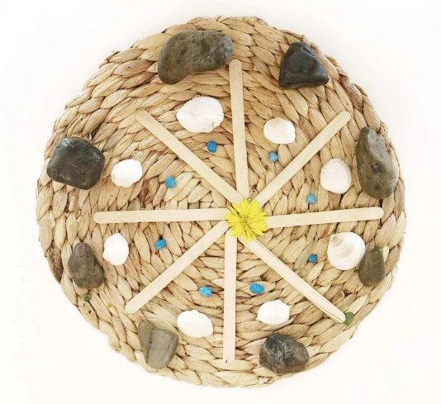
Simply engage with your senses as you work. Notice the weight of the stone in your hand. The smell of the leaf or flower. The texture of the shell. The colour of the feather. It’s a lovely way to connect with the earth and the environment around you in a mindful way.
What you’ll need:
- A round base of some sort – we used round placemats, but you could also use a paper plate or some cardboard.

- A selection of natural items – we used shells, pebbles, flowers, stones, and leaves. We also used some cotton thread and some popsicle sticks to create the lines in our mandalas.

What to do:
Just gather your supplies together and get creative! Mandalas are typically symmetrical, with a repetitive pattern or sequence of some sort. But of course, this isn’t vital to this particular exercise! Don’t worry about whether your mandala looks good, or “right” and just focus on the process of creating and being aware as you work.

