Literacy activities week beginning 13.7.20
Activity 1
Here is Sunny again. He has gone on another adventure! Where do you think he is? Have a look in the background – what can you see? What’s the weather like? What might he do there? Do you think he likes it?
Draw and label everything he needs in his suitcase. If you have any old magazines at home you could cut out pictures and stick them on if you like.
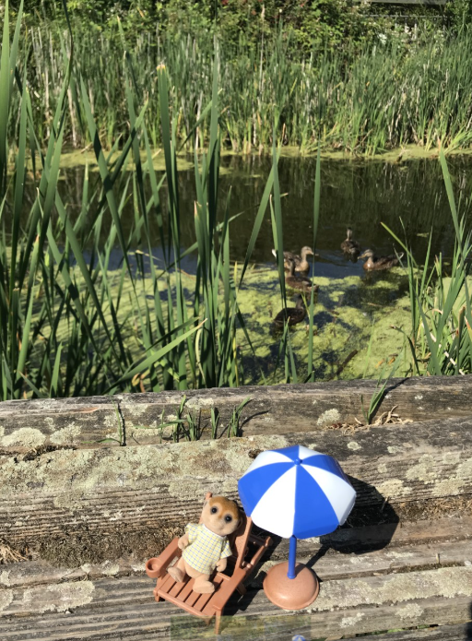
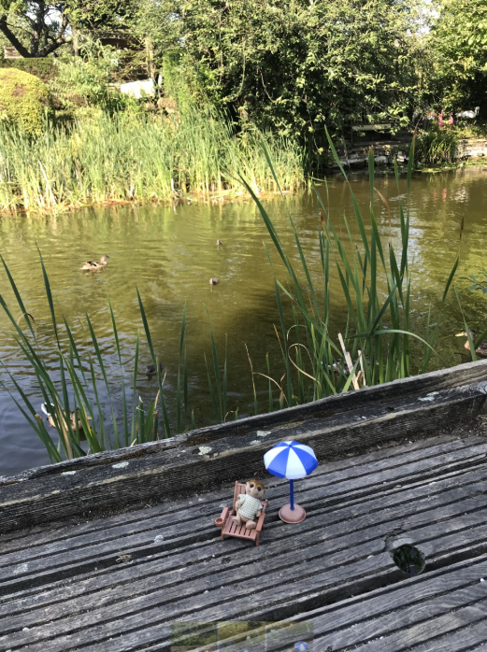

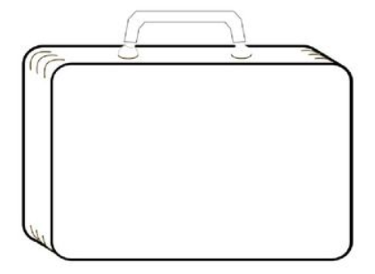

Activity 2
Last week you wrote a postcard from Sunny to his family about his visit to the farm. Today we’d like you to write a letter from Sunny to his family telling them all about his new adventure.
Letter checklist –
- Start with Dear/To …
- Write using I eg I am having a lovely time here …
- Describe where you’re staying – what can you see, hear?
- Say what you’ve been doing
- Ask a question – don’t forget the ?
- Finish your letter by signing off – from Sunny
- Remember to write in sentences – capital letter to start and full stop to finish
- Write neatly on the lines with letters correctly formed – tall letters tall
- Clear finger spaces!
- Remember to read your letter back to check it makes sense

Activity 3
Have a look on the National Geographic webpage with an adult and watch the short YouTube clips all about meerkats.
https://www.natgeokids.com/uk/discover/animals/general-animals/meerkat-facts/
https://www.youtube.com/watch?v=W4og8g_X22o
https://www.youtube.com/watch?v=NokF599u1Ck

You will all be meerkat experts by now! How many facts can you remember? Write a little fact sheet or make a poster about meerkats. Think about - Where they live? What they eat? What they look like? When they sleep? How they behave? Remember to make your fact sheet eye catching!

Activity 4 Reading comprehension
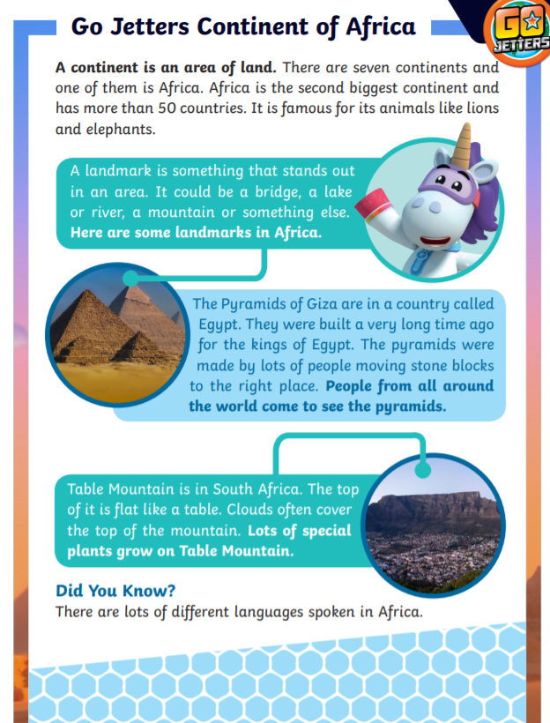

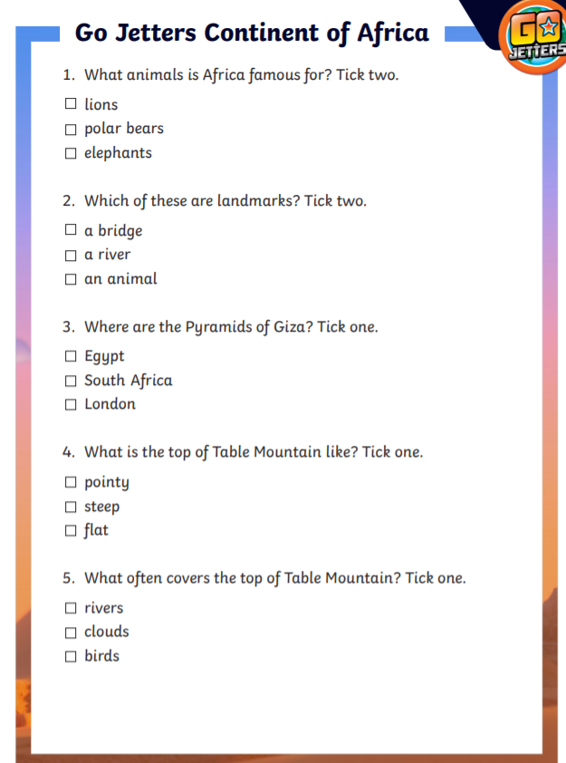

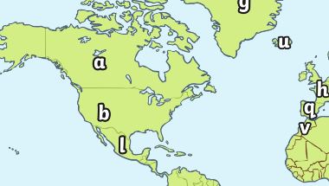
Activity 5 Spelling / Grammar
Have a look at (and print if possible) the world map. (See attached pdf names Capital and lower case matching)

Can you match the flags to their country by matching the lowercase and upper-case letters? As an added challenge can you find out which country the flag is from? If you write down a country name remember it will start with a capital because it’s a name!
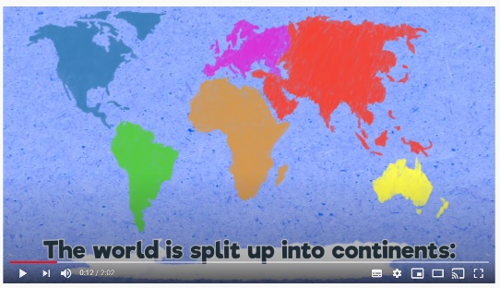
See if you can spot the continent Africa – with a grown up you could find all the continents – here’s a little song to help you learn them!

https://www.youtube.com/watch?v=K6DSMZ8b3LE

