Topic Activities week beginning 13.7.20
Activity 1 – Science
Watch this short clip about the four seasons and have a go at the quiz that follows after -
https://www.bbc.co.uk/bitesize/topics/zkvv4wx/articles/zcx3gk7

Now watch this clip that shows what happens to different landscapes through the four seasons -
https://www.bbc.co.uk/teach/class-clips-video/the-changing-seasons/zh4rkmn

Split a page of your book into 4 and draw and write about each season. Think about … the months in each season (remember capital letters for names of months!), the weather and nature.

Activity 2
Listen to and join in the months of the year song –
https://www.youtube.com/watch?v=5enDRrWyXaw
Can you learn it? Can you teach it to someone in your family? Now write down the months of the year in order and draw a careful little picture next to each month to help you remember. (The months are at the bottom to help with spelling and remember the capital letter!)
As an extra activity can you answer these questions?
- What is the first month of the year?
- What months are in summer?
- What month is Christmas celebrated?
- When is your birthday?
- How many months are in a year?
- What month is it now?

May | January | December | February | August | July
November | March | September | April | October | June

Activity 3 – Art
Watch the seasons clip again -
https://www.bbc.co.uk/teach/class-clips-video/the-changing-seasons/zh4rkmn

Pause the video on your favourite image. Create a piece of art about a season using the paused image as inspiration! You could do a careful pencil drawing and practice your sketching skills. You could use pencil crayons to add colour to your artwork or paints if you have them. You could do a collage using torn paper from old magasines if you like or even make a sculpture! It’s up to you!
Here are some artworks to give you some ideas – can you tell which season they are?
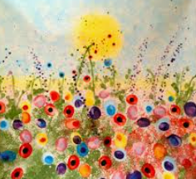
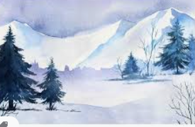

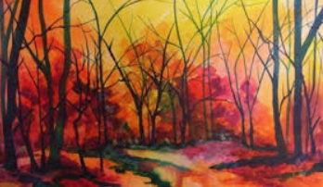
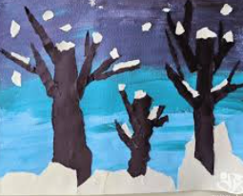

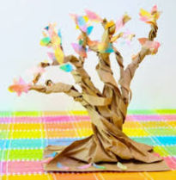
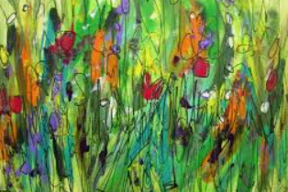
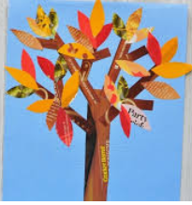

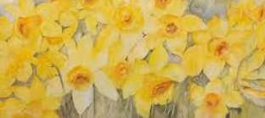

Activity 4 - DT
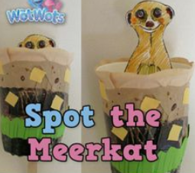
Make a pop up meerkat!
You will need:
Scissors
Glue/cellotape
Paper/card (cereal box)
Paper cup or similar (from recycling)
Lolly stick/straw (or strip of card from recycling)
Felt tips/crayons/paints

Instructions
- Draw a meerkat outline that will fit inside your cup (if you don’t have a cup you could use a toilet roll and close in the bottom or another small box out of the recycling). You will only need to draw the top half of the meerkat. Carefully colour it in. Cut it out and stick it to the top of the lolly stick.
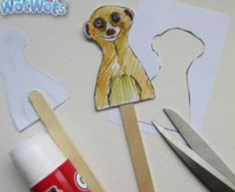

- With a grown up’s help, make a slot in the bottom of the cup/box for the lolly stick to go through.
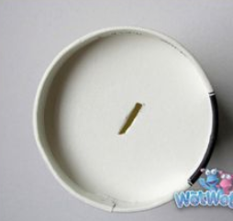

- Decorate the outside of the cup/box with scraps of paper, magazines, felt tips etc. Think about where meerkats live – what colours are their surroundings?
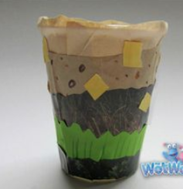

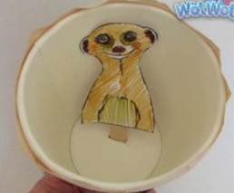
- Push the meerkat on the stick through the slot in the cup and pop him up and down!

Activity 5 - Science
Go on a signs of summer hunt with a grown up.
On your next walk/bike ride or outing have a look for all the signs of summer. You could also look in your garden or out of the window – look at the weather, nature, what people are wearing, activities people are doing. When you get home make a list or draw careful pictures of everything you saw.
Some things to look out for …
