Topic Activities w/c 6.7.20
Activity 1 - History
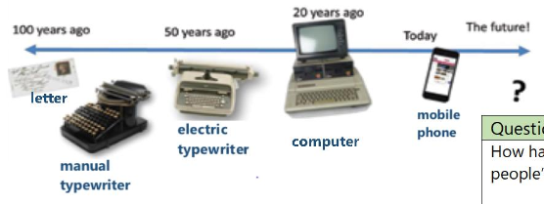
We have learnt about the invention of the telephone and about different ways to communicate. The ways of communication have changed so much over time:

No one knows what amazing invention might be next?
What will Apple launch next? Have a think about what you would create if you were an inventor. Draw a picture of it, add labels. Write some sentences explaining what it does. How do messages pass to others? How does it have power? What size is it? Do people carry it? Wear it? We would love to see your great inventions!
Activity 2 - History
These four famous people have all invented things to help us communicate:
Which do you think is the most important to you? Ask everyone in your household which they think is the most important and why.
Draw a picture of each invention and write the name of the inventor next to it. Under each one you can write who thought this was the most important and why – try to use the word ‘because’ eg:

Television invented by John Logie Baird
My sister thinks this is the most important because she can find out about the news.

Activity 3 - PSHE
Over the last few months things have been very different for us all. We are all in little ‘bubbles’. Some of us are in a bubble at home, with our family, some of us have returned to school and are in a bubble with our classmates.
Some new friendships have formed, some new happy times have happened in our family. Draw or write who is in your bubble. You can write some sentences about happy things that have happened in your bubble:
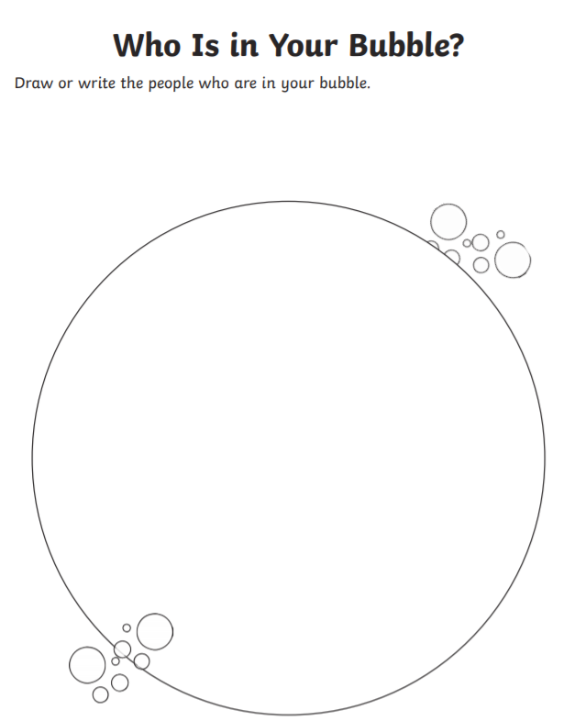

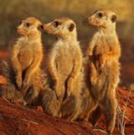
Activity 4 - Art
Our Literacy book is all about Meerkats, watch this short clip for some Meerkat facts:
https://www.youtube.com/watch?v=wwje73z-nCE
Then we are going to have a go at drawing a Meerkat. There are quite a few lessons on you tube, try this one:
https://www.youtube.com/watch?v=qZD5Nfyk3Co
Once you have drawn your Meerkat you can write some facts around it, use the ones from the video or find out some new ones!

Activity 5 – RE
We have been learning about Christian Churches and what we might find inside a church. Christian people often go to a church to give thanks to God. They find Churches are peaceful places and like to give thanks.
Saying ‘thank you’ is a lovely thing to do. Can you think of things you are thankful for? Can you say ‘thank you’ to some people in your bubble? Family?
Write a thank you letter to someone to say why you are thankful for them (there’s a template on the next page if you wish to use it)
Lots of us are very thankful for the lovely sunshine!
Finally, please look at the Sun safety PowerPoint. We are thankful for the sun – and we have seen lots of it in lockdown, but please stay safe in the sun!

