Abbey Road Primary School

Tewkesbury Close

West Bridgford

Nottingham

NG2 5ND

Tel: (0115) 9748055

Head Teacher: Mrs. Ly Toom Email: office@abbeyroad.notts.sch.uk

Dear Parents/Carers,

Welcome to Summer term week 7!

Another super, but wet week at school for 1P! We hope 1HB had a nice week doing their learning at home again. Thank you for emailing and sharing some of your work – it really does make us smile 😊.

Here are the ideas for the week:

* 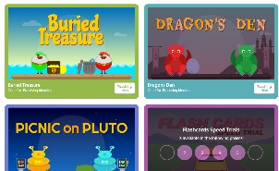Physical activity : Joe Wicks (3 times a week now), Cosmic Yoga, walk, bike/scooter ride, in the garden etc, plus there’s some fun PE planning on Abbey Road website, Oti from Strictly has some good half hour dance workshops on YouTube too. Also on YouTube there’s some fun dough disco videos to help with fine motor control – definitely worth a look! On YouTube there are some lively dance videos –‘Kidz Bop’ that are good fun.
* Phonics – The phonics with Rosie has finished now so we suggest you play a game on Phonics Play:

[www.phonicsplay.co.uk](http://www.phonicsplay.co.uk)

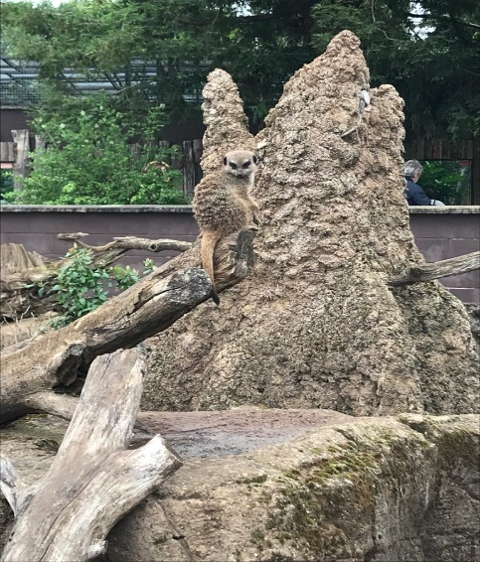 Try different games – lots of fun ones to choose from. If you hover over the game you can see which phase it is linked to.

* Maths – We are continuing with the White Rose Maths, this is the last week of maths.
* Literacy – Some more daily activities connected to Meerkat Mail. Mrs Boughton and Mrs Hicking have seen Meerkats at Twycross zoo over the last few weeks, this is Mrs Hickings photo
* Topic activity – 5 are planned for the week. Some lovely activities around the Seasons. Hopefully summer will look a bit more cheerful next week!
* Reading – Sharing a book, using the viper questions to further learning. - <https://www.oxfordowl.co.uk/for-home/> This website has free ebooks for your child to read. They are colour banded just like school.

Many thanks and have a good week!

The Year 1 Team

SUMMER TERM 2 WEEK 7