Add by making 10
Here is an example for you to look at:

These ten frames show 7 and 4. Count the counters to find the total .
7 4

o | o | o | o | o
o | o
o | o | o | o

7 + 4 = 11

Now we can use the same counters to make 10 and write the addition.

o | o | o | o | o
o | o | o | o | o
o

10 + 1 = 11
__________________________________________________________________________

- Draw counters to show that 6 + 7 is the same as 10 + 3
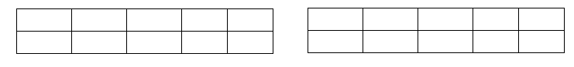
6 + 7

10 + 3

- Draw counters to show that 8 + 5 is the same as 10 + 3

- Draw counters to show that 9 + 4 is the same as 10 + 3

Complete the additions. Use the tens frames and red and yellow counters to help you.

- 7 + 6 = 10 + _____

- 8 + 3 = 10 + _____

- 9 + 8 = 10 + _____

- 6 + 9 = 10 + _____

- 7 + 8 = 10 + _____

